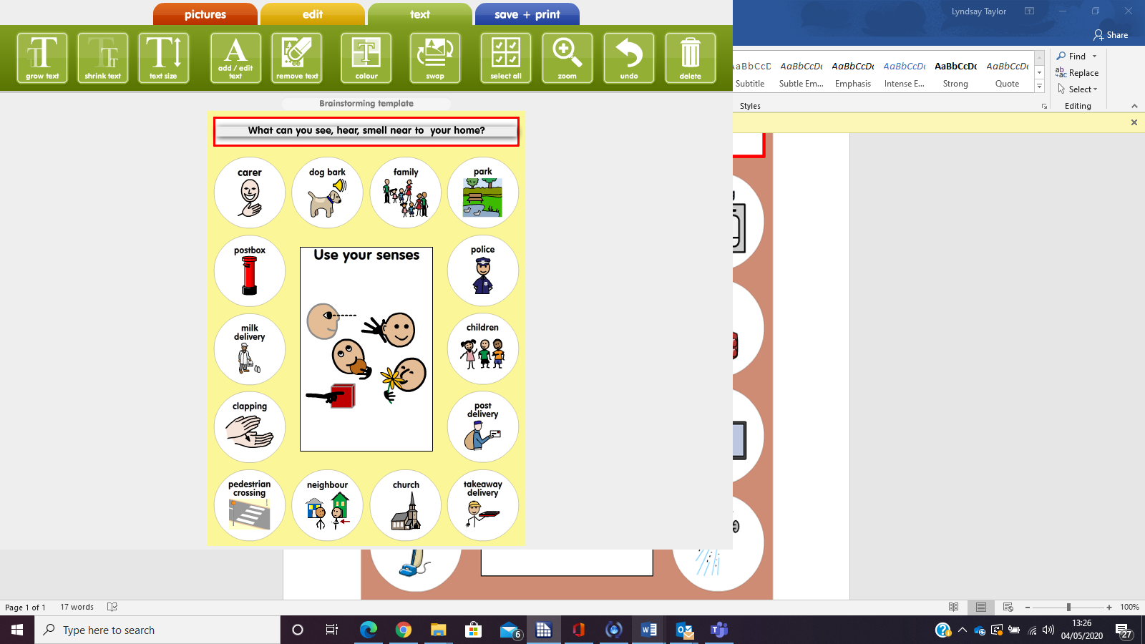

**A Treasure Hunt** – Can you find (with help) some of these everyday items near to your home? 😊