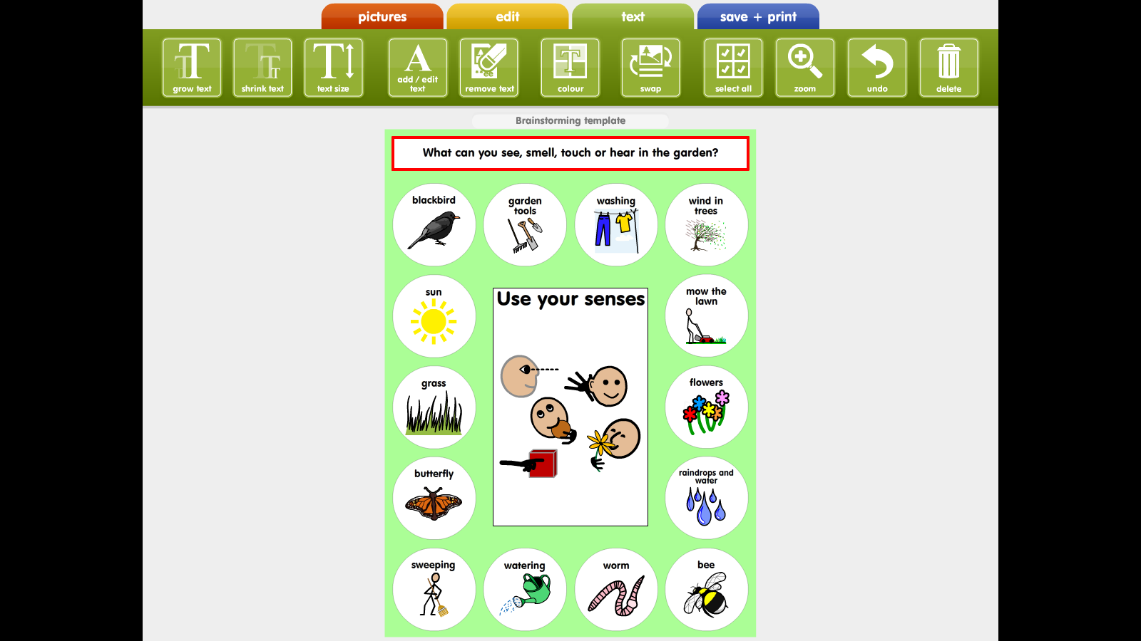

**A Treasure Hunt** – Can you find (with help) some of these in your garden? 😊