**Communicate**

**Explore**

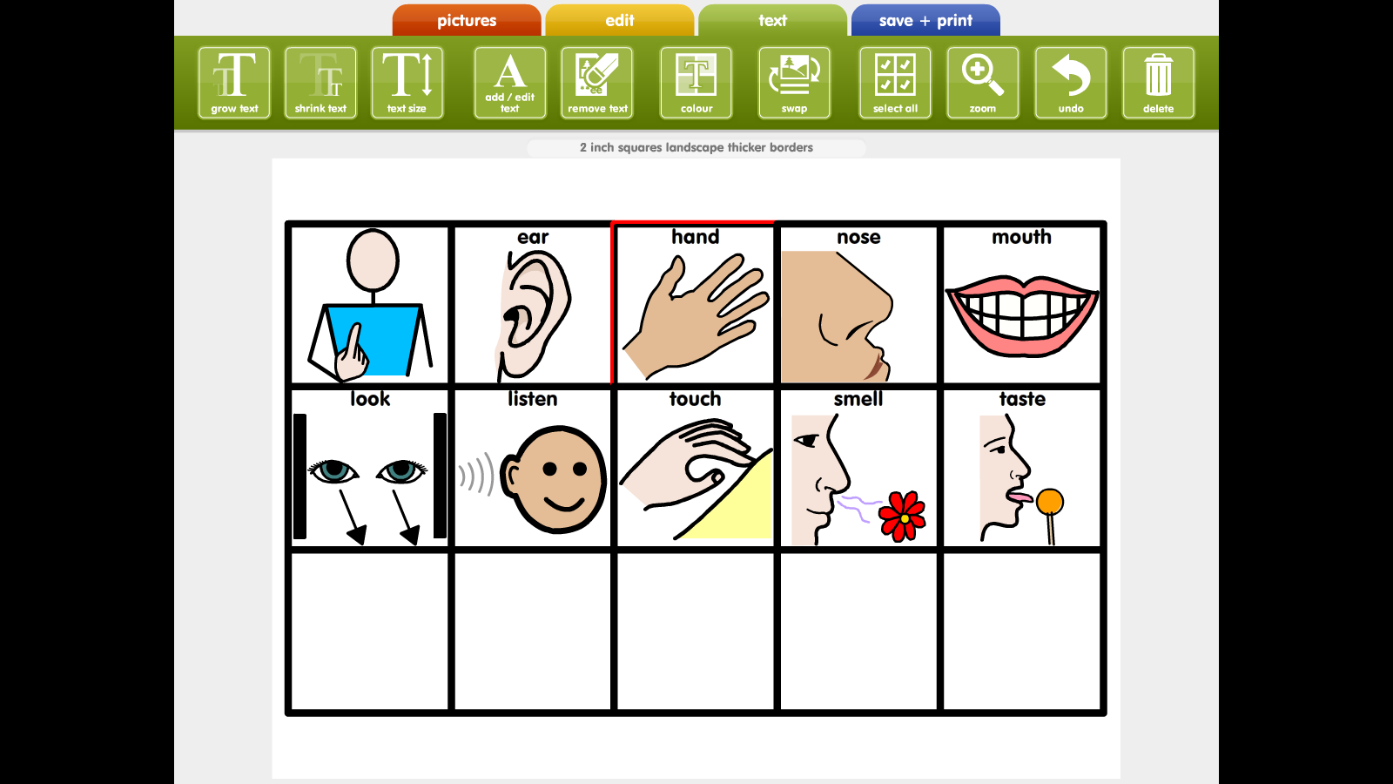

**My choices**

My name is ____________________

My photograph:

**My targets**

This booklet will help you achieve your targets.

You will achieve your targets by making choices.

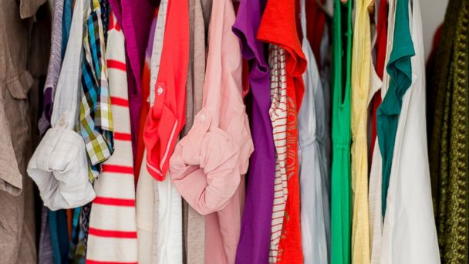You will make choices about:

Clothes



Food and drink

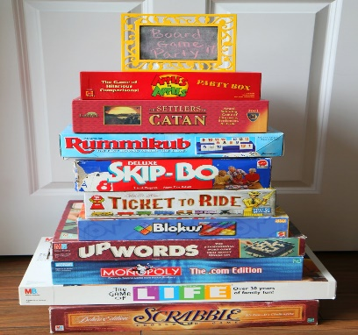

Activities

**Instructions for parents / carers**

This booklet will help the person in your care to achieve their targets around:

* Making choices
* Showing an interest
* Listening to others
* Responding to others

The activities in this booklet will support the person to make choices, based on day to day activities.

A tally chart has been created to help you to keep a track of when the person has made a choice. This will also be used for evidence and assessment purposes.

There is also space at the back of the booklet to add photographs, videos or your own statements about what the person has done to achieve their targets.

**My tally chart**

To be completed when I have made a choice.

|  |  |
| --- | --- |
| **My options:** | **The choice I made:** |
| Clothes |  |
| Food |  |
| Drinks |  |
| Activities |  |

**My daily choices**

I will make a choice from two.

This could be a choice shown between -

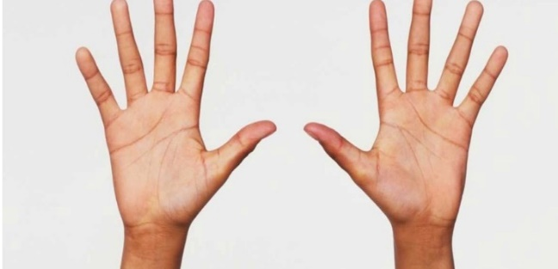

Two hands





Two real objects

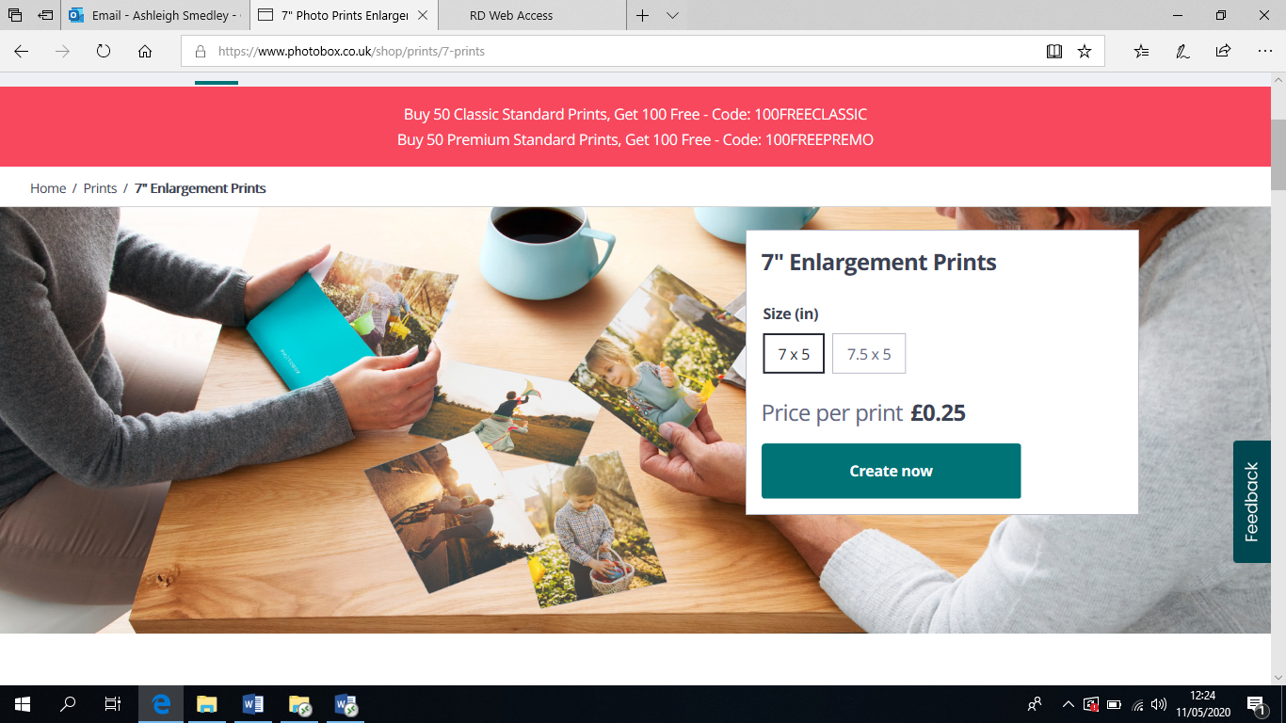

Two photographs

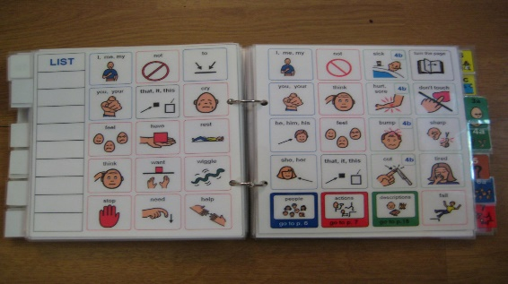

Communication book

**My daily choices**

Today, I will make a choice of:



**What to wear:**



**What to eat:**



**What to drink**



**What to do:**

**My photographs**

Add photographs or videos of you making your choices.

Your parent / carer can write what you have done.