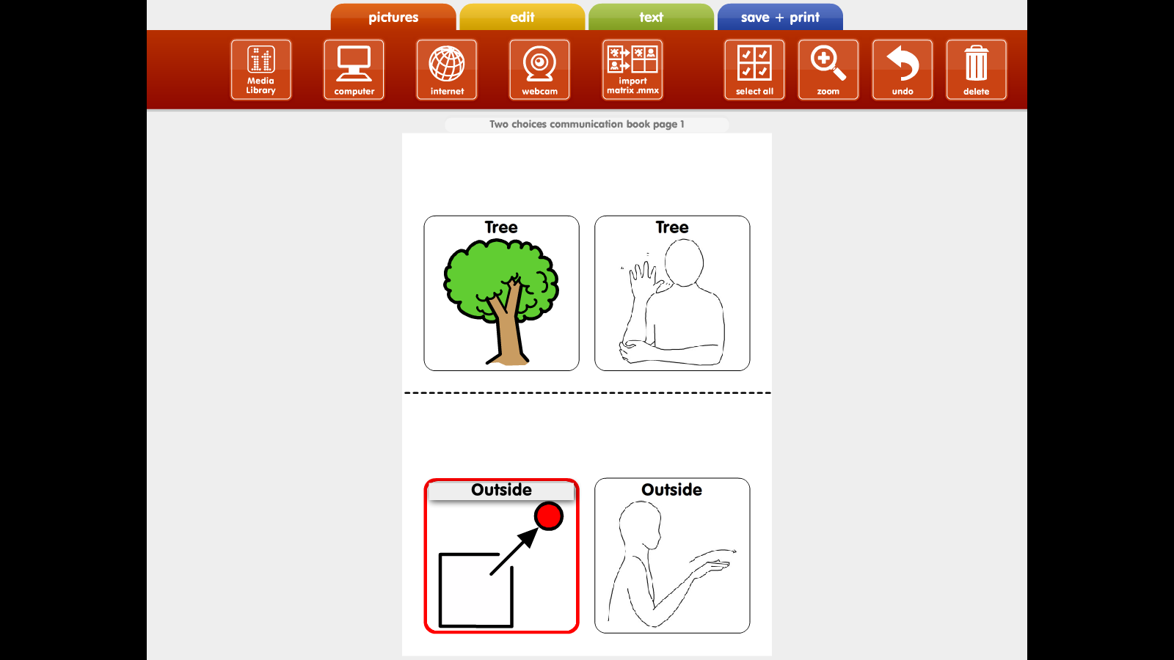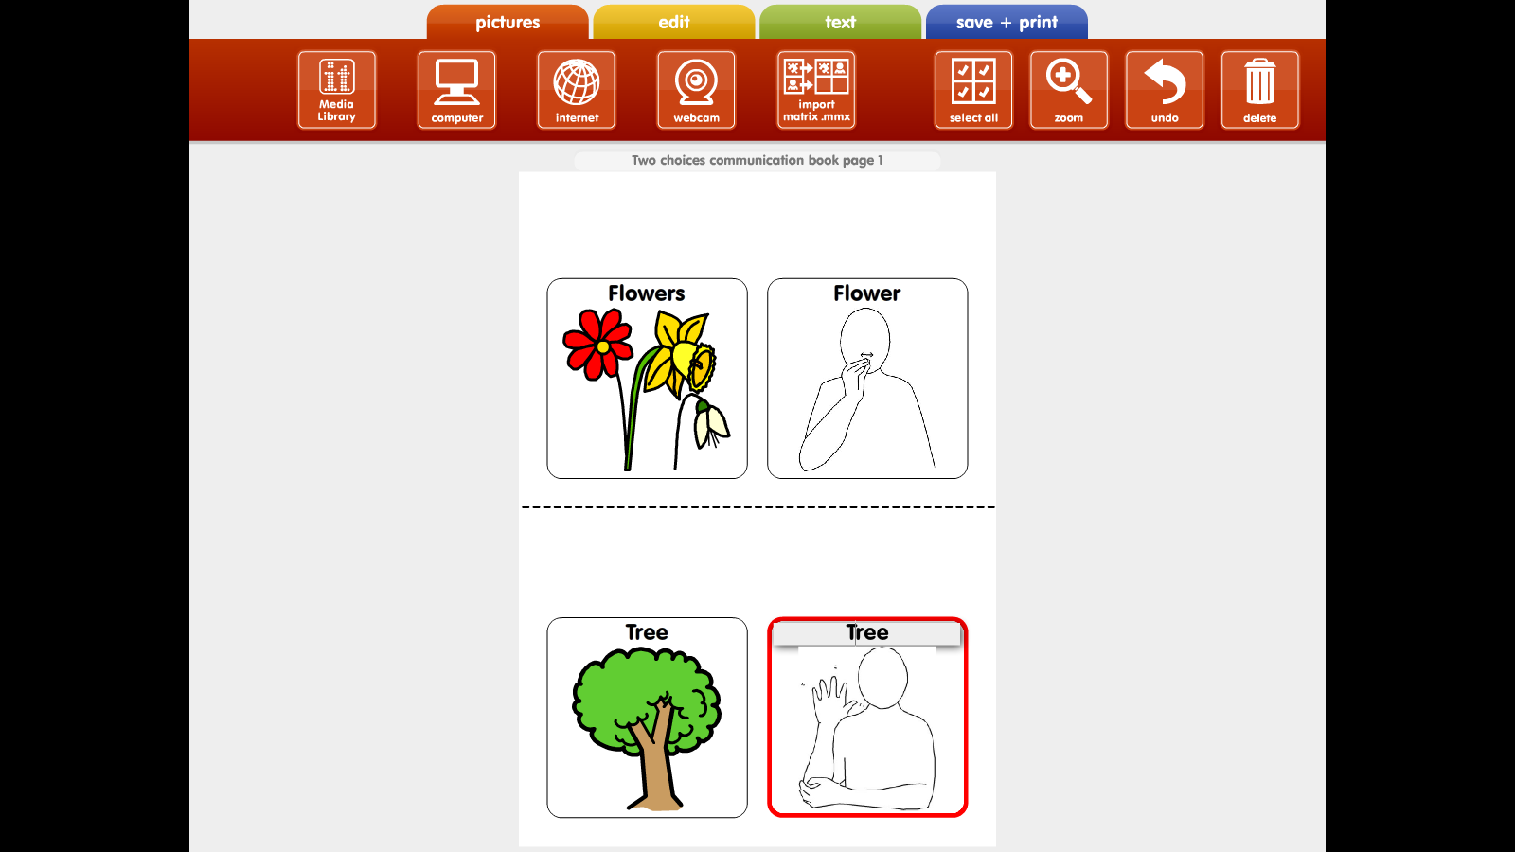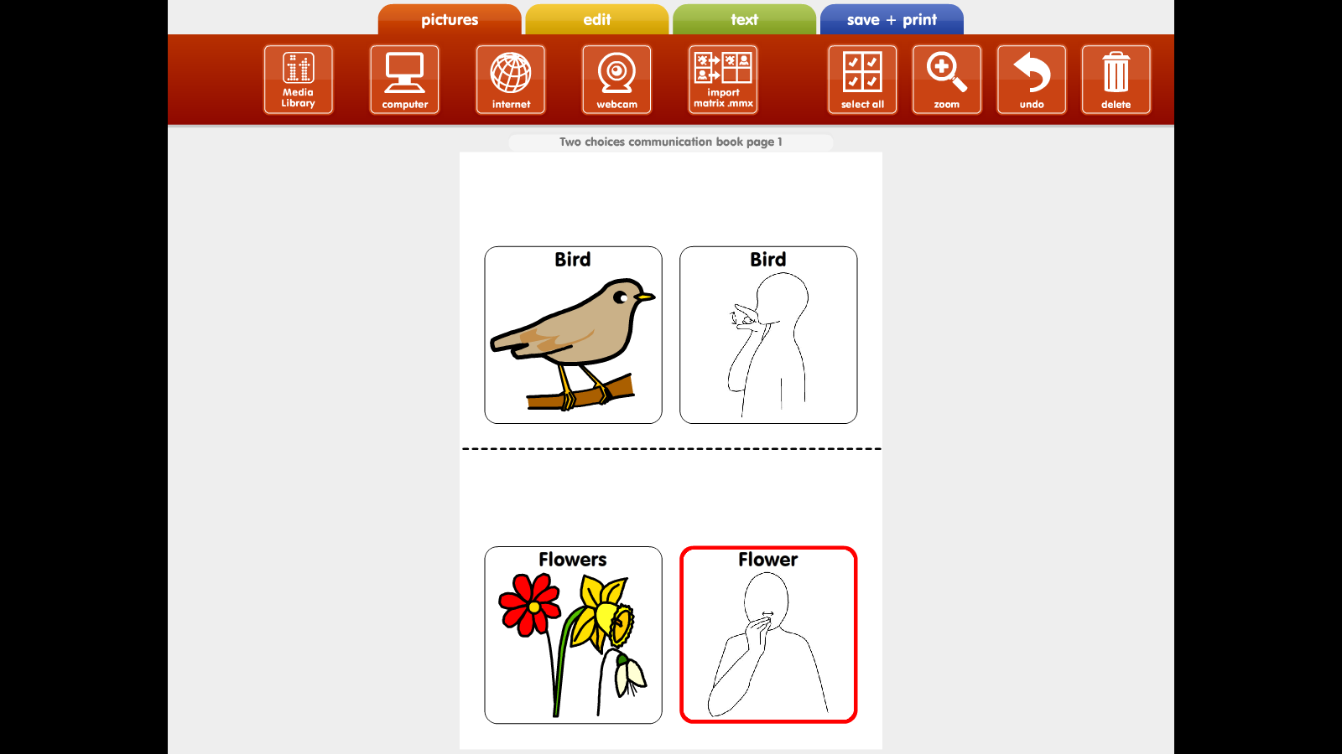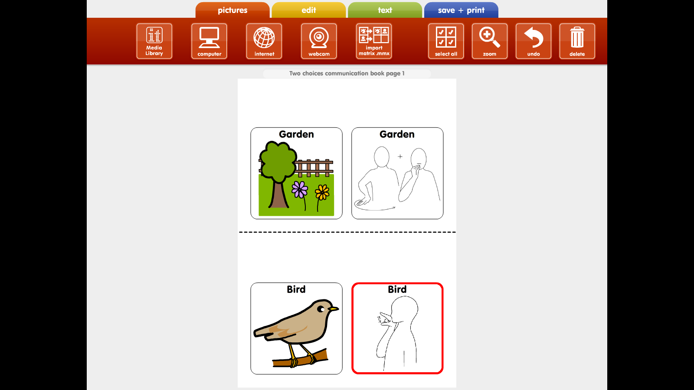

**Example – Makaton graphic can be inserted here.**

**Example – Makaton graphic can be inserted here.**

**Example – Makaton graphic can be inserted here.**

**Example – Makaton graphic can be inserted here.**

Please send any photos or videos of your wonderful signing to College