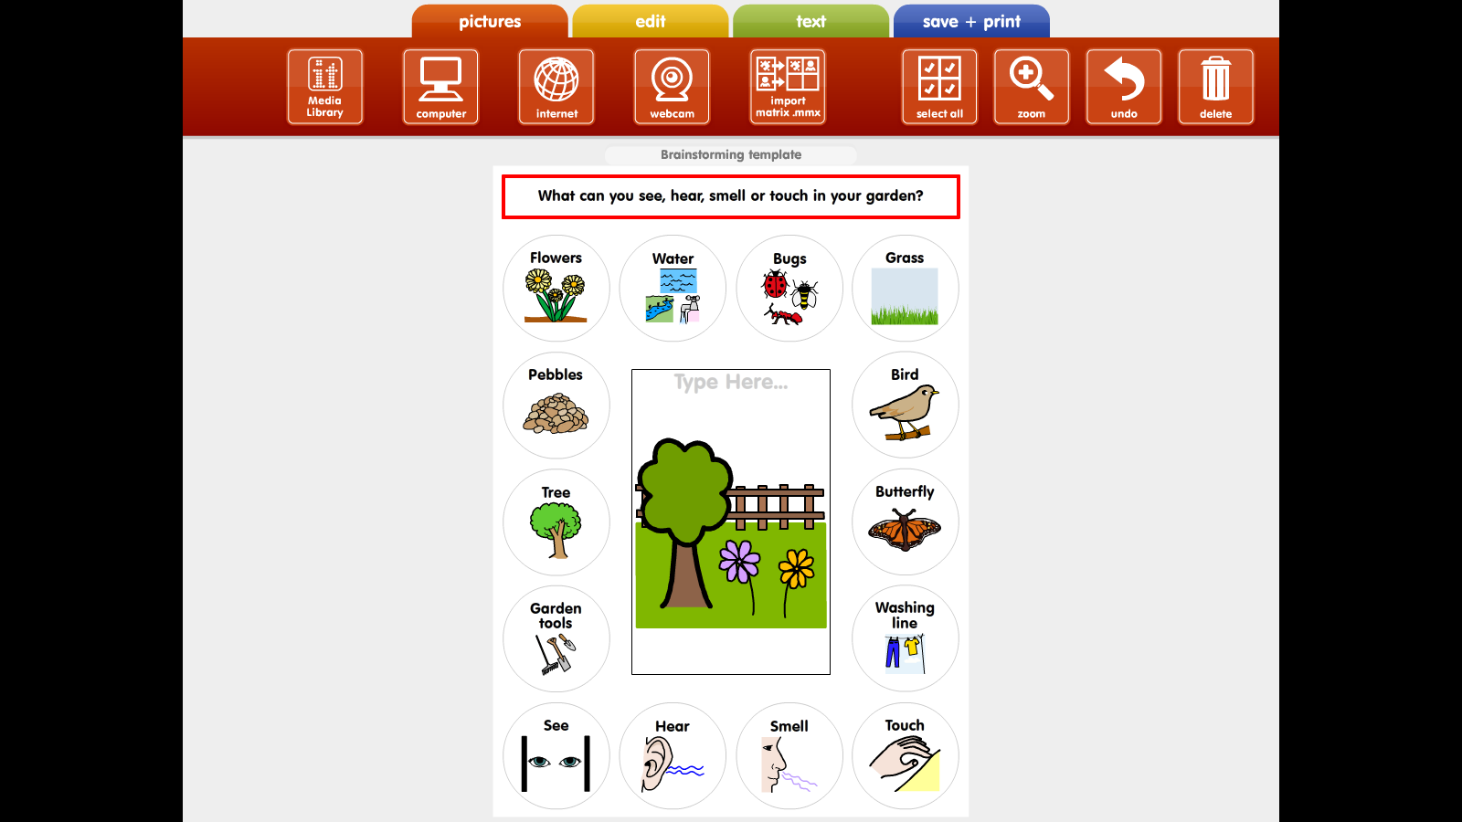

**It would be lovely if you could send some photos via Dojo or email.**