Brief;
Reflect on your work time in the café at Springfield park. Think about how your own actions have a direct impact on others that you work with and the customers you serve. In order to understand what GOOD CUSTOMER SERVICE is; you must also be able to identify poor customer service.
Alan

Vocational studies
Catering
Customer service
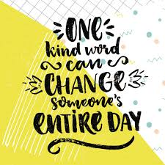

What is a definition of good customer service?
Good customer service typically means providing timely, attentive, upbeat service to a customer, and making sure their needs are met in a manner that reflects positively on the company or business

Think about your experience in the café and write a paragraph in your own words describing good customer service.

What does customer service mean?
Customer service is the act of taking care of the customer's needs by providing and delivering professional, helpful, high quality service and assistance before, during, and after the customer's requirements are met.

Think about your experience in the café and write a paragraph in your own words describing customer service.

What are your strengths?

Some examples of strengths you might mention include:
- Enthusiasm.
- Trustworthiness.
- Creativity.
- Discipline.
- Patience.
- Respectfulness.
- Determination.
- Dedication.

Think about your experience in the café and compile a list of your strengths and give an example of how you use each strength in the work place.

So, what about POOR customer service?
If you have access to the internet you may want to have a laugh at the comical poor customer service of; Fawlty Towers: The best of Basil (part 1)

Can you say what was poor customer service in the clip?

