Using QR Codes

QR codes can be used to enhance many activities and lessons delivered remotely
They encourage independence and use of technology and are a great way to add differentiation to activities.
QR codes allow easy weblinks to be added to paper documents, aiding accessibility.

QR Scanner
To access QR codes you will first need to download a free QR scanner/reader app from the app store onto your tablet/iPad. Some phones and tablets have one already built in to the camera.

How to Create QR Codes
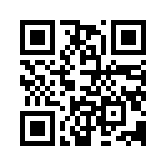
Scan the code above to visit the QR stuff website (there are many other QR code generator sites too). Here you can create QR codes that link directly to a huge range of media types including YouTube, Widgit Online , Plain Text, Emails, Voice recordings, iTunes, image files and PDF files.
Simply attach or type in your document or paste in a web address and a QR code is created. Save and print this and you are ready to go!

How to Use QR Codes
On the following page you will find some examples of how QR codes can be used to enhance transitions and allow the learners more autonomy in accessing information, if they are able to use an ipad either with or without a switch and/or support.
There are also loads of websites that offer interesting and innovative suggestions on how to use them in an educational or recreational way.

- Student Profiles
Add a QR code next to each learner’s photo to allow the other learners to find out more about them, watch their latest YouTube video or link to their skype or email. Great for helping new learner’s get to know each other.

- Staff Profiles
Creating short staff one page profiles and adding a QR code sound recording allows learners to hear staff, giving them a more personalised experience and helping them recognise staff by their voices when they get to college. See point 4 for instructions.

- Sensory Stories
Create a sensory story where the sound and vision effects can be accessed through the QR code.
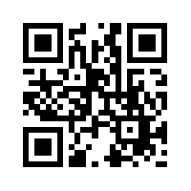(YouTube Blackbird singing)
Similarly, you can create interactive stories where the learner can make decisions by choosing from a choice of 2 or more.

- Talking QR codes
Make the QR codes talk to you using Vocaroo. Go to the website, record what you want to say, press save and create a QR code. It will produce a QR code that you can copy, paste and print or embed in a document.
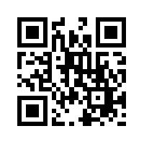Vocaroo website

- Video Link QR codes
Record and save virtual video tours of the college onto Google Drive, or similar secure site. Right click picture to create a shareable url link. Copy and paste this into your QR generator website. The QR code will then link directly to your video. Great for including in transition packs or welcome packs.
- Accessible ‘Getting to Know You’ Tasks
QR codes can be used to linked to resources for student transition tasks. The below example links to Widgit symbols to help a student explain the things they find difficult.
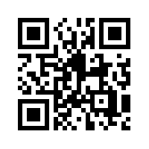Published Widgit document

- Learning Skills Needed for College
QR codes could be used to give instructions on how to complete life skills tasks needed for college.

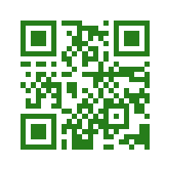How to make a drink - Widgit

- Lists to Help with Learners’ First Day
Plain text can be added to a url. Lists and reminders can be added. Learners can then keep them safe on their phone or device offering them more privacy than a written paper list.
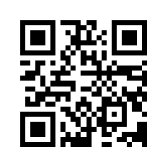Plain text – 1st day at college list

- Other ideas
Story book choices, reading lists, home learning, links to email addresses, mental health websites, iTunes, Skype, Twitter, YouTube, Facebook

