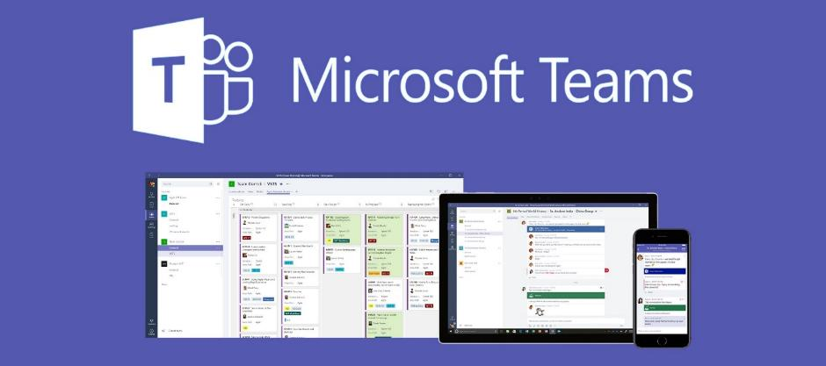
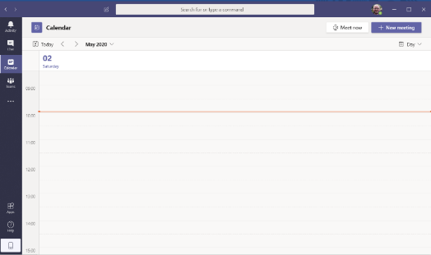
Download Microsoft Teams – follow link – Open

Click on calendar

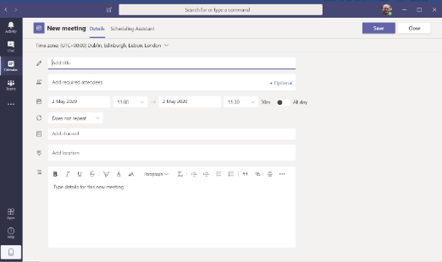

Fill in details as you would in outlook to set up a meeting
Add parent/carer email address here

click save
Click join in Calendar

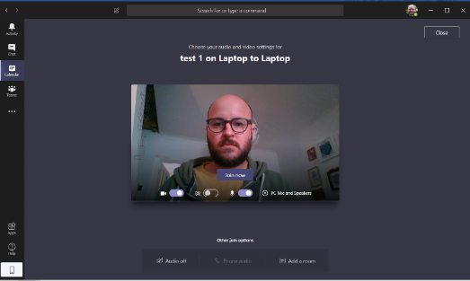
Make sure your camera and microphone are on and your location is correct following safeguarding guidance
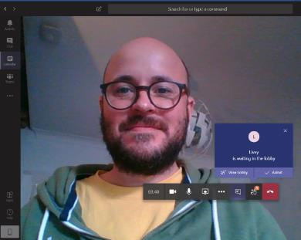
Wait to see the lobby
Click Admit

At this point the live streaming will be active

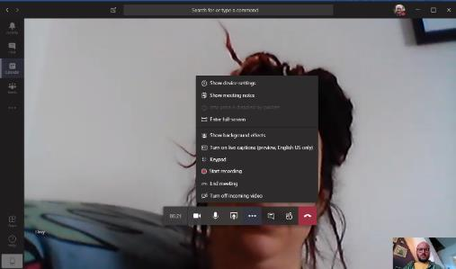
To start Recording
Click on the 3 dots
Click - Start Recording

When call is finished
Click on the 3 dots then - Stop Recording
Hang up
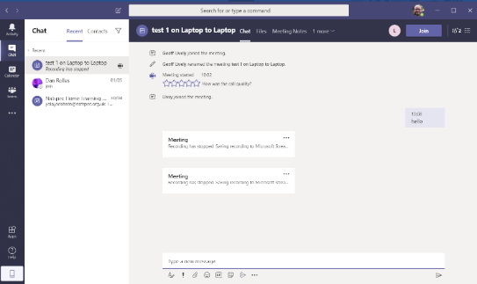
When you have ended the call it will go to this screen.
You will see the call has been recorded

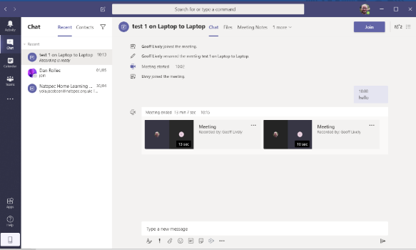
Wait for the recording to process – this will take some time and be working in the background

This will automatically happen but can take quite a while depending on length of video and internet connection

To download the video
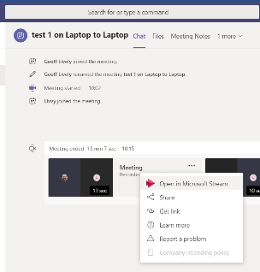Click on the 3 dots – Click on Open in Microsoft Stream
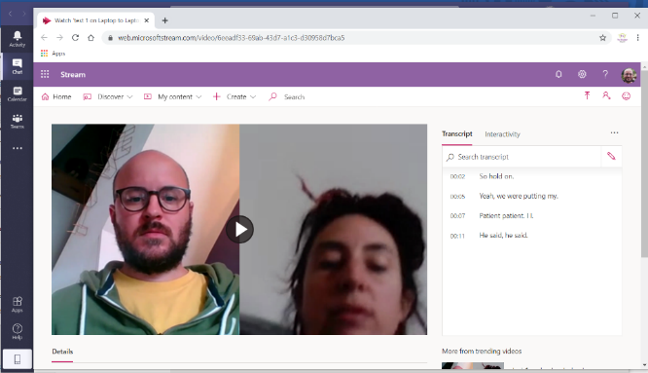

Microsoft Stream will open automatically in a browser

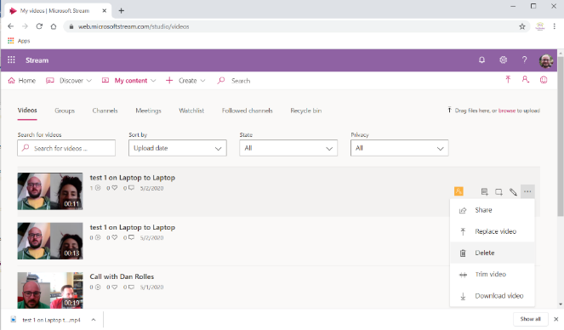
Click on my content

Click on videos

Click on the 3 dots

Click download video

The video will download in the bottom left of the browser

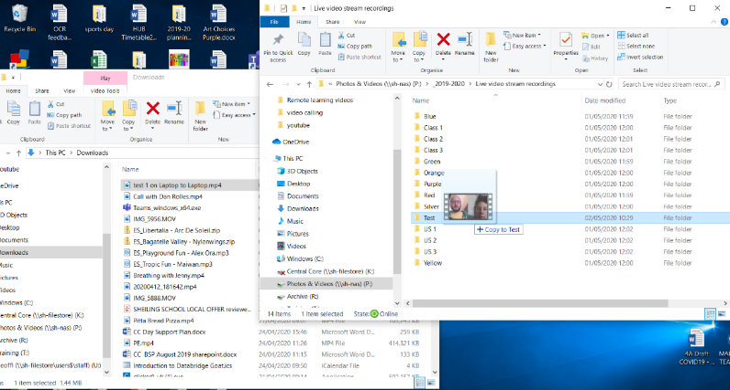
Drag the video into the file using VPN

Photos and Videos – 2019-2020 – Live video stream recordings – Class group

The videos can then be deleted from Microsoft Stream following the same process as downloading but by clicking Delete

