My name is
I work at
When you attend __________I will help you with______________.

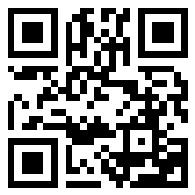
If you’d like to hear my voice, scan this with your phone or tablet. (If your camera doesn’t scan the code, download any free QR scanner)

Adding your QR recording

• Visit vocaroo.com
• Press the button to start and stop recording
• Press ‘save and share’
• Choose the ‘QR code’ button (bottom left)
• Press ‘Save QR code’
• Copy and paste code into your document

