****Two people smiling in a cafe

**Vocational studies**

**Catering**

**Brief;**

**1.** There’s a load of information contained on the shopping receipts you receive when you purchase goods.

Before you go shopping; make yourself a shopping list with estimate costs of the individual items and estimated total.

**2.** On your return, inspect your receipt and complete the shopping review.

Alan

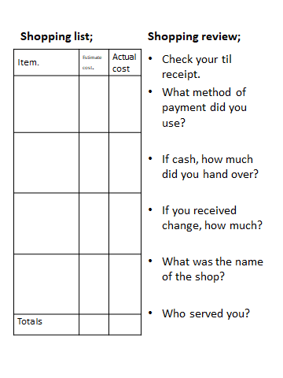

Were you surprised at the actual costs and by how much information is stored on the receipt?