Rainbow Craft Instructions

Sensory Rainbow Craft Pack
Rock Painting in Bright colours
Crafting skills: setting up a work space, choosing colours and using paint
Maths and English skills: following instructions, counting, creating a pattern/sequence.

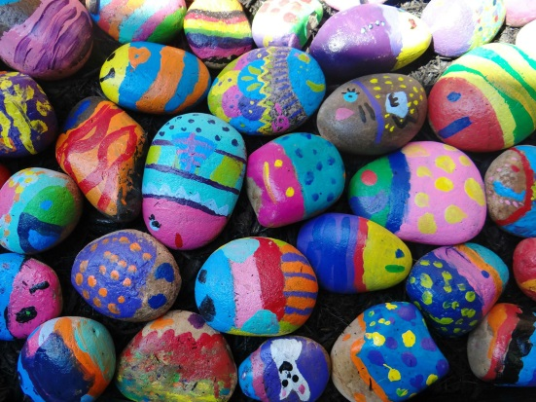
What you will need:
- Large/ Medium garden rocks
- Brightly coloured acrylic paints
- Different sized paintbrushes
- Pots for paint
- Larger pot or tray for second instructions
Instructions:
- Choose a rock to work with from your selection (The bigger the better)
- Choose 3 of the brightly coloured paints and pour a small amount of each into pots
- Using a brush cover the rock in one colour to create a base/ background
- Allow this to dry for 5 to 10 minutes
- Using more brushes or even your fingers create a pattern or design onto the painted surface
- Allow this to dry
- Repeat onto more rocks

Alternatively:
      - Using the tray/larger pot
      - Pour blobs of 3 to 4 of the brightly coloured paints into the tray/pot
      - Using a paintbrush, gently swirl these together
      - Choose a rock
      - Dip the rock on one side into the paint
      - Place to dry
      - repeat on more rocks

You can get very creative with this craft
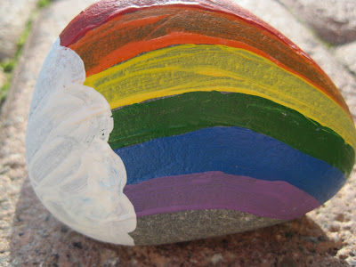
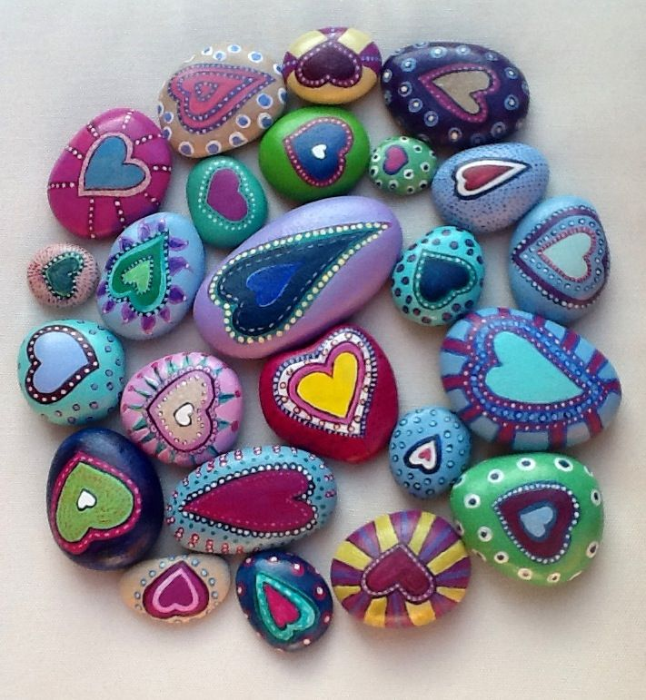

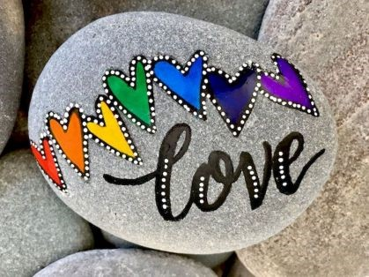
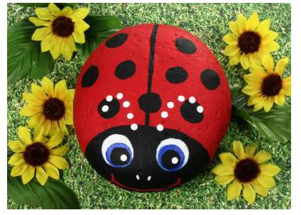

Rainbow in a bag
Video tutorial available)
Crafting skills: setting up a work space and choosing colours
Maths and English skills: following instructions, shape or letter recognition
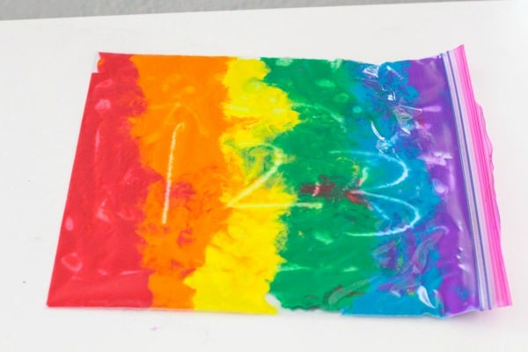
What you will need:
- A selection of large/ small zip lock freezer bags
- Coloured paint – red, orange, yellow, green, blue, purple
- A tray
- Tape
Instructions:
- Place the tray in front of you
- Take a zip lock bag and place on the tray
- Starting with the red paint pour paint into the bag
- Repeat this with the other paints, following the sequence of red, orange, yellow, green, blue and purple
- Seal the bag closed (Tape this edge if you want to)
- Move the bag carefully and place it with the square shape of it being flat on the table or tray in front of you
- Carefully spread the paint in the bag from the bottom to the top revealing the rainbow
- Practice drawing shapes and letters in to the paint
- Repeat this once the paint becomes too mixed up
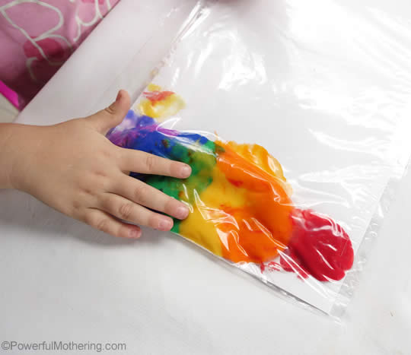
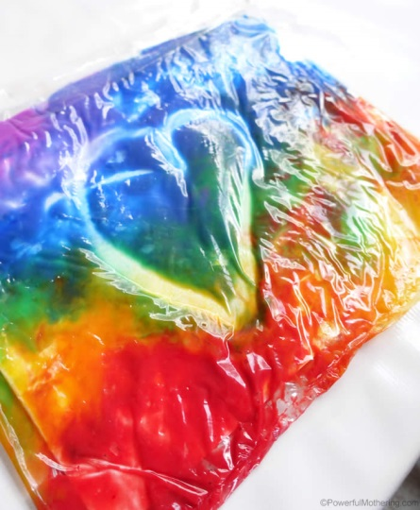
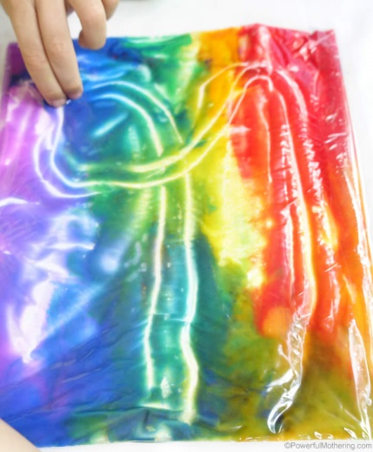

Shaving foam rainbow art
(video tutorial available)
Crafting skills: setting up a work space and choosing colours
Maths and English skills: following instructions and counting
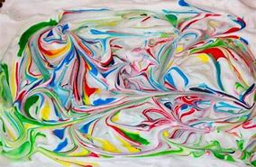
What you will need:
- A deep baking tray/ lid to a shoe box
- Coloured paint – red, orange, yellow, green, blue, purple
- 2 – 3 cans of Shaving foam
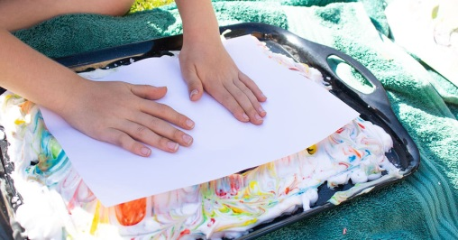
- A4 White paper
- A4 Coloured paper
- Paint brush
- Piece of cardboard
Instructions:
- Place the tray/ box lid in front of you
- Shake the can of foam
- Spray the foam into the tray covering as much of the surface as you can
- Pour 10 small blobs of each coloured paint onto the foam all over
- Using the end of a paint brush, gently swirl the paint around the foam to create a pattern
- Take a piece of paper and carefully place it on top of the foam
- Gently press the back of the paper
- Carefully removed the paper
- Using the cardboard scrape off the excess foam and place to dry
- Swirl the paint again
- Add another piece of paper on top of this, keep doing this
- When the foam and paint become too mixed up start again from the very beginning using a fresh layer or foam

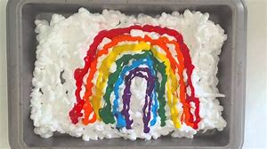
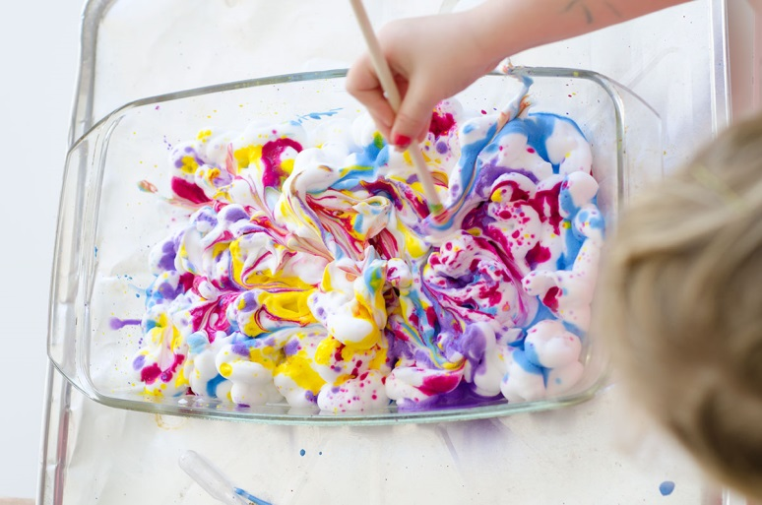
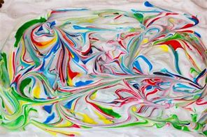
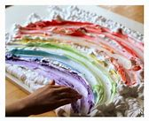

Rainbow Salt dough
Crafting skills: setting up a work space and choosing colours
Maths and English skills: following instructions and counting
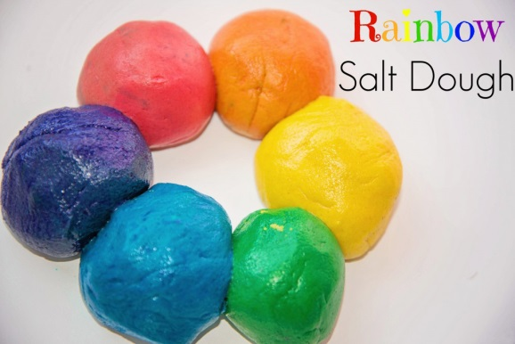
What you will need:
- A mixing bowl
- 6 smaller bowls
- Metal spoon for mixing
- 2 cups of Plain flour
- 1 cup of Table salt
- 1 cup of water
- Food colouring – red, yellow, orange, green, blue and purple
- Scents if you want to make it extra sensory – lavender oil, peppermint oil, orange oil, lemon oil, tea tree oil, vanilla extract, etc

Instructions:
      - In your mixing bowl place the 2 cups of flour and 1 cup of salt
      - Add to the mix slowly the cup of water and mix with the metal spoon (2 drops of 1 scented oil if you want)
      - Knead the dough with your hands until it becomes a soft but not too sticky ball
      - Add more flour if it is too sticky
      - Split the ball into 6 pieces
      - Place these into the 6 small bowls
      - Open the pieces to reveal the centre then place 2 drops of food colouring inside
      - Cover the colouring then knead the dough again, pulling and twisting it apart to colour it (You can add more drops if you want a darker colour)
      - You should have 6 coloured doughs
      - Cover each bowl with cling film to stop them from drying out
      - This can now be used to play with or make air dried decorations
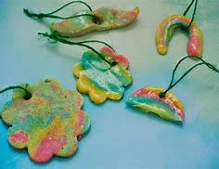
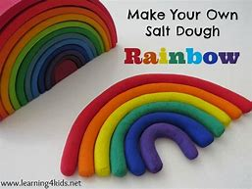

Rainbow Sponge painting
(video tutorial available)
Crafting skills: setting up a work space, painting, colours
Maths and English skills: following instructions, counting, positioning, copying a simple pattern

You will need:
- Flat surface to work on – table or tray
- Table cover
- Paper/card
- Sponge (a clean kitchen sponge works well)
- Poster paint – a rainbow of colours
- Something to wipe fingers on (damp cloth)

Instructions
- Cover your table or collect your tray
- Collect your tools and materials
- Start by adding a drop of each rainbow colour paint, onto your sponge forming a line (see photo)

- Now – carefully hold the sponge over one side of the paper and lower the painted side down and press gently.
- You need to carefully move your hand across the paper (hand over hand support will help with this) to create one smooth rainbow
- The temptation is to now wiggle the sponge
DO NOT WIGGLE THE SPONGE!
- Stop and lift the sponge up carefully – you now have one rainbow print

- You can now add more paint to the sponge (or use up what is left) and create a rainbow print under the last one.
- Repeat and create a rainbow print above the first print.
- Keep on repeating this process until you created rainbows all over your paper – can you cover all of the white background?
- Leave your picture to dry
- Now you need to wash up and tidy away your workspace

Rainbow String painting
Video tutorial available)
Crafting skills: setting up a work space, painting, colours
Maths and English skills: following instructions, counting, positioning

You will need:
- Flat surface to work on – table or tray
- Table cover
- 2 pieces of paper/card
- Heavy book
- String
- Poster paint – a rainbow of colours
- Something to wipe fingers on (damp cloth)

Instructions:
- Cover your table or collect your tray
- Collect your tools and materials
- Start by adding a drop of each rainbow colour paint, onto your large paper, so they are touching and forming a line.
- Lay your string across the paint and slightly twist so the paint covers all sides of the string.

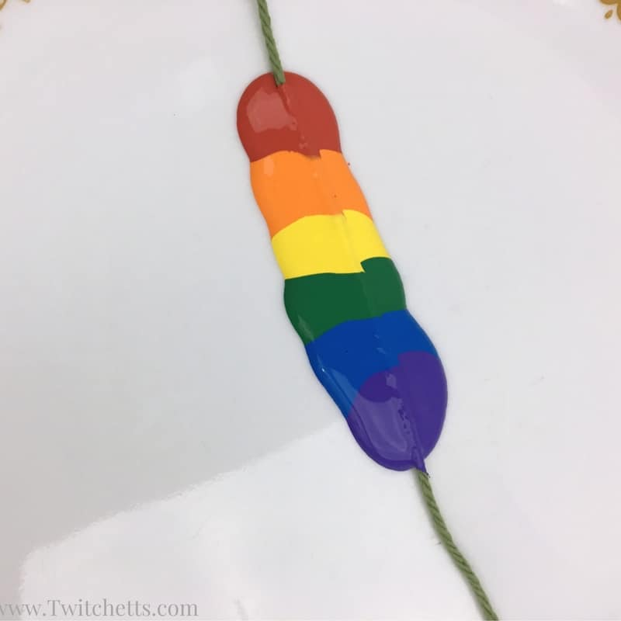

- Lay the string across a piece of paper so the ends hang off the edges
- Place a second piece of paper (the same size if possible) on top.

- Press down onto the paper as you pull the string back out.
- Note: you can use a heavy book to help hold the paper down.

- Remove the top paper to reveal the design.
- Repeat until you are happy with the project.
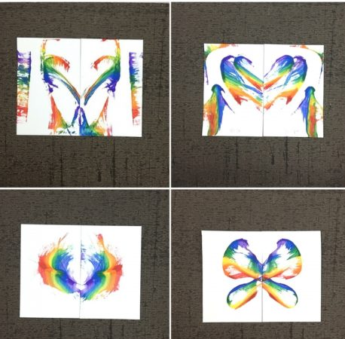
** Play around with where you place the string on the paper and how you pull the string off the paper.
It's amazing all the different effects that can be created!
- Leave your picture to dry
- Now you need to wash up and tidy away your workspace

Rainbow Comb painting
Crafting skills: setting up a work space, painting, colours
Maths and English skills: following instructions, counting, positioning

You will need:
- Flat surface to work on
- Table cover
- Tin foil and a baking tray or tray to put it on
- Comb (Included in your pack)
- Poster paint – a rainbow of colours
- Something to wipe fingers on (damp cloth)

Instructions
- Cover your table
- Collect your tools and materials
- Make sure your foil is laid flat on a baking tray or some sort of tray
- Squirt your paint onto the foil in a rainbow pattern
- Red
- Orange
- Yellow
- Green
- Blue
- Purple
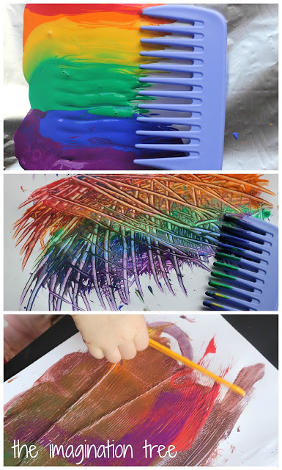
- Carefully dip your comb into the rainbow paint and move it in different directions to create rainbow effects.
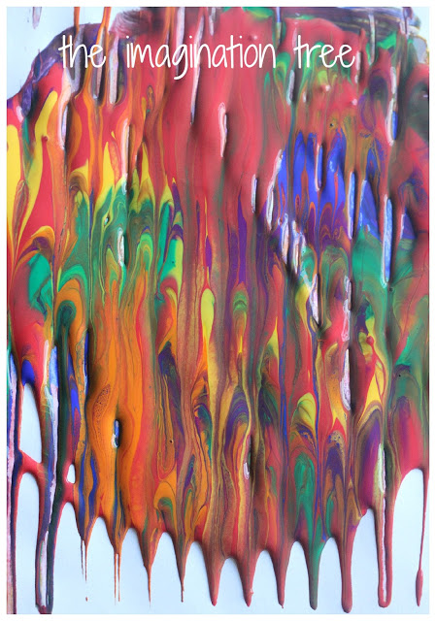
- Add more paint and you will get a rainbow marbled effect

- You can explore different patterns in the paint

** If you want to – you could turn the foil over onto paper and create a printed image of your design!!!

- Leave your picture to dry

- Now you need to wash up and tidy away your workspace

Rainbow sensory bottle
Crafting skills: setting up a work space, cutting, colours
Maths and English skills: following instructions, counting

You will need
- Flat surface to work on – table or tray
- A clean and dry plastic bottle with a hole in the lid (included in your pack)
- Rainbow coloured pom poms or beads
- A handful of rice
- Small spoon/ funnel or some paper to create a funnel
- Rainbow ribbons
- Scissors
- Sellotape

Instructions
- Cover your table or collect your tray
- Collect your tools and materials
- Unscrew the lid of your plastic bottle
- Put the rainbow coloured pom poms or beads into the bottle
- Now carefully add a handful of dried rice into the bottle. You could use a spoon or a funnel or you could make a funnel out of a sheet of paper!
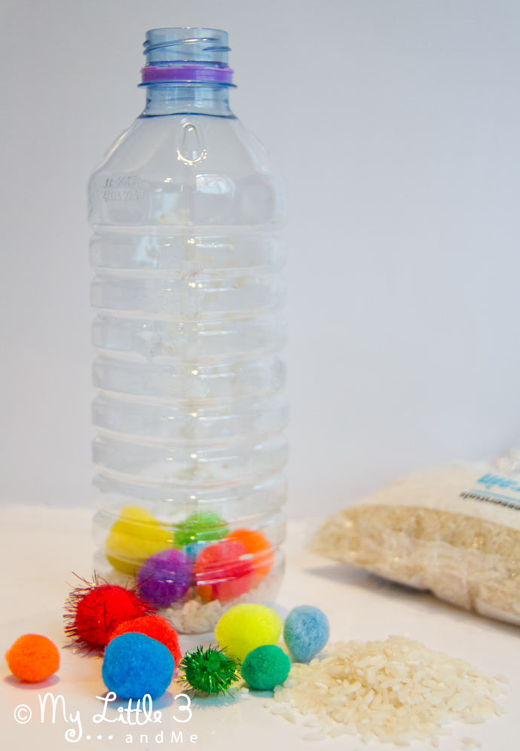
- Decide how long you would like your rainbow ribbons to be and cut them using scissors
- Gather the ribbons at one end and put some sellotape around the end. This will help you to push them through the hole in the lid (the hole has already been made for you)
- Tie a knot in the ribbons inside the plastic lid
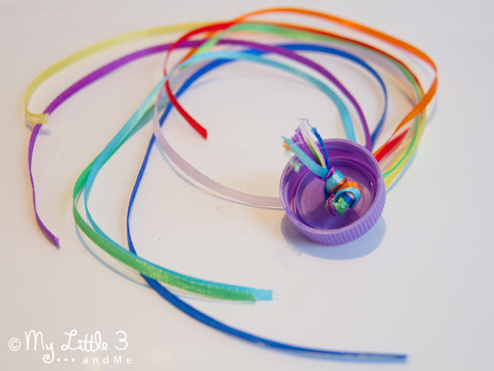

- Now screw the lid onto the bottle
- You have now made your Rainbow Sensory bottle – Shake it and enjoy
- This would be great to use while you sing along to a one of Rosie’s Makaton song videos!
- Now tidy up your work space

Rainbow Ribbon Ring
Crafting skills: setting up a work space, painting, colours
Maths and English skills: following instructions, counting, sorting by colour

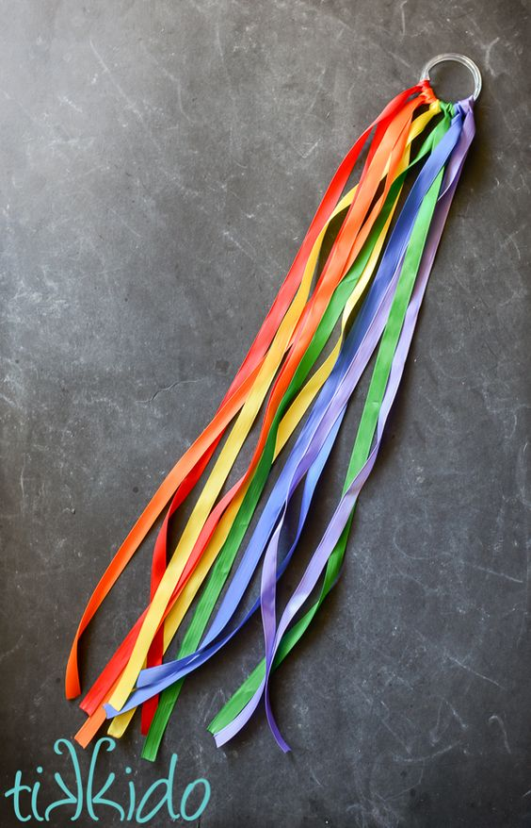
You will need
- Flat surface to work on – table or tray
- A ring (there is one included in your pack)
- Rainbow ribbons
- Scissors

Instructions
- Collect your tools and materials
- Sort your ribbons by colour
- Red
- Orange
- Yellow
- Green
- Blue
- Purple
- Decide how long you would like your ribbons to be. They could be different lengths
- Use the scissors to cut them
- Tie each ribbon to the ring

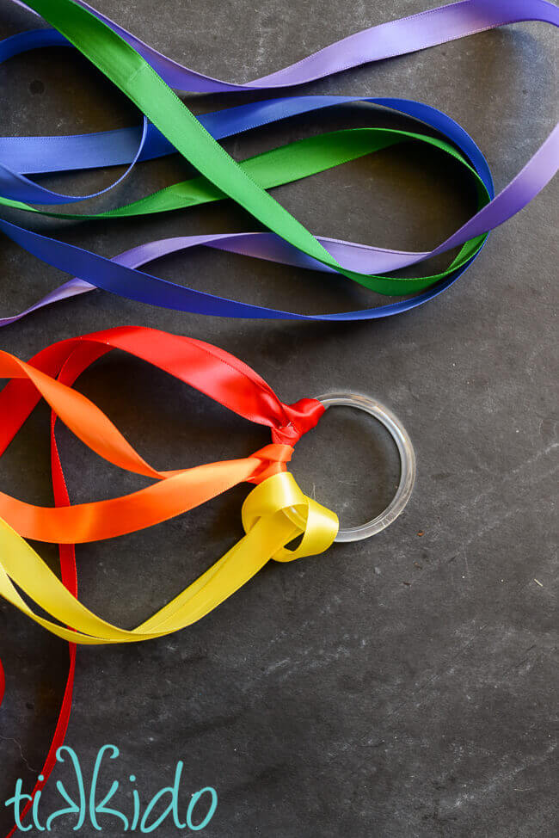

- And that’s it!
- You have now made your Rainbow Ribbon Ring – Shake it and enjoy
- This would be great to use while you stretch to Andy’s rainbow stretch video or sing along to a one of Rosie’s Makaton song videos!
- Now tidy up your work space

