Targets for ICT
Basic/Entry Level

Our theme is
Rainbows
The project below is an optional task for you to do whilst at home. If you decide that you would like to complete it then there is no time limit. Please don’t feel you have to rush and get it done.

We are seeing rainbows everywhere; people are using them to show our support for the NHS. You may have been sent a craft pack (if you requested one) which will contain some ideas of crafts for you to make. To link into craft, the tasks below will give you the opportunity to search for other rainbow images and maybe pictures of real rainbows! You could use these pictures in your craft project or use them as a guide to work to.
Please take photos of yourself creating your project as we can use these as evidence for your targets (no rest while you are at home! ).

Target - Open google and search for pictures of rainbows (this can be other internet search engines e.g. yahoo, Bing)
Steps | Feedback  Tick which one is relevant
Turn on your computer | - With lots of support  - With a prompt e.g. press the on button  - Can do independently
Open the internet | - With lots of support  - With a prompt e.g. click on internet icon  - Can do independently
Go to the internet and type in google into address bar | - With lots of support  - With a prompt e.g. go to address bar  - Can do independently
 | Comments (Optional)
Type in “rainbows” into search box and press enter  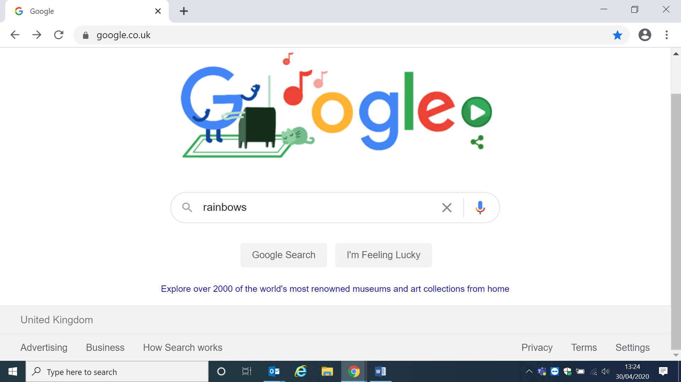 | - With lots of support  - With a prompt e.g. go search box/point to search box  - Can do independently
 | Comments (Optional)

Be able to scroll down or arrow down to see different images/pictures  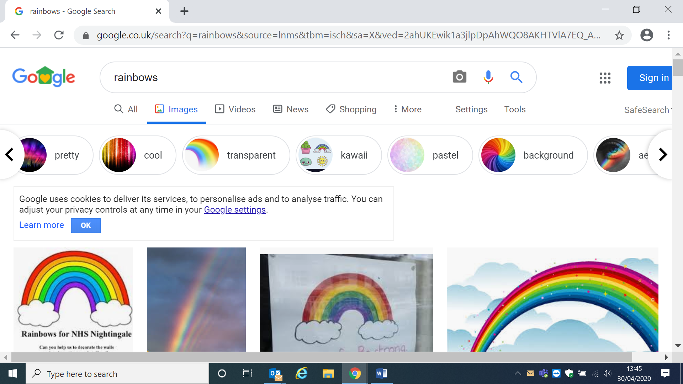 | - With lots of support  - With a prompt e.g. use mouse  - Can do independently
 | Comments (Optional)

Choose a picture/image and save it.  Click on the image and then using the right button on a mouse click on the picture. A menu will appear  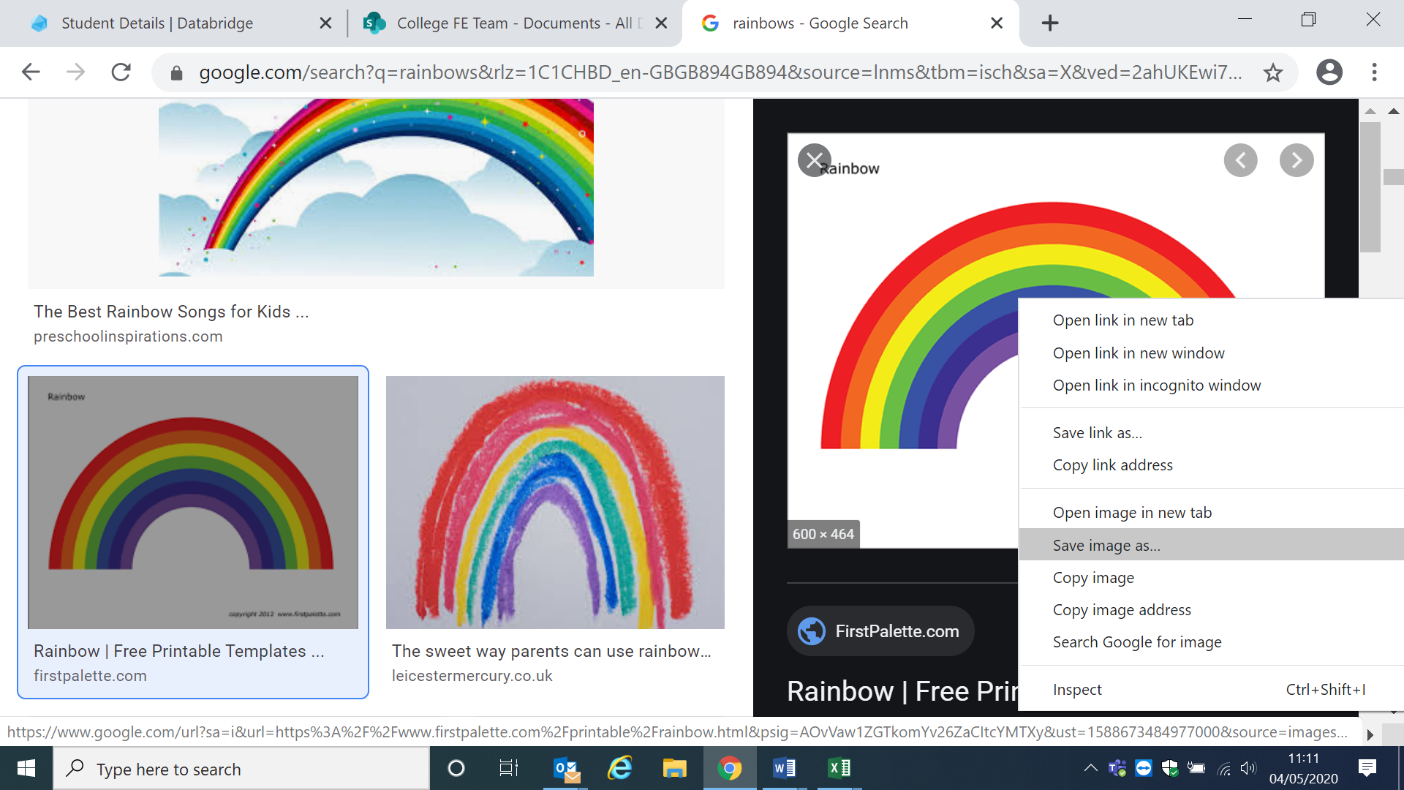 | - With lots of support  - With a prompt e.g. use right button on mouse  - Can do independently
 | Comments (Optional)
Click save image as  Give your image a name – try to remember it! | - With lots of support  - With a prompt e.g. what are you going to call the file  - Can do independently
 | Comments (Optional)

Key
Lots of support –  - this could be physical support e.g. demonstrating how to do something  - telling them step by step how to do something | With a prompt –  - this could be telling them to open the internet  - reminding them how to scroll down with the mouse or telling you to scroll down with the mouse | independently  - being able to complete the steps completely by themselves.

If you are able to print out your pictures that would be great. Please get someone to take photos of you completing the above tasks and email them if possible to jbanks@rnibcollege.ac.uk
Once completed please send this form back in the envelope provided in your craft pack or send by email to jbanks@rnibcollege.ac.uk .
Happy Searching!

Jules Banks ICT Tutor

