Targets for ICT
Advanced Level

Our theme is
Rainbows
The project below is an optional task for you to do whilst at home. If you decide that you would like to complete it then there is no time limit. Please don’t feel you have to rush and get it done.
We are seeing rainbows everywhere; people are using them to show our support for the NHS. You may have been sent a craft pack (if you requested one) which will contain some ideas of crafts for you to make. To link into craft, the tasks below will give you the opportunity to search for other rainbow images and maybe pictures of real rainbows! You could use these pictures in your craft project or use them as a guide to work to.
Please take photos of yourself creating your project as we can use these as evidence for your targets (no rest while you are at home! ).
Students/Parents/carers – please could you complete the form below by ticking which option you feel you/your young person has completed the task. If you can, please give any comments as to how you/ they did the task.

Your mission is to
Create a poster about rainbows giving information about how rainbows are created. The poster should include images and text. Email your ICT tutor sending your work as an attachment.

or

Complete a craft project. (You could do both! ).

Steps | Feedback  Tick which one is relevant
Go to google or any search engine e.g. Bing/yahoo/chrome and search for images of rainbows  Address bar  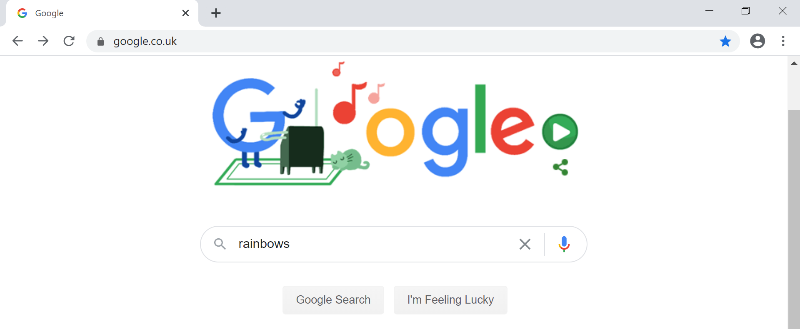 | - With lots of support  - With a prompt e.g. go to address bar  - Can do independently
 | Comments (optional)
Copy and paste a picture/s into a document or an email. Right click on image to show menu as below. Click on copy image.  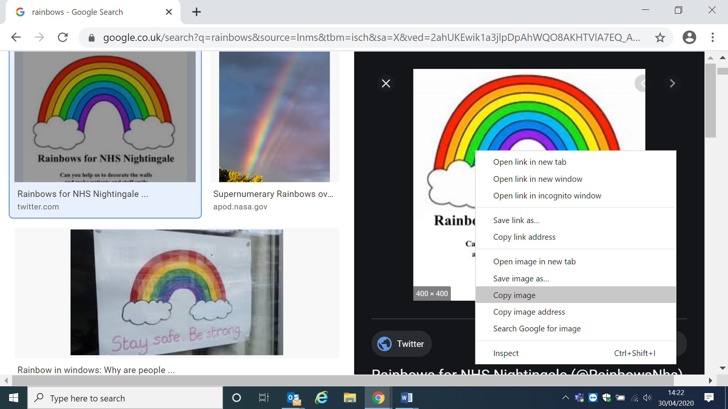  Go into word or an email and right click and paste.  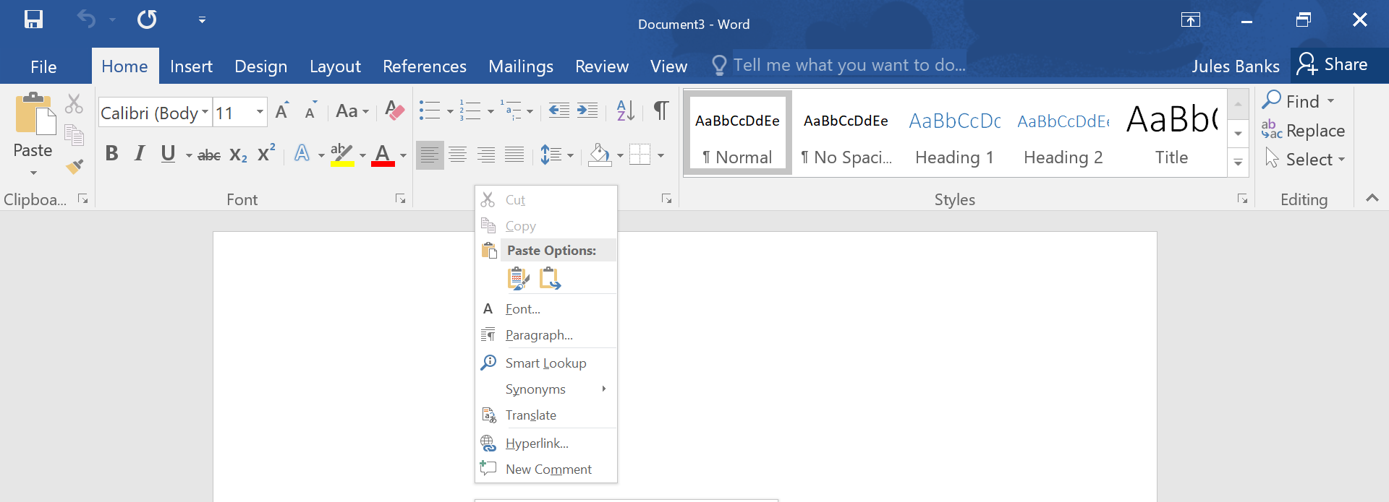  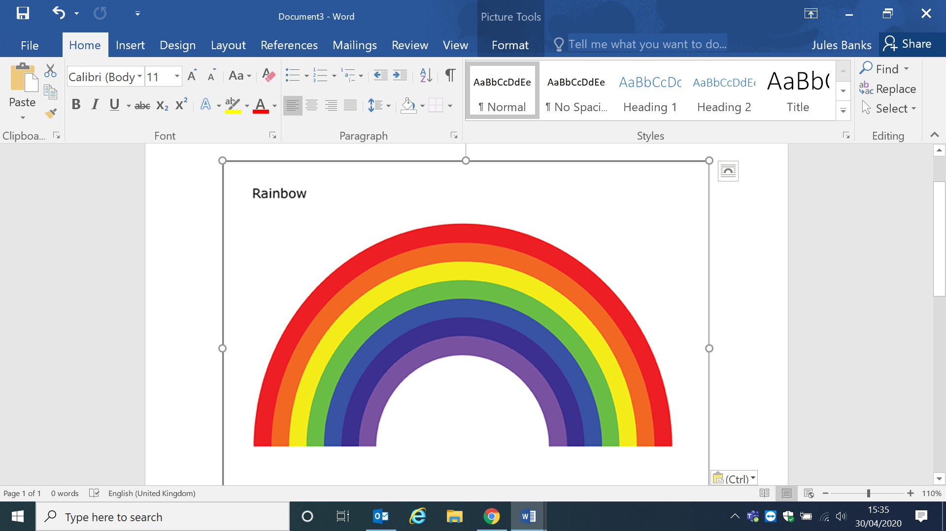  You can email me the picture if you paste it into an email. | - With lots of support  - With a prompt e.g. press right button on mouse  - Can do independently
 | Comments (optional)
- With lots of support
- With a prompt e.g. open word
- Can do independently

 | Comments (optional)
Now you have your rainbow image/s, create a poster about rainbows with images and text.  - Include the picture/s that you have found on the internet.  - Include information about how a rainbow is made – write in your own words don’t copy and paste information from the internet  - Format the document  - Change the font size/colour of font  - Change alignment of your text e.g. left align, centre or right align  - Change the orientation of your document to landscape  - Put a border around your poster  If you are completing the craft project  Include photos of yourself making your crafts | - With lots of support  - With a prompt  - Can do independently
 | Comments (optional)
If you are completing the craft project and want to use the pictures you have found on the internet, then please print them out.  - Print images/pictures | - With lots of support  - With a prompt e.g. go to file then print  - Can do independently
 | Comments (optional)

Save your work – remember to click on file then save. Give it a name you will remember!  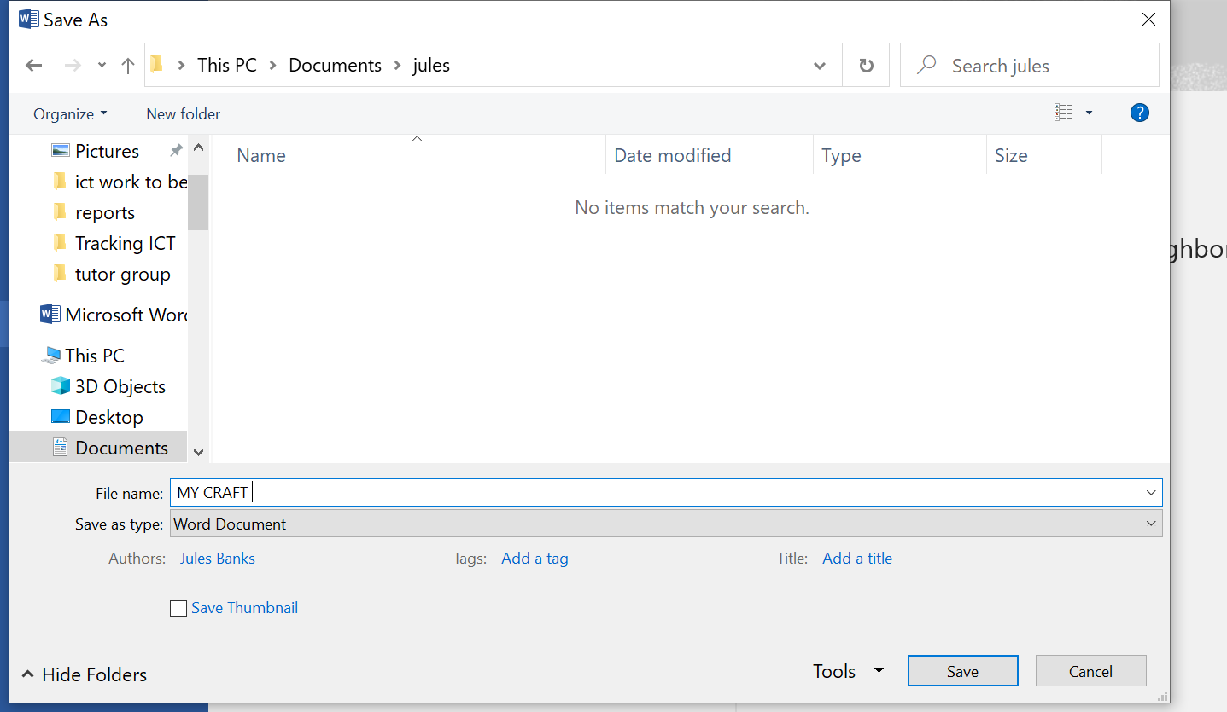 | - With lots of support  - With a prompt e.g. click on file and save  - Can do independently
 | Comments (optional)

Send your poster/photos as an attachment in an email  Go to new email and type your message address it to jbanks@rnibcollege.ac.uk  Go to the paperclip icon  The dialogue box will appear choose your file and click on insert  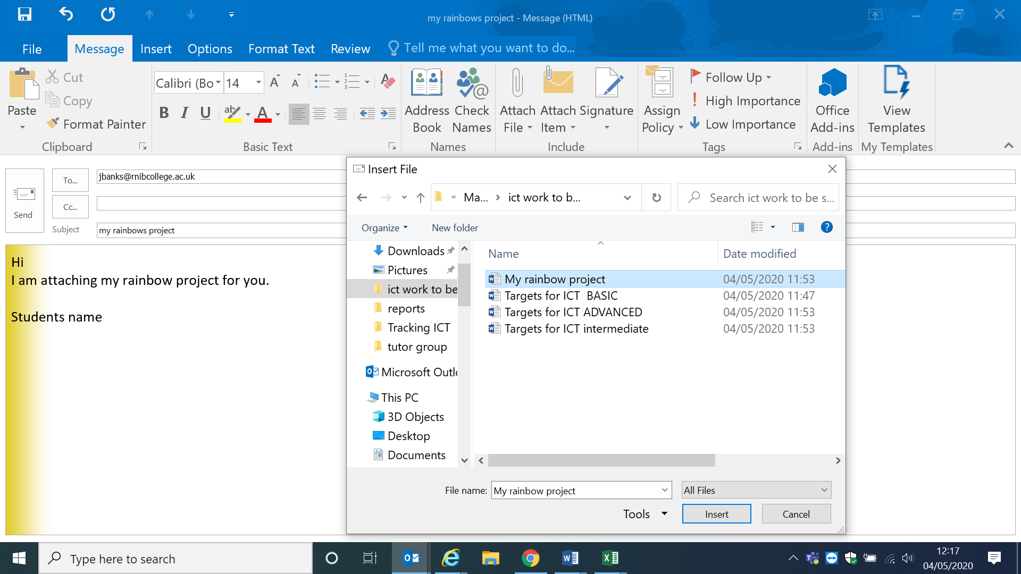  Finally click on send to send me your fantastic work! | - With lots of support  - With a prompt e.g. attach file  - Can do independently
 | Comments (optional)
Wow! You did it!

Key
Lots of support –  - this could be physical support e.g. demonstrating how to do something/hand on hand support.  - telling them step by step how to do something | With a prompt –  - this could be telling them to open the internet  - reminding them how to scroll down with the mouse or telling you to scroll down with the mouse | independently  - being able to complete the steps completely by themselves.

If you are able to print out your posters/pictures that would be great. If possible please get someone to take photos if you can of you completing your work and email them to jbanks@rnibcollege.ac.uk
Once completed please send this form back in the envelope provided in your craft pack or send by email.
Happy Searching!
Jules Banks ICT Tutor

