Rainbow Craft Instructions

Rainbow Sun catcher
Crafting skills: setting up a work space, cutting, colours, threading
Maths and English skills: following instructions, following a pattern/ sequence, counting, shape recognition, measuring.
You will need:
- Flat surface to work on – table or tray
- 30cm of beading wire
- 1 heavy bead
- Rainbow coloured beads
Instructions:
- Collect your tools and materials
- Create a rainbow pattern with the coloured beads on your flat surface.
- Take your beading wire and push it through the hole in the large bead
- Knot the thread tightly to lock the bead in place – this now is the bottom of the sun catcher
- Take the top of the beading wire and start to thread your beads on: one by one
- Try to keep to the Rainbow pattern you created in step 3
- Keep threading until you are near to the top of your beading wire or you run out of beads!
- Leave about 5cm - for a hanging loop
- Knot the final top bead in place – so that it cannot fall off
- Now create a loop and knot it tightly
- You should now be able to pick your Sun catcher up and product check it.
- Now tidy away your workspace
Rainbow Beaded decoration

Crafting skills: setting up a work space, cutting, colours, threading
Maths and English skills: following instructions, following a pattern/ sequence, counting, shape recognition, measuring.

What you will need:
- Wooden rod with hooks in (included in pack)
- Beads in different colours.
- Beading line.
- Scissors
- ruler
Instructions:
- Measure three lots of 40 cm of beading line.
- Tie beading line to hooks in wooden
Rod.
- Thread on beads in a pattern of
- 3 purple
- 3 blue
- 3 green
- 3 yellow
- 3 orange
- 3 red
- Double knot beading line on last red bead threaded on.
- Repeat for the other two pieces
Of beading line.
- Cut off excess beading line.

Paper or Card Rainbow heart
(Video tutorial also available)

Crafting skills: setting up a work space, cutting, colours, gluing
Maths and English skills: following instructions, following a pattern/ sequence, counting, shape recognition, measuring.

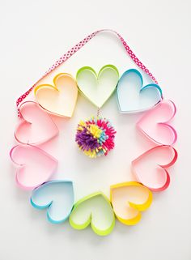
You will need:
- Flat surface to work on – table or tray
- A range of coloured paper – rainbow selection
- Pencil or pen
- Ruler
- Scissors or paper trimmer
- Glue stick or PVA - a glue stick is cleaner but you could use PVA which is stronger - with a small glue spreader (like a cotton bud).

Instructions:
- Cover your table or collect your tray
- Collect your tools and materials
- Turn paper landscape way round
- Use ruler to mark lines 5cms apart.
- Carefully use scissors or paper trimmer to cut along lines to make paper strips
- Take one strip and fold it in half. Cut along this line
- You should now have 2 strips of paper – 14.5cm long by 5cm wide
- Stack them on top off each other and either staple or glue together at the top
- Open the bottom to create a V shape
- Then fold around and to the top to make a heart shape. Staple or glue together
- You have now made one heart loop
- Follow steps 3 to 9 and create 10 heart loops in different rainbow colours
- Now lay out the heart loops into a circle garland as in the picture
- Use a small amount of glue in the middle of each heart at the side and glue them together
- Product check – hold up the garland: does it look like the finished craft photo?
- Now you can add a ribbon hanging loop – measure approx. 30cm of ribbon and staple onto a heart at the top – to the left and the right
- Product check - hold up the garland: does it look like the finished craft photo?
- Your heart wreath is now ready to hang up
- Now clean up your work space

Rainbow heart decoration
(Video tutorial also available)

Crafting skills: setting up a work space, cutting, colours, gluing
Maths and English skills: following instructions, following a pattern/ sequence, counting, shape recognition, measuring.
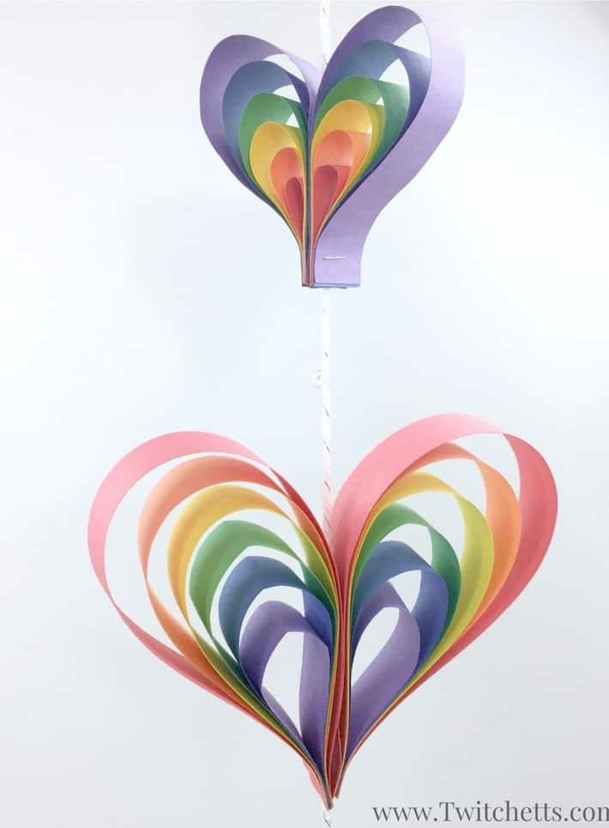

You will need
- A4 paper - every colour of the rainbow.
- Scissors or paper trimmer
- String
- Glue - PVA glue or a glue stick would both work
- Stapler – if you have one
- Clothes Pegs or Paper Clips.
- Ruler

Instructions
- Cover your table or collect your tray
- Collect your tools and materials
- Lay a stack of rainbow coloured papers on top of each other
- Start by cutting yourself paper strips. You need two strips of two different lengths for two different sized hearts.

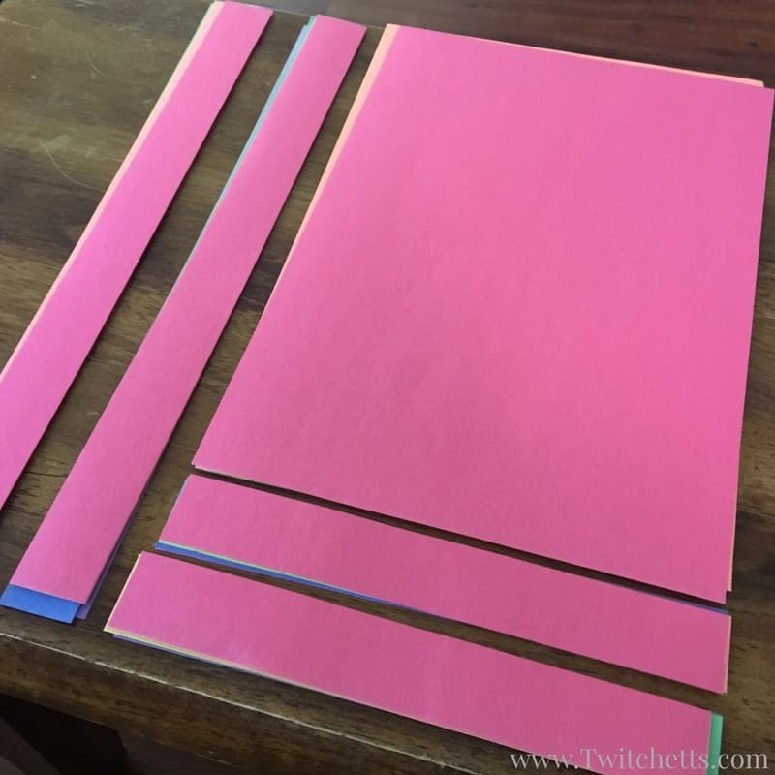
- Next, lay them out so that you can see each color, in rainbow order. Whichever colour is on the bottom will be the outer layer of the heart.
- Get your strips and trim off about 2cm of each of the colours that hang over the bottom of your outer colour. In this picture below the outside color is red.

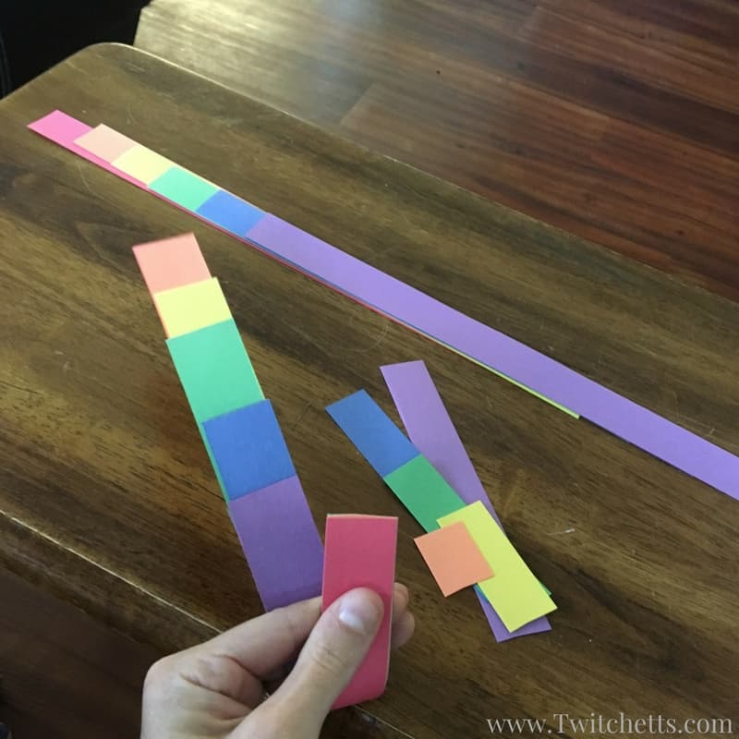
- You should be trimming off a little orange, more yellow and so on until a large amount of purple.
- Starting with your smallest strip, purple in my example, create a teardrop.
- Next, fold over the blue, green, and each color until you get to your red. Secure your rainbow teardrop with the stapler/ a little glue and repeat.

- You can make as many hearts in as many sizes as you want! Lay your hearts with the wrong side of the staples facing up. Add glue to both pieces and lay your string right down the center.
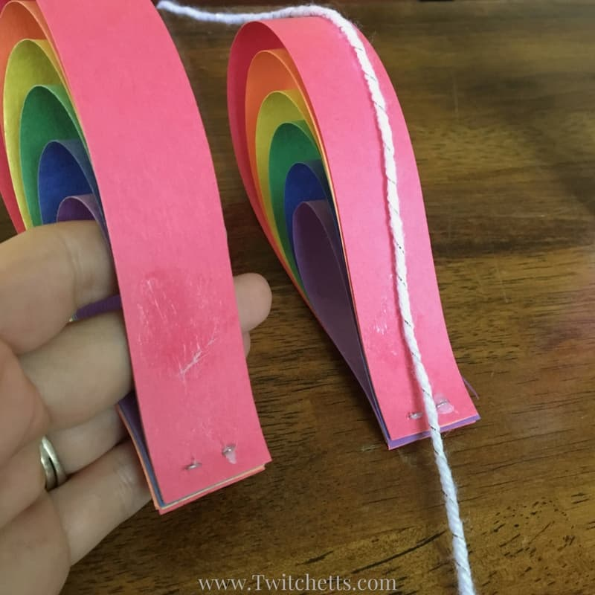

- Secure with a clothes peg or paper clips until dry.
- You can place multiple hearts on the same string.

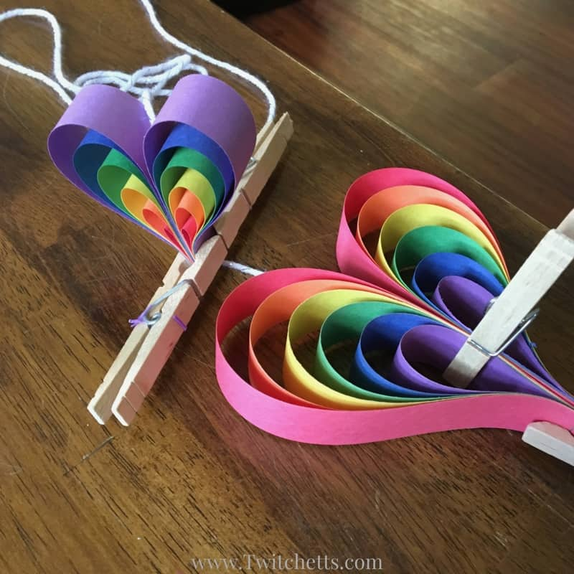

- Once they are dry remove clothespins and hang your heart mobile!
- Product check - hold up the garland: does it look like the finished craft photo?
- Now clean up your work space

Dandelion Rainbow Fingerprint Picture
(video tutorial also available)

Crafting skills: setting up a work space, painting, colours
Maths and English skills: following instructions, counting, shape recognition.

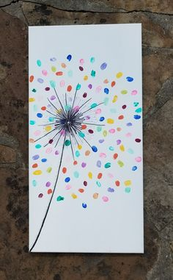
You will need:
- Flat surface to work on – table or tray
- Table cover
- Poster paint – a rainbow of colours
- Paint pots (any pots will do – yoghurt pots, egg boxes etc)
- Fingers and something to wipe them on (damp cloth)
- Black pen

Instructions
- Cover your table or collect your tray
- Collect your tools and materials
- Put all the different paint colours you are going to use in their own little pots
- On white card draw a dandelion stem with a black pen (see finished picture).
- At the top dandelion stem draw lines going outwards – a bit like a firework (see finished picture)

- Choose one finger to start with and put it carefully into the paint
- Carefully press your finger onto a space around the Dandelion (see picture)
- Then press your finger onto another space
- Wipe your finger clean or choose a different finger to use
- Press your finger into a different colour of paint
10.Carefully press your finger into a new space around the Dandelion
11. Repeat this process for all the different colours
12. When you have used all of your paint colours product check your work – are there any gaps? If there are - fill them in
14. Leave your picture to dry
15. Now you need to wash up and tidy away your workspace

Rainbow Heart Watercolour Art
(video tutorial also available)
Crafting skills: setting up a work space, colours, painting
Maths and English skills: following instructions, counting, positioning - horizontal
What you will need:
- White Card
- Black heart stencil
- Water colour set (included in pack)
- Pot of water
- Paint brush
- Paper towel/ kitchen towel
- Black pen

Instructions:

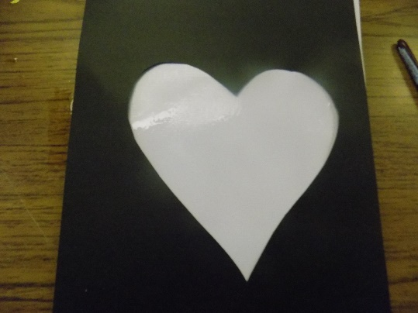
- Set out all the equipment you will need
- Using your brush paint water all over the card. If the card is damp it means the paint will blend together easily.
- Lay black heart stencil on top of card.

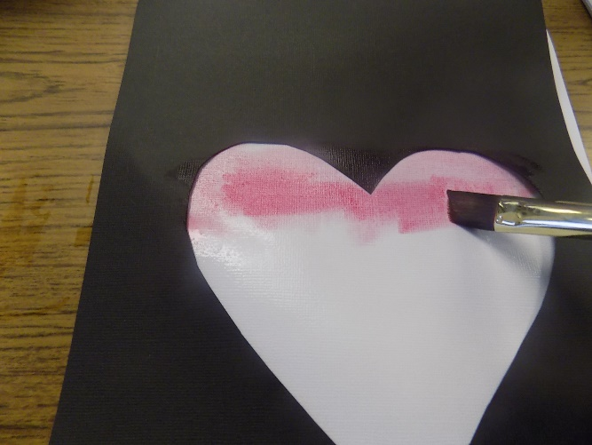
- Put red paint on your brush and paint a horizontal stripe across the top of the heart.
- Wash your brush in the water pot

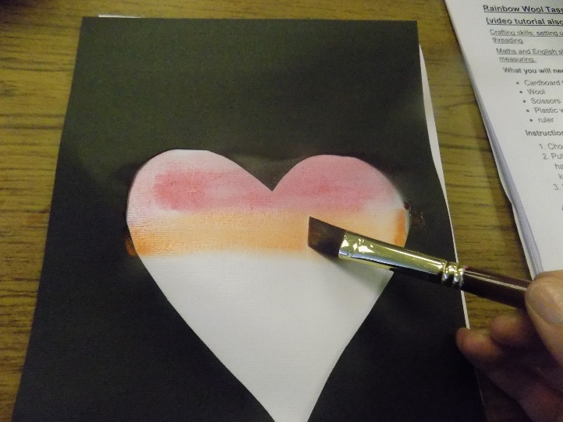

- Put orange paint on your brush and paint a horizontal stripe underneath the red stripe. They do not need to be touching. The paint will naturally spread out on the damp card
- Wash your brush in the water pot.
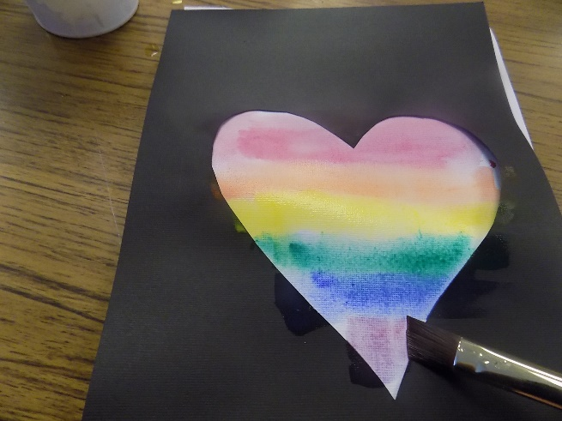
- Repeat painting horizontal stripes in yellow, green, blue and purple.
* Remember to wash your brush between each paint colour!

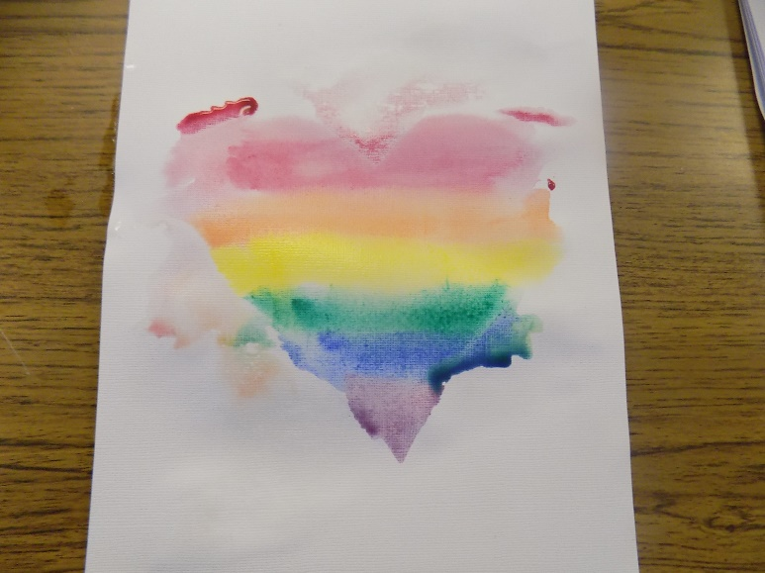
9. when heart shape is filled with paint stripes gently remove black heart template.
10. the edges will not be perfect . This is part of the watercolour effect. Leave painting to dry completely.

11. Once dry use a black felt tip pen to draw a heart. You can use a template or draw freehand.
* you can now frame your art work if you want you could make a smaller heart and add this to one of your card blanks to send to someone .

Rainbow Tree Watercolour Art
(video tutorial also available)
Crafting skills: setting up a work space, colours, painting
Maths and English skills: following instructions, counting

What you will need:
- White Card
- Water colour set (included in pack)
- Pot of water
- Paint brush
- Paper towel/ kitchen towel
- Black pen
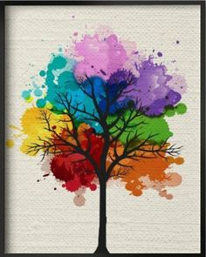

Instructions:

- get all the equipment you will need.
- Using your brush paint water all over the card. If the card is damp it means the paint will blend together easily.
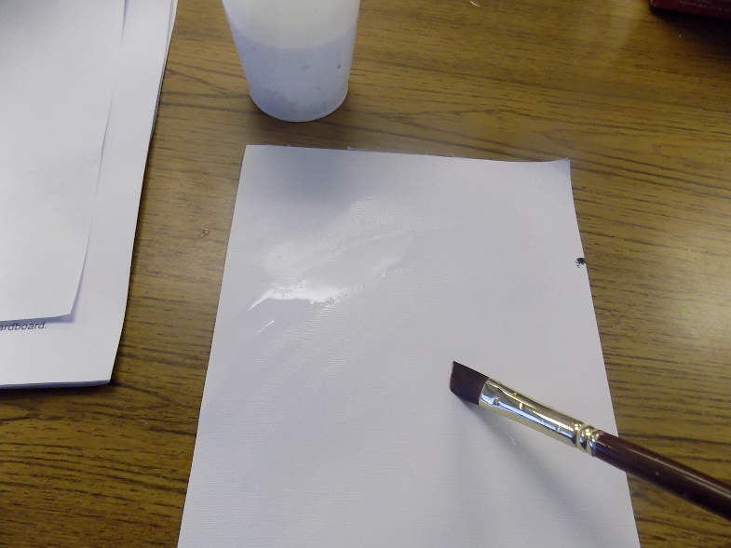

- Add splodges of water colour to the damp card. Remember to wash your brush in between colours.

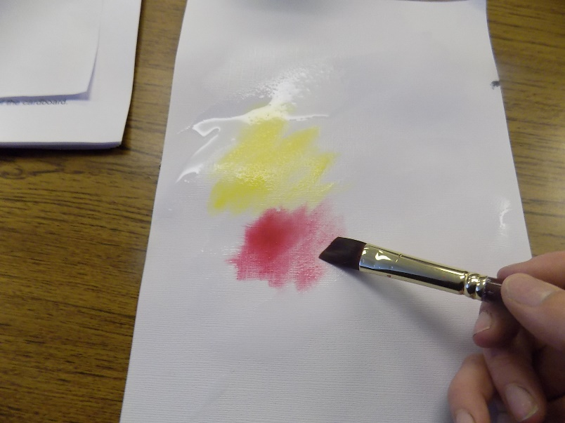

- Leave a small gap between the splodges of paint. This will give the paint a chance to spread to help create the water colour effect.

- Keep adding different coloured splodges of paint until you have a rough circle shape.
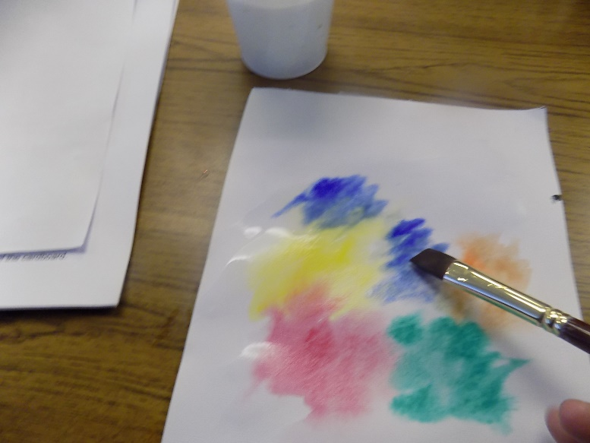

- Once you are happy with the shape leave it to dry.
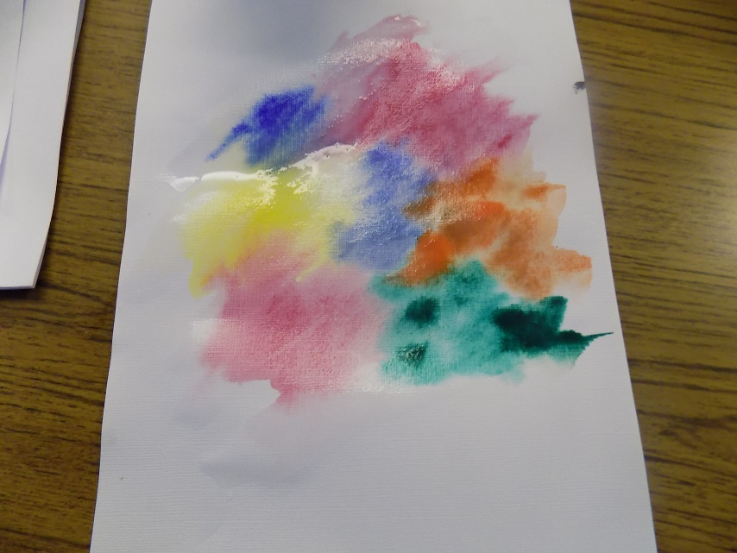

- Using your black felt tip pen add a trunk on the card, below your painting.
- On top of your painting add branches coming from the trunk
- Add extra details by drawing twigs coming from your branches.
*You can now frame your art work if you want you could make a smaller heart and add this to one of your card blanks to send to someone.
Rainbow Heart Card
Crafting skills: setting up a work space, cutting, colours, gluing
Maths and English skills: following instructions, counting, shape recognition, measuring.
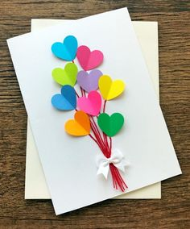
You will need:
- Flat surface to work on – table or tray
- Card and envelope
- A selection of rainbow coloured paper hearts – rainbow selection – precut or using a heart template
- Pencil or pen – if you’re making more hearts
- Scissors
- PVA - you need a stronger glue for this craft, with a small glue spreader (like a cotton bud) Only use a small amount of glue though.
- Wool
- Bow / ribbon
- Ruler
Instructions:
- Cover your table or collect your tray
- Collect your tools and materials
- Use your ruler to cut your wool into tails for your balloons.
- Carefully put a smooth layer of PVA glue down the middle of your card and carefully stick your /wool down to make your balloon strings
- Leave them to dry
- Collect your rainbow coloured pre-cut hearts or
draw around the heart template and cut around them carefully creating hearts in a range of colours
- Fold your hearts in half to make a line down the middle
- Pick one heart and carefully put a small amount of glue down the fold line on the back of the folded heart
- Carefully put the heart at the top of one of your balloon strings
- Repeat this for all your balloons
- Leave them to dry
- Now add a bow/ make a ribbon bow and glue it onto the bottom of the balloon strings
- Leave it to dry
- Product check your card by gently shaking it – to make sure nothing falls off
- Tidy up your workspace
- Decide who you would like to send your card to

Pom pom or Button balloon house card (Themed with the Disney film ‘Up’ in mind!)
Crafting skills: setting up a work space,colours, gluing
Maths and English skills: following instructions, counting, shape recognition.
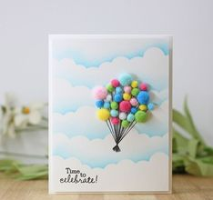
You will need:
- Flat surface to work on – table or tray
- Card and envelope
- Bigshot house cut out
- Pen (black or any other colour you want to use)
- A range of coloured pom poms/ buttons – rainbow selection
- PVA glue - PVA needs to be used when you are gluing wool/plastic to paper: it’s much stronger.
- Glue brush – this could be a paintbrush: but remember to wash it carefully with washing up liquid after using it, to get rid of all the glue!
Instructions:
- Cover your table or collect your tray
- Collect your tools and materials
- Turn your card so that it opens from right to left (just like a normal card: it’s very easy to do this upside down!)
- Choose where you want to put your house near the bottom of the card and glue it into place – glue stick or PVA glue can be used for this. Which is cleaner?
- Choose a pom pom or button and decide where you want it, above the house – it needs to look like a balloon flying above the house
- Use a small amount of PVA glue on each pom pom /button to keep your fingers clean
- Keep gluing until you have created all your balloons
- Now leave it to dry completely!
- When buttons are dry - product check your work: Does anything fall off? Are there any gaps? If there are - fill them in
- Now use a pen to draw balloon string lines from the house to the balloons
- Now you need to wash up and tidy away your workspace
- Decide who you would like to send your card to

Rainbow Button picture
Crafting skills: setting up a work space, colours, gluing
Maths and English skills: following instructions, counting, shape recognition, copying a pattern

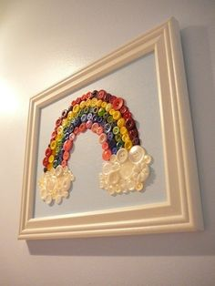

You will need:
- Flat surface to work on – table or tray
- Rainbow template
- A range of coloured buttons – rainbow selection
- PVA glue - PVA needs to be used when you are gluing plastic to paper: it’s much stronger
- Glue brush – this could be a paintbrush: but remember to wash it carefully with washing up liquid after using it, to get rid of all the glue!

Instructions:
- Cover your table or collect your tray
- Collect your tools and materials
- Turn Rainbow template landscape way round
- Sort your buttons into Rainbow colour piles – these can be flexible. It depends what colour buttons you have!
- Now you can start gluing in a rainbow colour pattern onto a rainbow template
- Rainbow line 1 = red
- Rainbow line 2 = orange
- Rainbow line 3 = yellow
- Rainbow line 4 = green
- Rainbow line 5 = blue
- Rainbow line 6 = Indigo (light bluey purple)
- Rainbow line 7 = Violet (deeper dark purple)
- Use a small amount of glue on each button to keep your fingers clean
- Keep gluing buttons on using the rainbow colour pattern
- When you have filled the rainbow template with your buttons – Leave it to dry completely!
- When buttons are dry - product check your work: Does anything fall off? Are there any gaps? If there are - fill them in.
- Now you need to wash up and tidy away your workspace

Rainbow Wool Tassels
(video tutorial also available)
Crafting skills: setting up a work space, cutting, colours, threading
Maths and English skills: following instructions, counting, measuring.
What you will need:
- Cardboard template (included in pack)
- Wool
- Scissors
- Plastic wool needle
Instructions:
- Choose some coloured wool.
- Put end of wool in slit in cardboard tassel templae (this has been highlighted on the cardboard). This will help keep the wool in place.
- Wrap wool around
cardboard 30 times.
- Cut another piece of wool
about 20cms long and thread
through plastic wool needle.

- Thread needle between
cardboard and wool at one end.
- Tie ends of threaded wool
together making a double
Knot.
- Cut all wool pieces at the other end of the cardboard.
- Remove wool from
cardboard.

- Fold wool in half to
make the tassel
shape.

- Cut another piece of
wool about 20cms
long.
- Tie wool in a double
knot around folded wool
end of tassel about
2cms from end.

- At other end of tassel
trim ends of wool using
scissors to neaten it.

You can make lots of different
coloured tassels to make a
garland decoration

Rainbow Wool Tassels Bookmark
Crafting skills: setting up a work space, cutting, colours, threading
Maths and English skills: following instructions, shape recognition, counting, measuring.

What you will need:
- Cardboard tassel template (included in pack)
- Wool
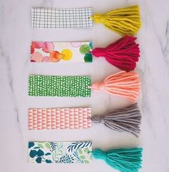
- Scissors
- Plastic wool needle
- Patterned card
- Hole punch

Instructions:
- Follow instructions to
Make a rainbow wool tassel.
- Cut a rectangle 15cms by
5cms from patterned card.
- Using a hole punch make a hole at one end of the patterned card.
- Thread hanging wool part of tassel through hole
- Gently tie tassel to patterned card. Be careful not to tear card.

Rainbow Wool Tassels keyring
(video tutorial also available)

Crafting skills: setting up a work space, cutting, colours, threading
Maths and English skills: following instructions, counting, measuring.
What you will need:
- Cardboard keyring tassel template (included in pack)
- Wool
- Scissors
- Plastic wool needle
- Needle
- Keyring
- Coloured beads
- Embroidery thread
Instructions: Same as tassel instructions but on a smaller scale so a bit more fiddly!
- Choose some coloured wool.
- Put end of wool in slit in cardboard keyring tassel template (this has been highlighted on the cardboard). This will help keep the wool in place.
- Wrap wool around
cardboard 15 times.
- Cut another piece of wool
about 15 cms long and thread
through plastic wool needle.
- Thread needle between
cardboard and wool at one end.
- Tie ends of threaded wool
together making a double
Knot.
- Cut all wool pieces at the other end of the cardboard.
- Remove wool from
cardboard.

- Fold wool in half to
make the tassel
shape.

- Cut another piece of
wool about 15cms
long.
- Tie wool in a double
knot around folded wool
end of tassel about
1cm from end.

- At other end of tassel
trim ends of wool using
scissors to neaten it.
- Make 2 or 3 more tassels like this. Think about using colours that compliment each other

- Cut about 30cms of embroidery thread and tie to keyring.

- Thread embroidery thread onto a needle.

- Thread on 3 coloured beads.

- Thread on the first tassel.
Push needle through tied end
end of tassel in the centre.

- Pull tassel gently along thread
until it reaches the beads.

- Thread on the remaining tassels.
Thread on one more bead at the
bottom and tie a knot to stop the
tassels off.
- Cut off any extra embroidery thread.

Pom Pom using a pom pom maker
(video tutorial also available)

Crafting skills: setting up a work space, cutting, colours
Maths and English skills: following instructions, measuring.

What you will need:
- Pom pom maker
- Wool
- Scissors
- Plastic wool needle

Instructions:
- Take your pom pom maker, and open up the arches.
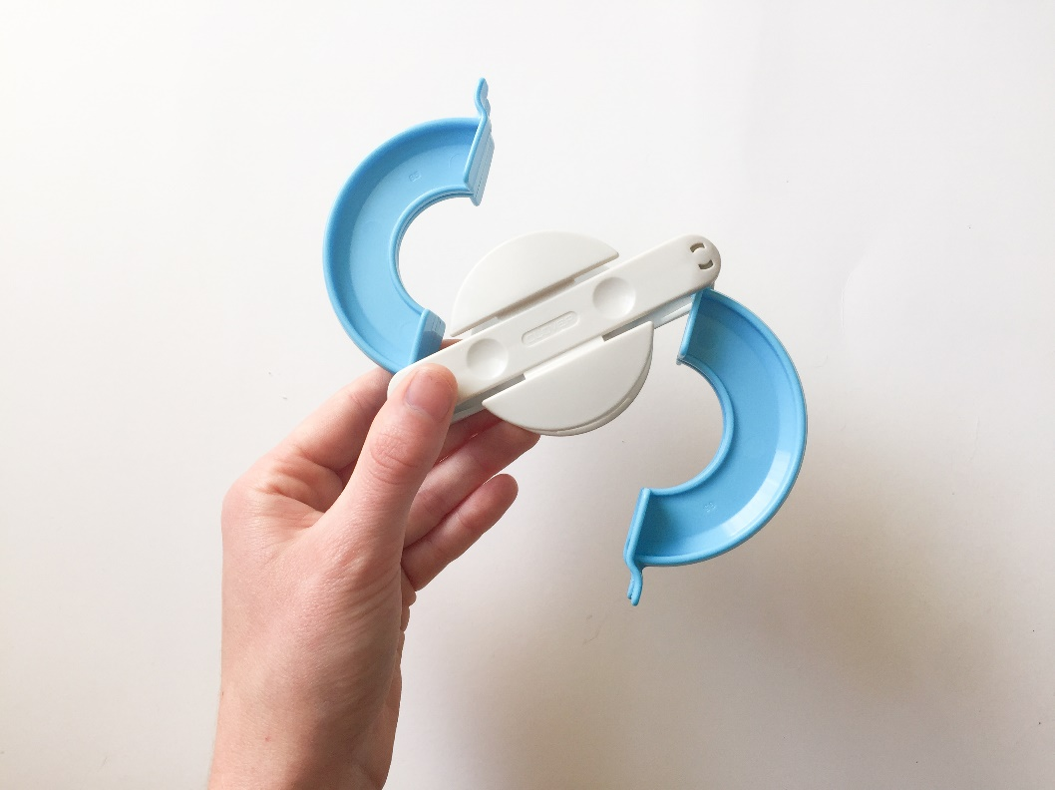

- Start wrapping your wool around the left side of the two top arches. Start wrapping the wool on the left, and move across to the right
- Keep wrapping the wool around until you reach the right hand side. Make sure there are no gaps.
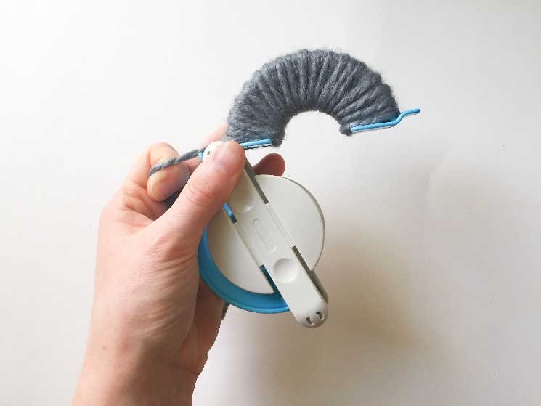
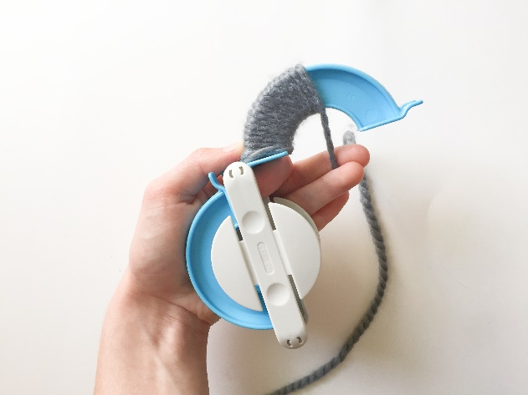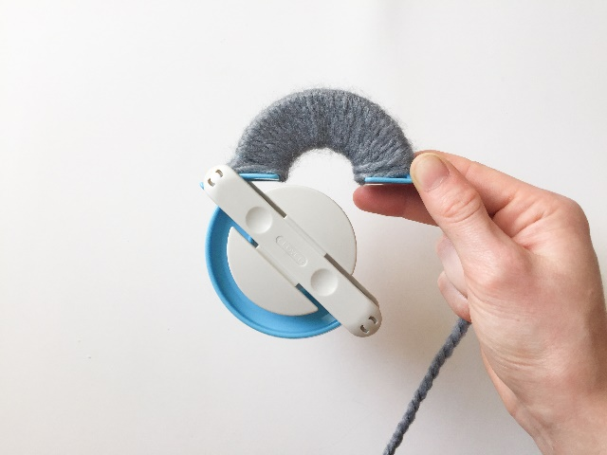
- Now wrap the wool around again , going from right to left to create another layer.

- After the second layer, wrap wool around from left to right to make a final third layer.
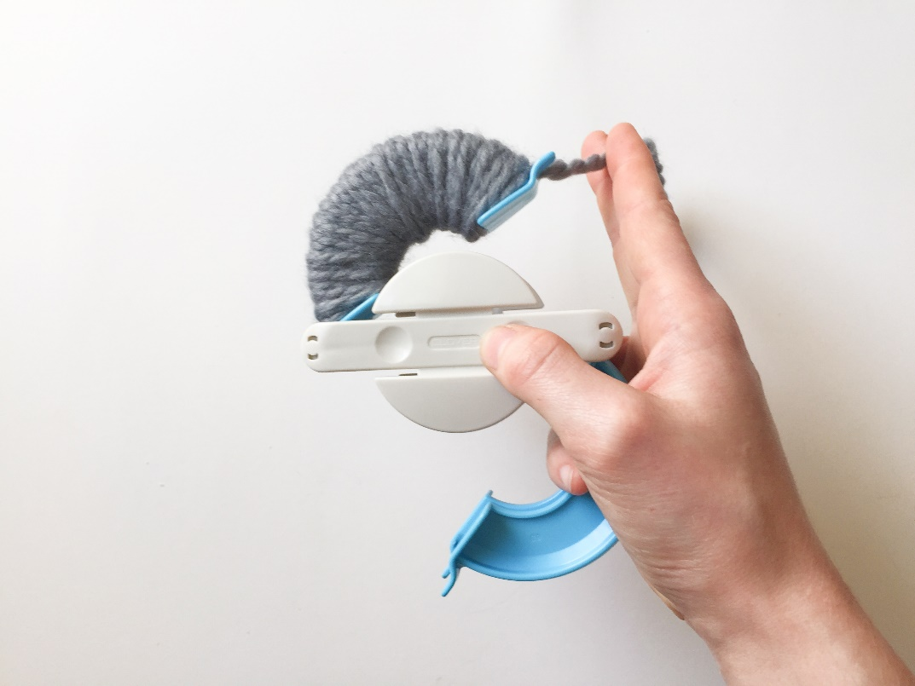

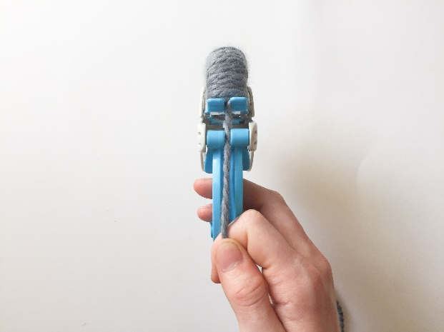
- Now push the top arches down. Line up your wool with the space in between the two bottom arches.

- Pull the wool through the
Bottom arches and start
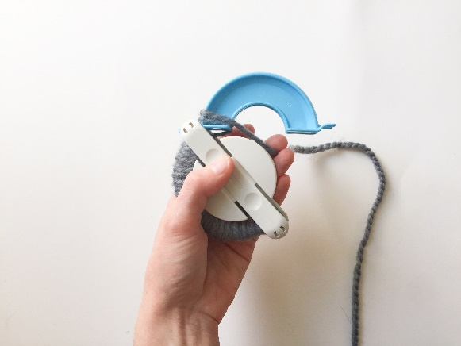
wrapping the wool around
them, like you did for the
top arches.

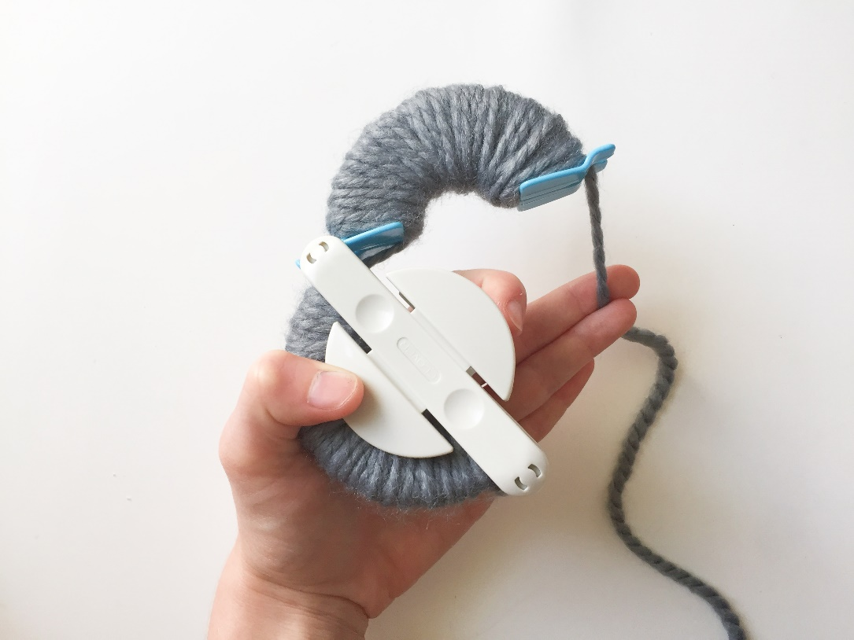
- Like the top arches wrap the wool from left to right and repeat two more times to make three layers in total.

- Close the bottom arches. Cut off wool.
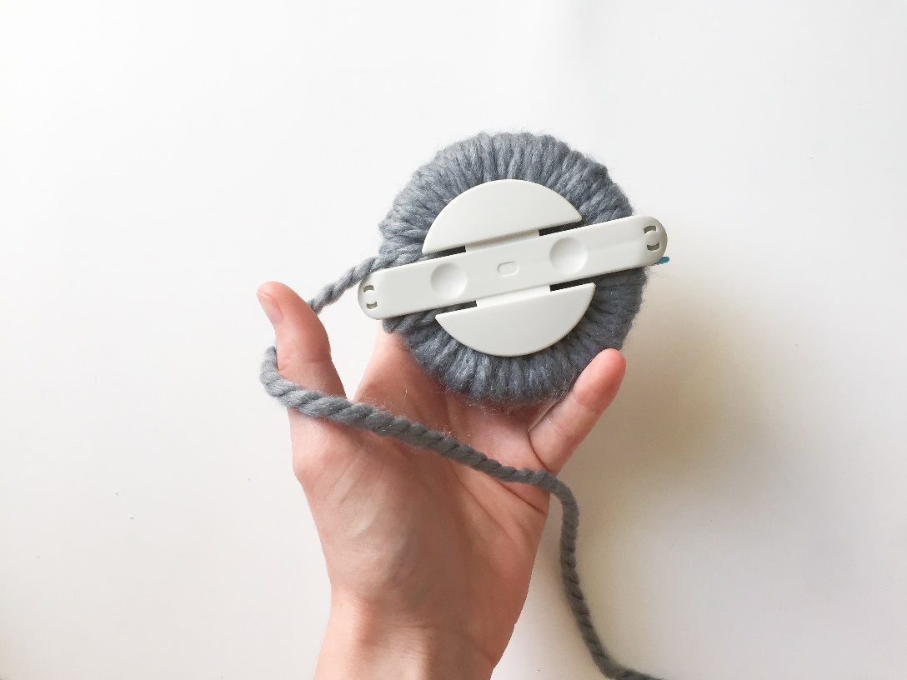

- Turn the pom pom maker on its side. Start cutting the wool between the two gaps on the arches.
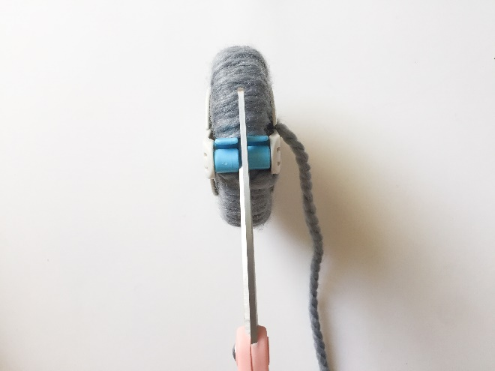
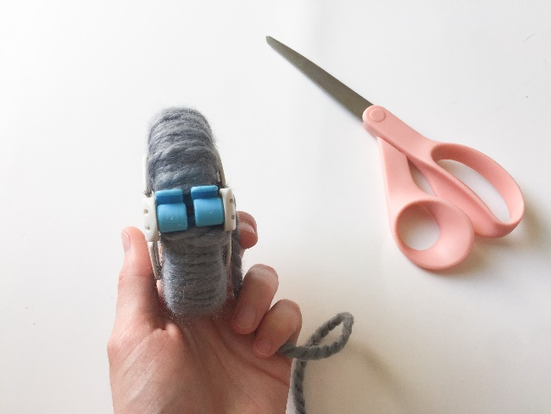

- Cut all along the top arches.
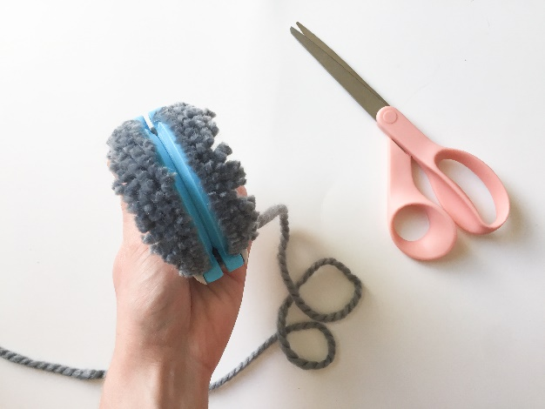
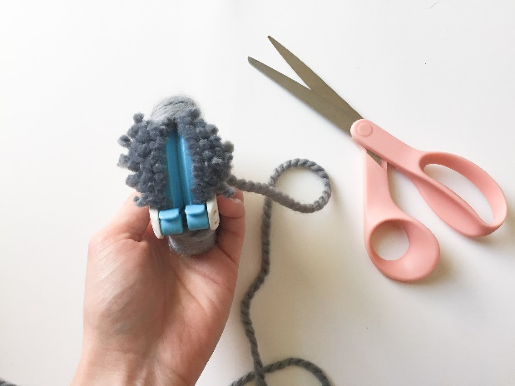

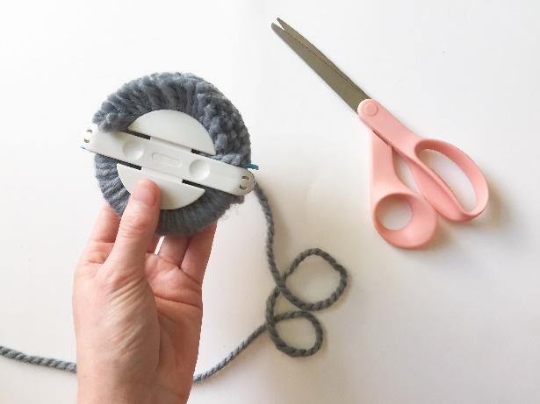
- Make sure you
hold onto the
middle of the
pom pom
maker so it
doesn’t ‘pop’
apart.

- Now cut along the bottom arches. Remember to keep hold of the pom pom maker in the middle.
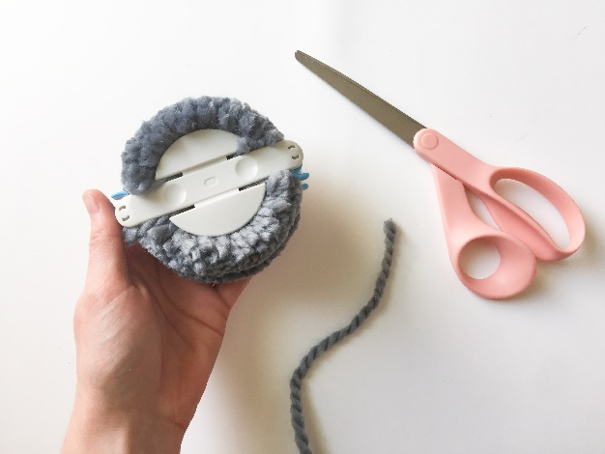
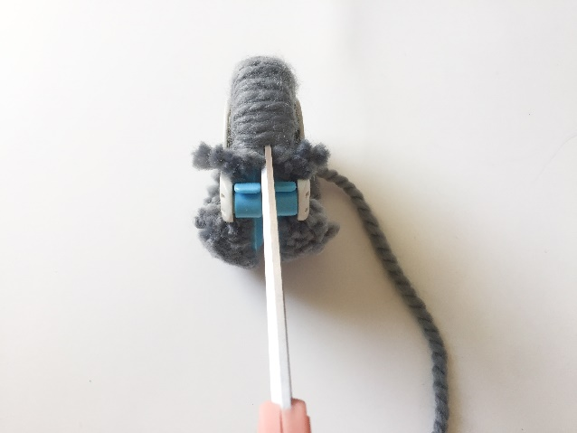

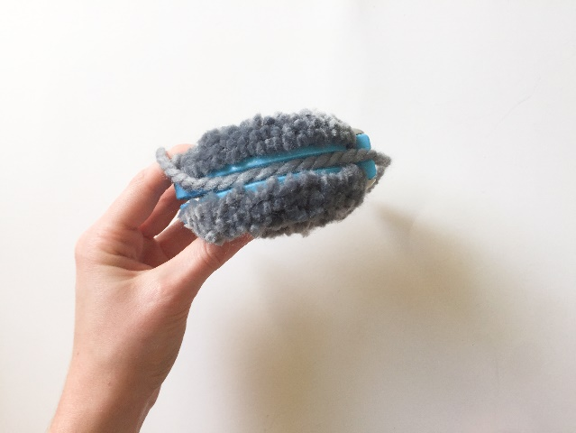
- Cut another piece of wool about 30cm long
- Wrap wool around middle of pom pom maker. (where you’ve just cut).
- Tie wool in a double knot.
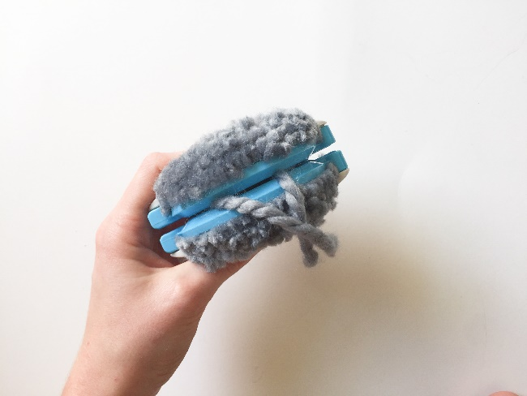
- Wrap wool around
Other side of pom pom maker and double knot again. Repeat this 2 more times.

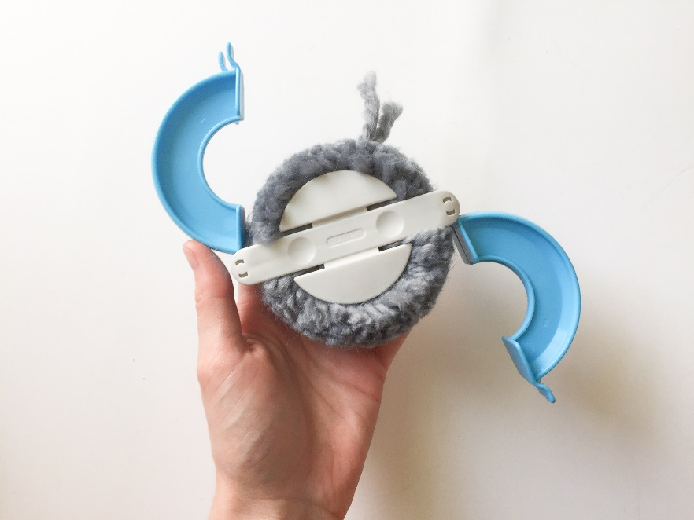
- Gently open both sets of arches on the pom pom maker.

- Gently pull apart the 2 halves of the pom pom maker.

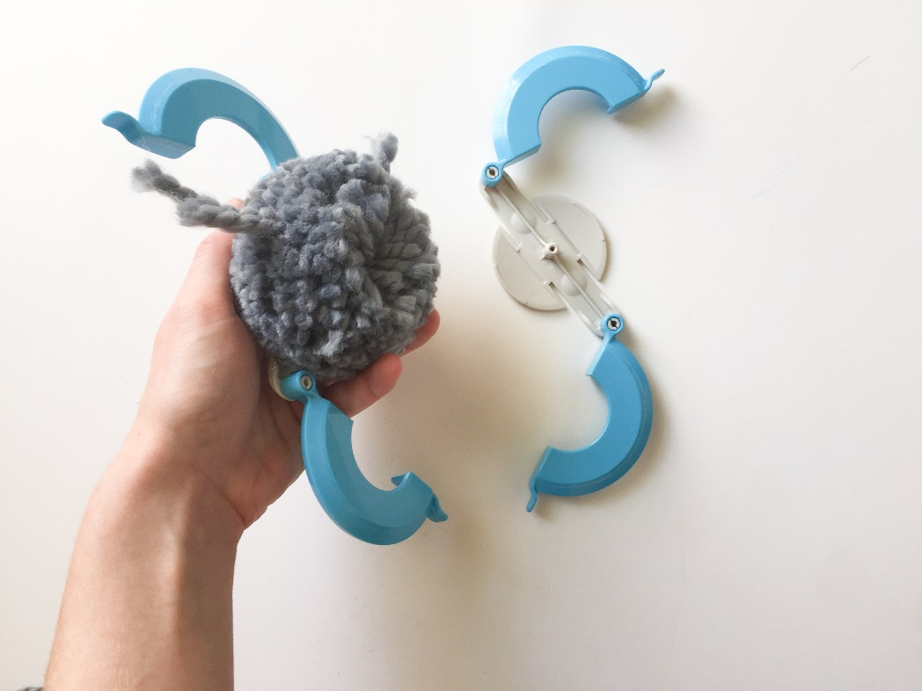

- Remove pom pom. Gently fluff and roll pom pom between hands to make it even.

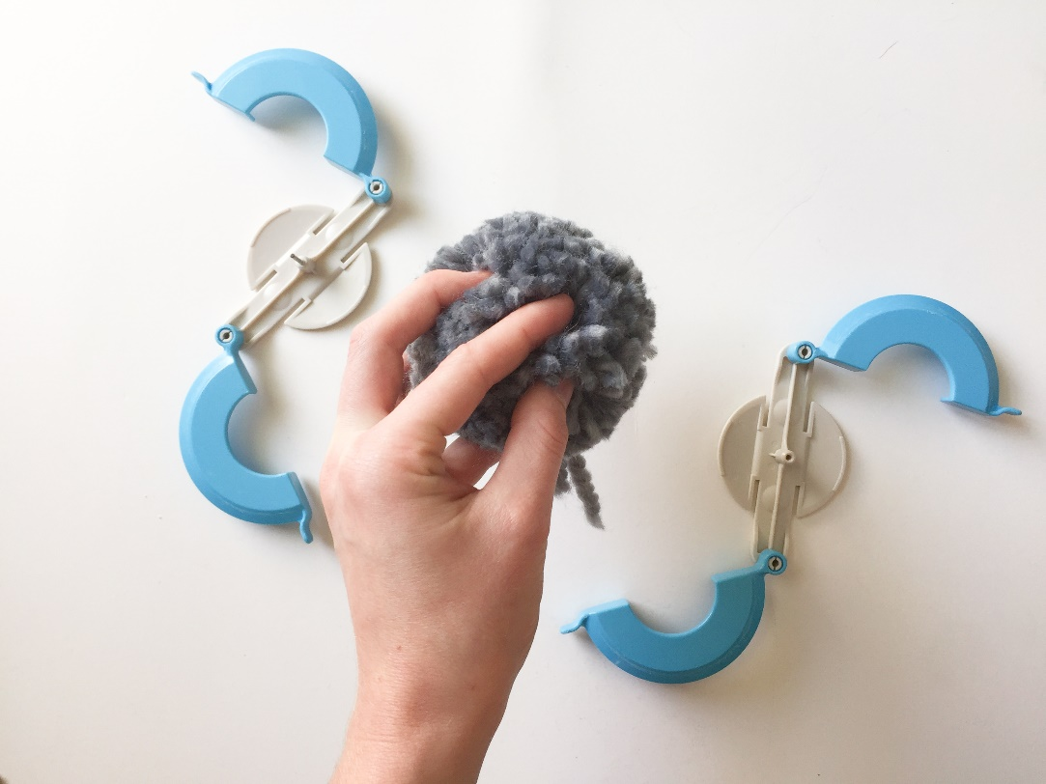

- Cut off any uneven bits of wool leaving the piece of wool you used to tie it together. This piece can be used to attach the pom pom to other items

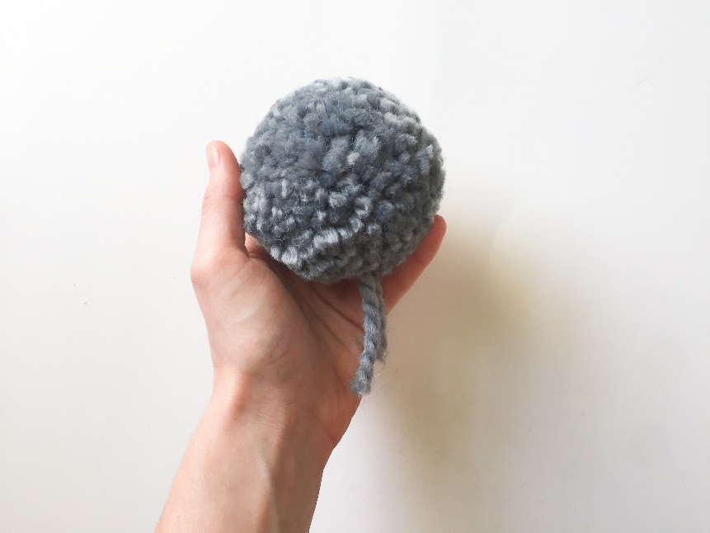

Pom Pom Garland

Crafting skills: setting up a work space, cutting, colours
Maths and English skills: following instructions, measuring, making a pattern/ sequence, counting

What you will need:
- Pom poms
- Wool
- Scissors
- Plastic wool needle
- Ruler
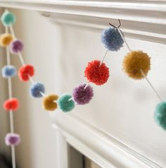
Instructions:
- Using pom
Pom instructions make lots of pom poms in different colours.

-Think about colour choices. You could make a rainbow effect, choose complimentary colours or think about making a pattern using colours.
- Measure about 1 metre of wool. (You can measure more if you want a longer garland).
- Thread wool onto plastic needle.
- Push needle through middle of pom pom and gently pull pom pom along the wool.
- Keep threading pom poms onto wool. Leave about a 10cm gap between pom poms on the wool.
- Hang up garland

Pom Pom and Tassel Rainbow Garland

Crafting skills: setting up a work space, cutting, colours, threading
Maths and English skills: following instructions, measuring, making a pattern sequence, counting

What you will need:
- Pom poms
- Tassels
- Wool
- Scissors
- Plastic wool needle
- Coloured beads
- Ruler

Instructions:
- Using pom Pom instructions make several of pom poms in different colours
- Using Tassel instructions make several tassels in different colours
- Measure 3 pieces of wool:
- 1 X 50 cm
- 1 X 70 cm
- 1 X 90cm
- Tie one set of wool ends together.
- Thread plastic needle onto longest piece
- Thread tassels onto longest piece of wool. Push needle through top of tassels.
- Next thread plastic needle onto middle piece of wool.
- Thread pom poms onto middle piece of wool. Push needle through middle of each pom pom.
- Thread about 20 beads onto shortest pies of wool.
- Tie other ends of wool together in a knot.
- Move along items on wool so they are in the middle when the garland is hung up.

Rainbow tote bag

Crafting skills: setting up a work space, cutting, colours, threading, gluing
Maths and English skills: following instructions, following a pattern/ sequence, counting, shape recognition

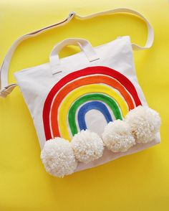
What you will need:
- Pom poms
- Tote bag
- Scissors
- Biro/pen
- Needle
- Thread
- PVA glue (optional)
- Felt
- Rainbow template

Instructions:
- Using pom Pom instructions make several of pom poms in white. These will be the clouds.
- Cut up rainbow tote bag template for the different coloured rainbow stripes.
- Draw around rainbow stripes onto different colured felt using a biro.
- Cut out felt stripes
- Lay out felt stripes to make a rainbow.
- Use a running stitch to sew rainbow stripes onto the tote bag
Note: if you don’t want to sew you can glue the rainbow stripes down using PVA glue but put newspaper/magazine inside the bag to stop glue going through to other side of bag.
- Sew (or glue) white pom poms to bottom of rainbow to make the clouds

Rainbow Heart Tote Bag

Crafting skills: setting up a work space, cutting, colours, threading, gluing
Maths and English skills: following instructions, following a pattern/ sequence, counting, shape recognition

What you will need:
- Tote bag
- Scissors
- Biro/pen
- Needle
- Thread
- PVA glue (optional)
- Felt
- Heart template

Instructions:
- Cut out heart template.
- Draw around Heart onto different coloured felt using a biro.
- Cut out felt hearts.
- Lay out felt hearts to make a circle/ wreath pattern. You could make a pattern/sequence using different coloured hearts if you wanted to.
- Use a running stitch to sew heart onto the tote bag
Note: if you don’t want to sew you can glue the rainbow stripes down using PVA glue but put newspaper/magazine inside the bag to stop glue going through to other side of bag.
Rainbow Bunting Pennant Decoration

Crafting skills: setting up a work space, cutting, colours, threading.
Maths and English skills: following instructions, following a pattern/ sequence, counting, shape recognition

What you will need:
- Bunting pennant
- Scissors
- Biro/pen
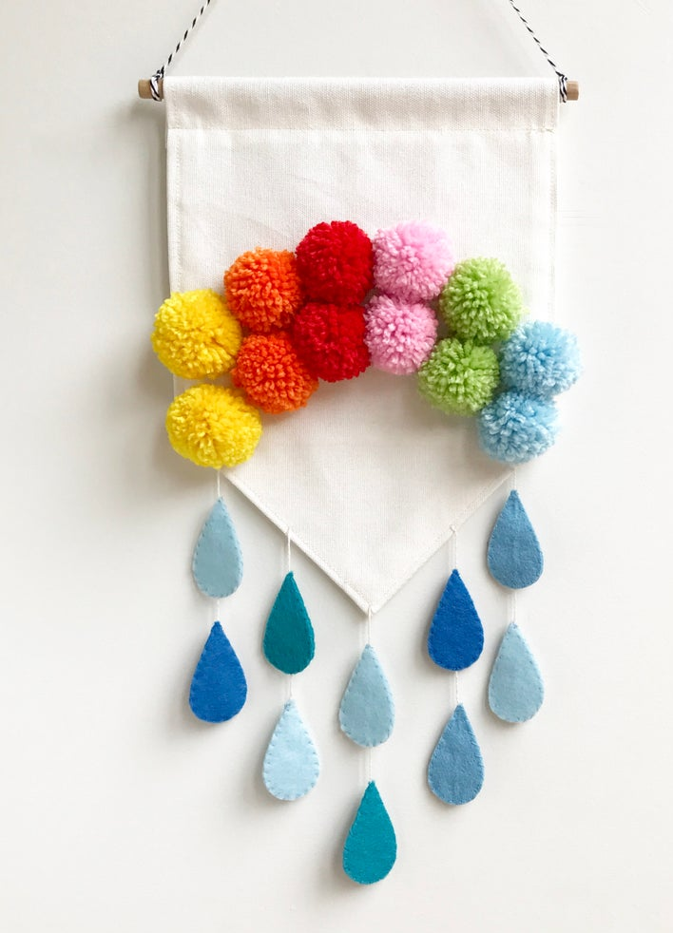
- Needle
- Blue thread
- Blue Felt
- Raindrop template
- Pom poms

Instructions:
- Using pom Pom instructions make several pom poms in different colours.
- Sew pom poms to
Fabric bunting pennant
to make an arch like a rainbow.
- Cut out raindrop template.
- Using template draw out 20 raindrops using a biro.
- Cut out felt raindrops.
- Put two raindrops together and sew together using a running stitch around the edge.
- Repeat with the rest of the felt raindrops. You should have 10 raindrops at the end
- Thread a needle with some blue embroidery thread.
- Sew 2 raindrops onto the thread, leaving a gap between them, see finished picture.
- Attach rain drops to point of bunting pennant.
- Repeat making 4 more threads with 2 rain drops on each thread. Try to make sure there is even spaces between the raindrops.
- Attach these to the bunting pennant, see finished picture.

