EACH DAY I CAN:
PLEASE NOTE SHARED AS AN EXAMPLE FOR ILLUSTRATION ONLY. COLLEGES/SETTINGS TO ENSURE IMAGES ARE USED TO COMPLY WITH COPYRIGHT AND WITH APPROPRIATE LICENCES IN PLACE. PLEASE INSERT OWN IMAGES AS APPROPRIATE.
I can choose | 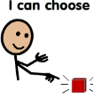
I can be happy and healthy

I can greet my family and carers in my own way | 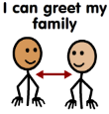
I can stay safe and look after myself | 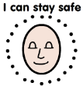
I can help at home in my own way | 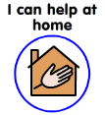
Parents/carers: Please fill in the tables together. You can use words or pictures
My Daily List
Name ___________________________
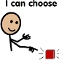
I can choose….

 | Monday | Tuesday | Wednesday | Thursday | Friday
I chose my clothes

I chose an activity to do with my family: read, craft, spa day

I chose my drink

I chose something to watch with my family
I chose some music to listen to

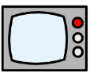
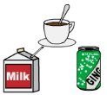
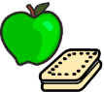
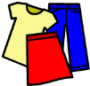

I can be happy and healthy….

 | Monday | Tuesday | Wednesday | Thursday | Friday
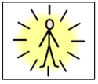
Today I….

To keep healthy, I can:
- Go outside for a short walk or trip in my wheelchair
- Go into the garden for 15 minutes
- Do 5 minutes of stretching to music
- Dance for 5 minutes to music
- Eat a healthy snack
- Eat some vegetables
- Eat a piece of fruit
- Play with my pet
- Smile or make a happy gesture to somebody
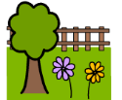
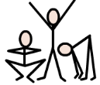
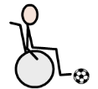

I can greet my family and carers in my own way…

 | Monday | Tuesday | Wednesday | Thursday | Friday
Today I…

I could:
- Sign good morning or good afternoon in my own way
- Smile at you
- Blink to your question
- Wave or reach out to you
- Use my voice to get your attention
- Use my symbols to tell you what I want
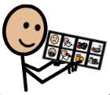
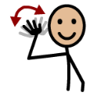
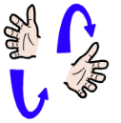
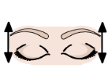
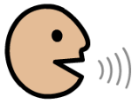

I can stay safe and healthy….

 | Monday | Tuesday | Wednesday | Thursday | Friday
I washed my hands with help or all by myself

I brushed my teeth or let someone brush my teeth

I put on an item of clothing with some or no help.

I can stretch my arms out to show personal space.
I can let you know if something is wrong or I am not happy.

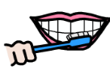
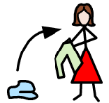
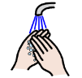

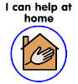
I can help at home in my own way….

 | Monday | Tuesday | Wednesday | Thursday | Friday
I listened to my family and /or carers
I helped to wash the dishes with my family
I gave out instructions to others in my own way
I smiled at somebody in my family
I sent a message (video or picture) to somebody
I held onto an object to help do a job in the home

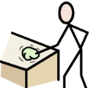
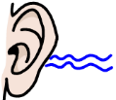
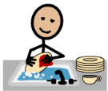
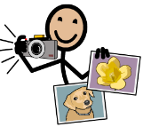
Use this space to add pictures or photos

