Art and Design Pathway
Photography

Storyboard Photography
(ART at Home PROJECT)

Task:
- You are tasked with producing a story but instead of using words you will use pictures.
- The storyboard should have no fewer than 5 photographs and no more than 12.
- You are to complete this at home - and you can even get the family involved.
- Use your photos to tell the stages of a story – like the chapters of a book. For example (and see below):

  - A lovely cup of tea – from making to drinking
  - A pasta meal – from preparation to eating
  - A paper plane – from making to flying
  - Getting back on the road – from breaking down to driving away
  - A medical emergency – from accident to medical help

- Complete your ‘Photography Storyboard Reflection Log’ - PLANNING
- Convert your photos to black and white
- Complete your ‘Photography Storyboard Reflection Log’ - REVIEW
- Email the photos (or a screen shot of your photoboard) to College
- Email your Reflection Log to College
- We will print the final storyboard when we get back to College!

How to take the pictures:
- SLR camera
- Digital camera
- Smartphone
- iPad/tablet

What story can I tell?
Your story can be about anything from making a cup of coffee to creating a crime scene!
Below is an example of a storyboard by one of our students who has documented the simple task of making a coffee. He has used macro photography in most of his images.
Could you do a storyboard that has landscape, portrait and macro photography in it? You can look online for other examples of storyboard and documentary photography. Good luck!
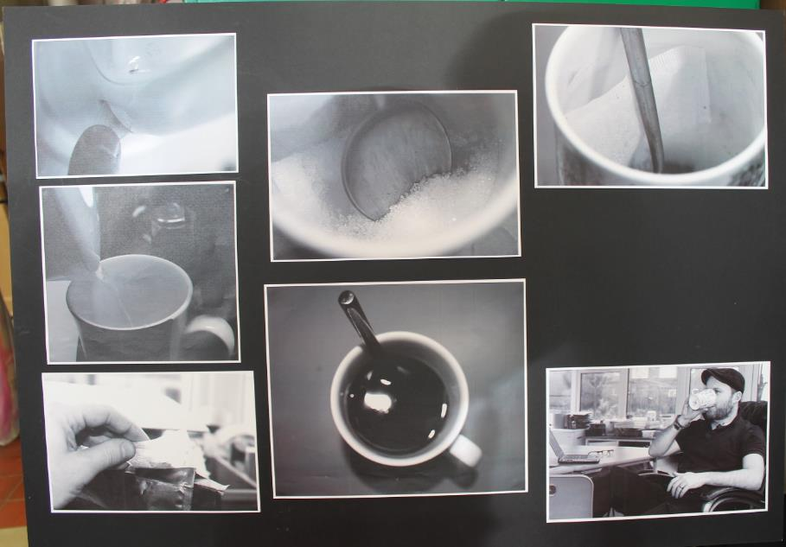

Examples of past students storyboards
Making Pasta
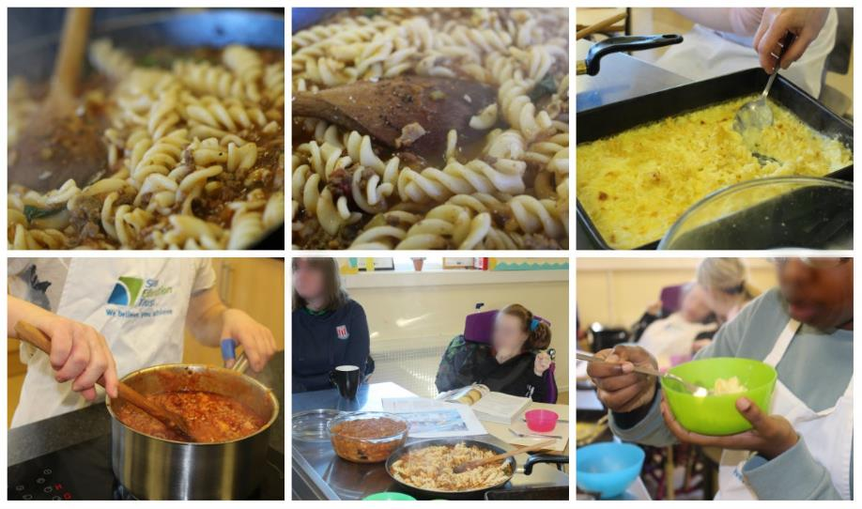
Flying a Paper Plane
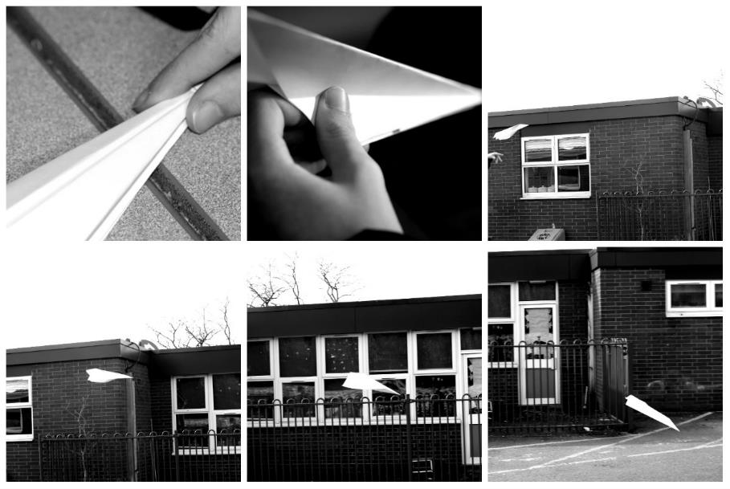
The Break down
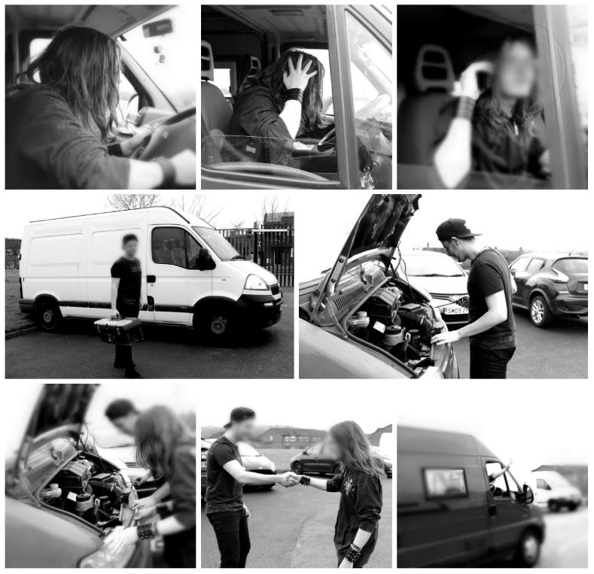
The Emergency
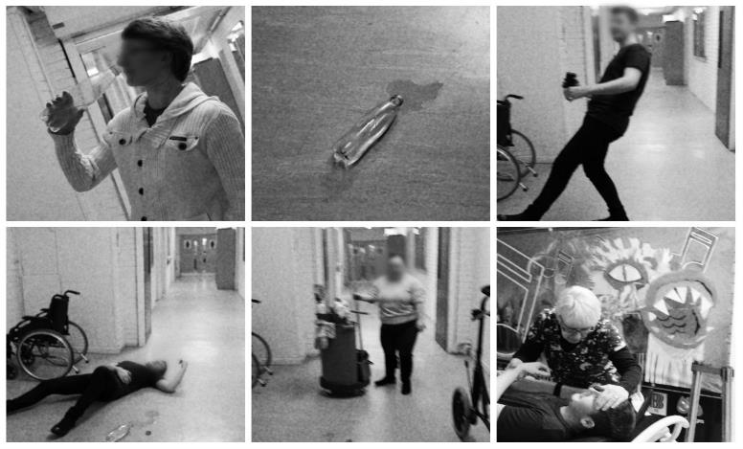

Art and Design: Photography Storyboard Planning and Reflective Log

Name _______________________ Class: Date: ___________

Photography Storyboard PLANNING
- What is the story?

- What do you need for the photoshoot?

- Describe where you will take the photographs.

- What problems might you encounter when taking the shots?

REVIEW:
- How did it all go? How did you solve any problems?

- Are you pleased with the end result? WHY?

