

**Keeping young people with**

**SEN Safe Online**

**Top Tips you can put in place at home to help keep young people safe online**



If you would like further information or would like to discuss online safety matters at The Sheiling Ringwood please contact our E-Safety lead - Geoff Lively - email geoff.lively@thesheilingringwood.co.uk

**Talk about staying safe online**

Sometimes the hardest thing is starting a conversation about online safety. Some parents and carers may think this information does not apply a young person due to their disabilities. It is true that some of the risks may differ but all children are at risk. To determine the specific and the best course of action we would advise having a conversation with their teacher or house manager about online safety activities they have done that could be replicated. Where possible start a conversation with your child. You can get some ideas of conversation starters at [**www.childnet.com/parents-and-carers/have-a-conversation**](https://www.childnet.com/parents-and-carers/have-a-conversation)

**Use parental controls and settings**

Parental controls and filters can be applied on your home internet, devices, phone networks and online services such as YouTube and steaming services. These can prevent a lot of unwanted content and mishaps but remember no filter is perfect and all work best when combined with parent / carer supervision and engagement. Visit the Parents’ Guide to Technology on the UK Safer Internet Centre website to find out how to set up controls on a device [**www.saferinternet.org.uk/parent-tech**](http://www.saferinternet.org.uk/parent-tech). Visit [**www.internetmatters.org/parental-controls**](http://www.internetmatters.org/parental-controls) to find out how you can set up controls on your home internet, phone network and streaming services. Always remember to choose a strong password and do not share it with your child.

**Supervise internet use**

The best safeguard for young people with SEN is appropriate supervision when using the internet. For many of the young people at the Sheiling self-occupation is difficult, so it can feel like a blessing when they are occupied and seemingly safe when using a device. This can expose them to unforeseen risks and they might accidently stumble across something which could upset or confuse them. Where possible we advise allowing access to devices in shared part of your home such as the living room or kitchen. This makes it easier for you to know what they are doing online and help them if needed.

**Set clear rules and expectations**

Technology can be incredibly empowering for people with SEN however unregulated use could quickly lead to problems like obsessive use, further detachment of social skills, disruption of sleep and other behavioral concerns. There are also many risks online that young people with SEN could be particularly vulnerable to. Set clear expectations for when and how they use devices, this will depend on the young person. Creating a family agreement or similar could be useful depending on the young person’s understanding. This might include things such as time spent online, where and when devices can be used and what to do if they see something upsetting. Alternatively or in addition try to establish clear routines that encourage a healthy mix of online and offline activities. This could be as simple as using schedules or now and next boards, setting clear times when you do and do not use the internet such as no devices at meal times or before going to bed.

**Enjoy being online together**

Use of technology and the internet have become a large part of everyday life and can be profoundly beneficial and fun. Despite the many benefits of using technology at home with young people with SEN there are also many risks that need to be considered. To keep young people safe online you need to understand how they use the internet, what are their motivations, abilities and limitations? The best way to find this out is by using technology and the internet with them. Have fun and get to know how they use their device. When exploring it together you can find out where the settings and safety features are.

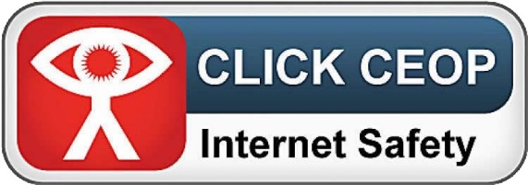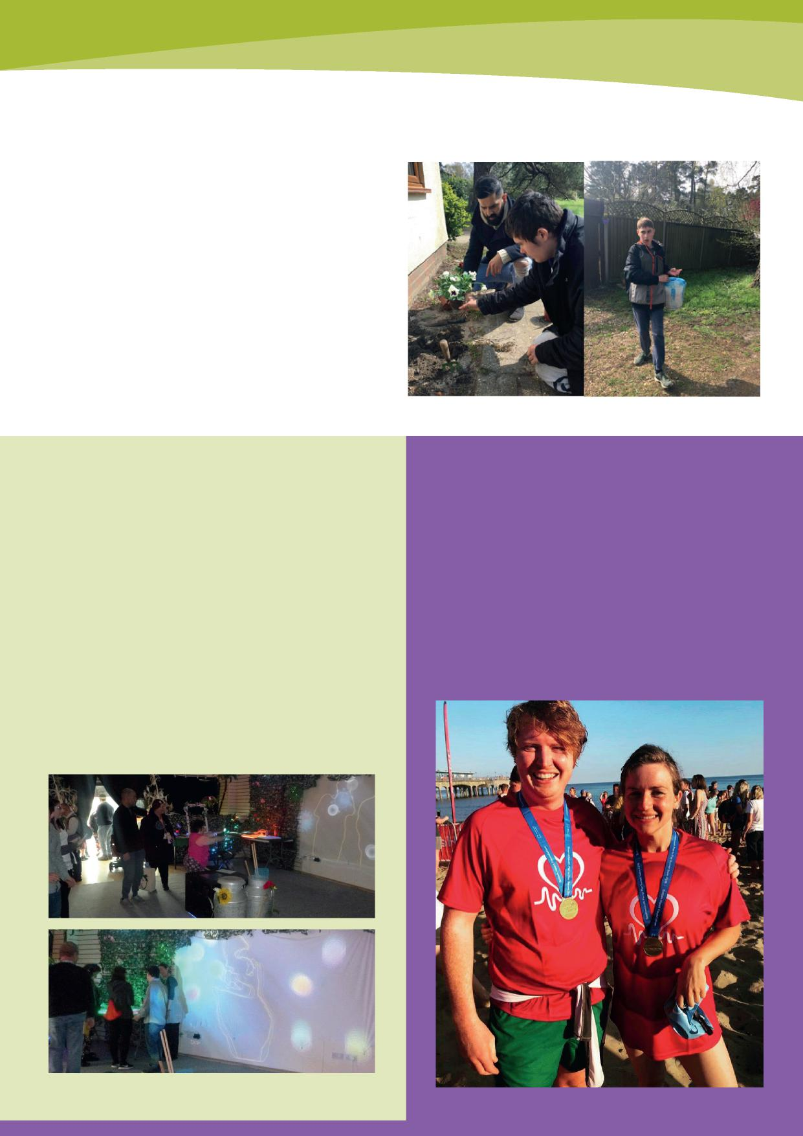

**The Report button looks like this**

**How to report online safety concern**

If you are worried or suspicious about someone who contacts a young person online report them to CEOP **(**[**www.ceop.police.uk**](http://www.ceop.police.uk)**)**. We have made this as easy as possible for you by adding the CEOP Report button to our website. For more information regarding reporting you can visit the parents and carers section of the Childnet website [**www.childnet.com/parents-help**](http://www.childnet.com/parents-help.)

**Find appropriate games and apps**

With hundreds of new apps being created every day it is impossible to keep up to date on what apps and games may be appropriate for a young person with SEN. We would always suggest doing research and asking a few questions before allowing access to a game or app. This would include - What are the risks? How this may affect my child relating to their specific needs? What could be done to mitigate risks? Do the benefits out way the risks? These can be difficult questions to answer. Websites like [**https://www.net-aware.org.uk/**](https://www.net-aware.org.uk/) will give a suggested age range and danger rating for specific areas. This is established and reviewed by children and parents. Age ranges can be misleading when applied to young people with SEN as developmentally they may not be ready for content despite their actual age however this will at least provide a gauge. When choosing from games they have age ratings, much like films and these are decided by the game’s content. PEGI (**pegi.info)** set these ratings along with content descriptors which indicate if a game contains things like violence, in app purchases or scenes of a sexual nature. Many apps from official sources will also have age ratings to help you decide if they are appropriate. This includes the Apple App store, Google Play and Windows Store apps. Reading reviews can also be a helpful way of finding out about suitability. Another consideration when considering the use of apps and games is many offer in-app purchases which means spending real money often linked to a bank card on in-game features. Many parents have had unexpected large bills after linking a card to an account then allowing their child to play a game and unwittingly buying content. You can turn off in-app purchases and protect them with a password in most device settings. To find more information about how to do this visit [**www.childnet.com/in-app-purchases**](http://www.childnet.com/in-app-purchases.).

**Visit our online safety webpage**

For more information on how to keep young people with SEN safe online and links to various useful sites please visit our website [**www.thesheilingringwood.co.uk/online-safety**](http://www.thesheilingringwood.co.uk/online-safety)including...



**Links found on our Website**

**Net Aware –** Information about the latest social networks, apps and games

[**https://www.net-aware.org.uk/**](https://www.net-aware.org.uk/)

**Share Aware** – Advice, videos and resources about sharing content

[**https://www.nspcc.org.uk/preventing-abuse/keeping-children-safe/share-aware/**](https://www.nspcc.org.uk/preventing-abuse/keeping-children-safe/share-aware/)

**ThinkuKnow** – Information, resources, games related to Online Safety

[**https://www.thinkuknow.co.uk**](https://www.thinkuknow.co.uk/)

**Parentinfo.org** – Newsfeed for parents with latest Online Safety articles

[**https://parentzone.org.uk/**](https://parentzone.org.uk/)

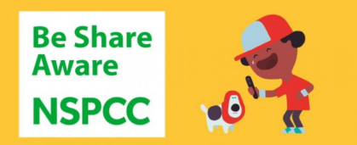



|  |
| --- |
| Image result for thinkuknow logo |





Created solely for promotion of safeguarding and online safety for The Sheiling Ringwood - Part of the[**SHEILING SPECIAL EDUCATION TRUST**](http://www.thesheilingringwood.co.uk/trustees/4589649449), a non-profit making limited company (No 8116370). Registered as a Charity (No 1149264) – information adapted from various sources including Childnet International Registered Charity no. 1080173 – Keeping under 5s safe online plus other links and png graphics freely available online. Not to be sold but used as educational resource for parents of vulnerable children to gain valuable information