

Moving on to (Name) College

(Name) College believes that every young person should have choice and control over their lives.

To help us support you in being able to do so, we would like to know more about what is important to you.

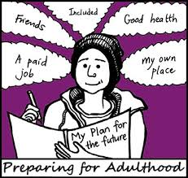

Name:



|  |  |  |  |  |  |
| --- | --- | --- | --- | --- | --- |
|  | Yes | | No | | Not sure |
|  | |  | |  |
|  | |  | |  |
| I would like to have a job |  | |  | |  |
|  |  | |  | |  |
| I would like to have a paid job |  | |  | |  |
|  |  | |  | |  |
| I would like to volunteer |  | |  | |  |
|  |  |  | |  | |

What type of work are you interested in?

__________________________________________________________________

Parent/carer comment:

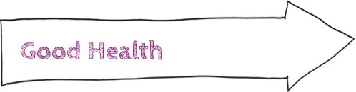

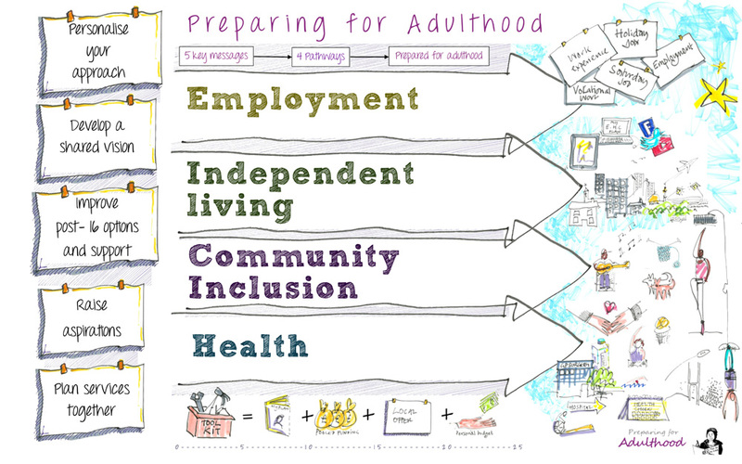

|  |  |  |  |  |  |
| --- | --- | --- | --- | --- | --- |
|  | Yes | | No | | Not sure |
|  | |  | |  |
|  | |  | |  |
| I can dress myself |  | |  | |  |
|  |  | |  | |  |
| I can eat independently |  | |  | |  |
|  |  | |  | |  |
| I can drink independently |  | |  | |  |
|  |  | |  | |  |
| I can wash myself |  | |  | |  |
|  |  | |  | |  |
| I can bath/shower myself |  | |  | |  |
|  |  | |  | |  |
| I can wash my hair |  | |  | |  |
|  |  | |  | |  |
| I can clean my teeth |  | |  | |  |
|  |  | |  | |  |
| I can get myself to the toilet, clean myself and adjust my clothes |  | |  | |  |
|  |  |  | |  | |

**Parent/carer comment:**





|  |  |  |  |  |  |
| --- | --- | --- | --- | --- | --- |
|  | Yes | | No | | Not sure |
|  | |  | |  |
|  | |  | |  |
| I can get around indoors without help |  | |  | |  |
|  |  | |  | |  |
| I can get around outdoors without help |  | |  | |  |
|  |  | |  | |  |
| I can cross the road safely |  | |  | |  |
|  |  | |  | |  |
| I can use trains, buses, taxis without help |  | |  | |  |
|  |  | |  | |  |
| I would like to learn how to use public transport by myself (bus, train, etc) |  | |  | |  |
|  |  |  | |  | |

**Parent/carer comment:**





|  |  |  |  |  |  |
| --- | --- | --- | --- | --- | --- |
|  | Yes | | No | | Not sure |
|  | |  | |  |
|  | |  | |  |
| I would like to live on my own |  | |  | |  |
|  |  | |  | |  |
| I would like to live with friends |  | |  | |  |
|  |  | |  | |  |
| I would like to stay at home |  | |  | |  |
|  |  |  | |  | |

**Parent/carer comment:**

Are you aware of the range of options available?

Would you like further information?





|  |  |  |  |  |  |
| --- | --- | --- | --- | --- | --- |
|  | Yes | | No | | Not sure |
|  | |  | |  |
|  | |  | |  |
| I can buy food, clothes and other essentials |  | |  | |  |
|  |  | |  | |  |
| I know how to manage my money |  | |  | |  |
|  |  | |  | |  |
| I can make a drink |  | |  | |  |
|  |  | |  | |  |
| I can make a snack |  | |  | |  |
|  |  | |  | |  |
| I can make a meal |  | |  | |  |
|  |  | |  | |  |
| I can look after my own clothes (wash/iron) |  | |  | |  |
|  |  | |  | |  |
| I can do housework (clean) |  | |  | |  |
|  |  | |  | |  |
| I know how to keep myself safe at home |  | |  | |  |
|  |  |  | |  | |

**Parent/carer comment:**



|  |  |  |  |  |  |
| --- | --- | --- | --- | --- | --- |
|  | Yes | | No | | Not sure |
|  | |  | |  |
|  | |  | |  |
| I can tell someone if I feel unwell |  | |  | |  |
|  |  | |  | |  |
| I sometimes worry or get upset about things |  | |  | |  |
|  |  | |  | |  |
| I sometimes don’t feel confident in myself |  | |  | |  |
|  |  | |  | |  |
| I would like someone to talk to about how I feel |  | |  | |  |
|  |  | |  | |  |
| I understand why I need to exercise |  | |  | |  |
|  |  | |  | |  |
| I take regular exercise |  | |  | |  |
|  |  | |  | |  |
| I understand what medication I am taking and why |  | |  | |  |
|  |  | |  | |  |
| I am responsible for taking my own medication |  | |  | |  |
|  |  | | | | |
| I am comfortable talking to health professionals who provide me with support |  | |  | |  |
|  |  | |  | |  |
| I understand my health condition and have all the information I want |  | |  | |  |
|  |  | |  | |  |
|  |  |  | |  | |



|  |  |  |  |  |  |
| --- | --- | --- | --- | --- | --- |
|  | Yes | | No | | Not sure |
|  | |  | |  |
|  | |  | |  |
| I understand why it is important to go to the dentist |  | |  | |  |
|  |  | |  | |  |
| I like going to the dentist |  | |  | |  |
|  |  | |  | |  |
| I know what to do if someone harms, threatens or otherwise behaves inappropriately towards me |  | |  | |  |
|  |  | |  | |  |
| I understand the changes that happen to my body as I get older |  | |  | |  |
|  |  | |  | |  |
| I know about sex and relationships |  | |  | |  |
|  |  | |  | |  |
| **Parent/carer comment:** |  |  | |  | |



|  |  |  |  |  |  |
| --- | --- | --- | --- | --- | --- |
|  | Yes | | No | | Not sure |
|  | |  | |  |
|  | |  | |  |
| I can contact my friends if I want to (telephone, email, online, etc) |  | |  | |  |
|  |  | |  | |  |
| I understand how to do this safely |  | |  | |  |
|  |  | |  | |  |
| I can meet my friends regularly at home / outside home |  | |  | |  |
|  |  | |  | |  |
| I am able to go to the cinema |  | |  | |  |
|  |  | |  | |  |
| I am able to go to cafes and restaurants |  | |  | |  |
|  |  | |  | |  |
| I can keep myself safe in the community |  | |  | |  |
|  |  | |  | |  |
| I have leisure activities that I enjoy |  | |  | |  |
|  |  | |  | |  |
| I would like to try new activities and interests |  | |  | |  |
| _____________________________________ |  | |  | |  |
| **Parent/carer comment:** |  |  | |  | |

Some statements have been taken from Winchester and Eastleigh Healthcare NHS Trust’s ‘Moving on Well’ resource pack.