**Give Coronavirus ‘no signal’!**

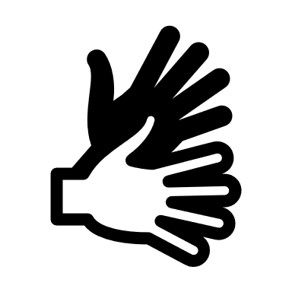

By the end of today, you would have checked your phone almost **100 times** and touched it **2600 times**!

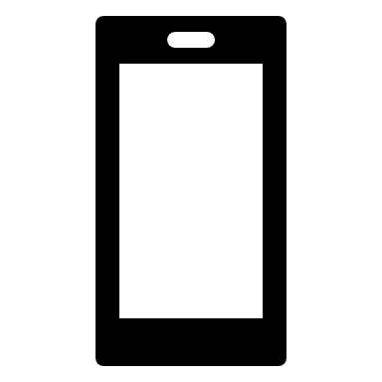







At a time when **Coronavirus** is being spread quite quickly, we want to **protect** ourselves as much as we can.

We have all been told that standing **2 metres apart** and **washing** our hands regularly can stop us from catching or spreading the virus.

However, is close contact and dirty hands the only **danger**?

Our **Smartphones** play a huge part of our lives and help us in many ways but they can also be **dangerous** if we are not careful.



***Just imagine……*** 

You are in Tesco shopping, and you have grabbed your trolley or basket.

  

You pick up some bread, milk, cereal, fruit and nice treats. While shopping, you check your phone to see what time it is, what is happening on tik tok, make or answer a phone call or even to take a photo of the large queue while people stand 2 metres apart!



Once you get home, you wash your hands with soap and warm water for 20 seconds knowing how many people have touched the same things that you have.





With those nice clean hands, you jump on the sofa and swipe your smartphone which still contains all the **bacteria** from your trip at the supermarket. You now have plenty of bacteria that can easily **transfer** to your **nose, mouth or eyes** because we touch our faces as much as our phones!







In many cases this may be harmless but in some cases it could make us **very ill**.

******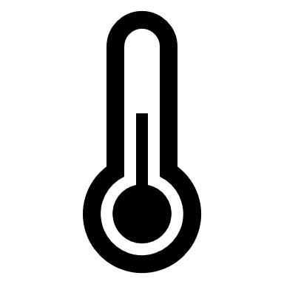



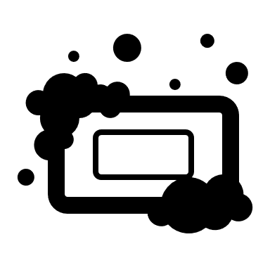

***So, what can we do?***

By cleaning our phone at least **twice a day**, once at lunch and once at dinner time, we can keep ourselves **safe**.

We must also clean our phones once we have arrived home if we have used our phone in a public place.



***How***

Remove the phone from your protective case.

Dampen a cloth with **warm water** and **soap** and gently rub your phone.

Some substances can harm the protective layer on your screens so a damp cloth that has normal soap and water will do just fine!

Be careful that you don’t get any moisture into entry points such as where you charge your phone as this could cause damage.

***And remember…..***

This doesn’t just apply to phones but also other things that are with us every day such as our **keys, wallets and purses**.

Make sure you wipe your keys, wallet and purses in a similar way.

  

**Follow precautions & Stay Safe!**

Do you have any worries, anxiety or concerns? Contact Sarb, your Health, Wellbeing and Pastoral Lead at **sarbjit.singh@ghc.rmt.org**

