Listen to music

Relax
Get creative
MINDFULNESS

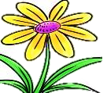
Activity Booklet

Plant

Talk with family and friends
Exercise

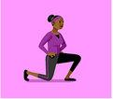

Contents:
- Introduction to mindfulness- Page 3
- Tips to help you practice mindfulness- Page 4
- Activity Log- Page 5

- Session 1- Your emotions, feelings and thoughts
    - Introduction- Page 6
    - Match the Emotions- Page 7
    - Emotions Fan- Page 8-9
    - My Feelings Chart-Page 10
    - I Am An Amazing Person! - Page 11

- Session 2 Mindfulness Practices
    - Introduction- Page 12
    - My Goals- Page 13
    - Question Time- Page 14
    - Name the story- Page 15
    - Mindfulness Challenges- Page 16
    - Movement Break- Page 17
    - Yoga- Page 18
    - Breathing Exercises- Page 19
    - Sensory Play- Page 20-26
    - Mindfulness Moments- Page 27

- Session 3 Mindfulness and Technology
- Introduction- Page 28
- Online resources- page 29

Introduction
Mindfulness is the practice of paying more attention to the present moment (what’s happening right now). The idea is to sit somewhere comfortable and quiet, in order to take the time to relax and think about your own thoughts and feelings.

Mindfulness is also about:

▪ Being positive when sharing your thoughts and emotions

▪ listening to other people’s thoughts and emotions

▪ Understanding when you should ask for help

▪ Understanding how to use different relaxing practices E.g. yoga

▪ Being creative, leaning new things and enjoying the moment

This activity book has been put together by the Occupational therapy team, to help give you a few ideas of how you can practice mindfulness; either on your own or with other people.

A five or ten-minute daily mindfulness practice can help to reduce stress and anxiety, increase concentration and engagement, improve social skills and develop problem-solving and decision-making skills. The benefits of mindfulness can be different for all; the more you practice the better you get.

If you would like any more information or if you have any questions, then please feel free to email the OT team on: OccupationalTherapy@portland.ac.uk

We hope you enjoy

Tips to help you practice mindfulness

Mindfulness is not something you can learn in one day; it takes time and lots of practise. Using these tips as a guide, may help you on your mindfulness journey.
Start each day as a new day
If you had a bad day the day before, leave that behind you (don’t keep thinking about it). How can you change any mistakes or avoid situations that made the other day bad?

Organize yourself
Make a to-do list; either at night or in the morning. It will keep you organized and make your daily routine easier to manage. It does not matter if you do not complete everything on your to-do list (there is no rush!).

Prepare the environment
Whether this is inside or outside, you can create a safe space anywhere to complete your mindfulness activities. By adding pillows, fairy lights, pictures or even putting on a bit of music, can help you to create a space that makes you feel comfortable to spend time in.

Be Kind to yourself
We have all had times when we have thought, “I’m not good enough”. Stop, take time to reflect and replace these thoughts with “I’m enough, just as I am”. You could even write down your achievements or happy thoughts, in a diary and go back to these when you need a quick mood booster (cheering up).
Take good care of yourself.
Share your experiences
Take time to talk with those around- face to face or on the telephone. Talking to those around, can be really helpful for all (helps others understand how you are feeling/helps you understand how others are feeling).

Activity Log

Keeping a log of various mindfulness activities/exercises you have tried can help you keep track of what works for you.

Below is a table that you can fill in, with an example of a mindfulness log.

Rating scale: 0 = did not enjoy/was not help 10 = really enjoyed/was helpful

Date | Mindfulness activity/exercise I completed | How long I engaged in it for | How I felt before (scale 1-10) | How I felt afterwards (scale 0-10)
1/1/20 | Breathing exercise | 5 minutes | 3 | 7

Your Emotions, Feelings and Thoughts
SESSION 1

I Am An amazing person!
Read and finish the sentences in the balloons below.
- Emotions can play an important role in how we think and what we do.

- We can show our emotions to others verbally (talking) or non-verbally (facial expressions).

- It is good to be able to understand our emotions so that you can tell others how you are feeling

- The emotions we feel can change how think about ourselves, how we behave and the decisions we make

- Sometimes we might need help

- Managing your emotions takes practice

The following activities will hopefully help you to start thinking about your emotions and how to make positive choices.

Match the Emotions

Match the words to the correct sentence- Sad, Happy, Angry, Excited

Dave was watching his favourite football team play football. Dave went to get a drink from the kitchen, and when he returned, he saw that the other team had scored. His team had lost!
This made Dave feel…
Clare had been waiting for a call, as she had been for a job interview the day before.
The phone rang, it was the manager from the new job. After talking on the phone, Clare started smiling and jumping up and down- she had got the job and will start tomorrow.
Clare is feeling…

Tom was playing in the garden with his brother. Tom was running around really fast trying to catch his brother and did not see that his lace had come undone. As he was running, Tom fell over and hurt his knee.
Tom is feeling…
After work it was time to go home. Sarah could not find her car keys, so started searching her desk and pockets. Sarah’s friend noticed that they were on the floor and picked them up for Sarah. This made Sarah…

Emotions Fan

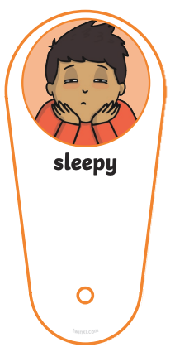
This is an emotions fan that you can cut out to use for the next activity. You can also use this fan, to help you to communicate how you are feeling to others around you. There are also blank ones, so you can think/draw your own emotions fans

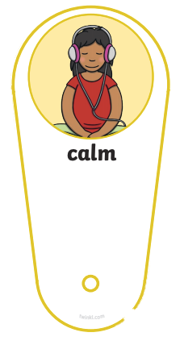

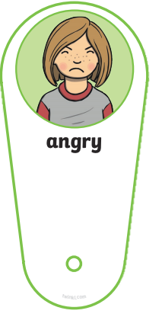

My Feelings Chart

Use this chart to write down how you feel, what happens when you feel like this and things that might help you deal with this emotion. You do not have to fill it all in now, you can go back to it as and when things happen. An example has been given.

When I feel… | This is what I do | This is what helps me
Angry | I may shout, feel hot, throw things, tell others to leave me alone | Quiet time alone, listening to music, playing on the IPad, talking to others when I am ready
I AM AN Amazing Person!
Read and finish the sentences in the balloons below
I am a good friend because…
I am really good at…
I am a good brother/sister because…
My special talent is…
My best joke to tell is…
I am unique because…
I am proud of myself when…
Other people say I am…
I am thoughtful because I…
Today I am feeling…
My favourite time of the day is…

SESSION 2
Mindfulness Practices
Don’t try and rush the activity.
Exercise indoors/outdoors

Socialise with friends/family.
Learn how to cook, play tennis, sew

Take small steps when practising mindfulness. No one is perfect

We can practice Mindfulness at any time and in any place; it all depends on the type of activity you wish to try, and whether you wish to complete it with other people or on your own. Engaging with different activities can help your body and mind feel more relaxed, as well as help you to build your confidence.

There are a range of activities you can try, such as breathing activities, painting, exercise and even sitting quietly and reading.
The following pages will help you with ideas of things you can try (remember to keep a log of the ones you liked/disliked, so you know for next time, which ones to try again)

My Goals

Having goals can be helpful, as it allows us to think about things we would like to achieve- now and in the future (for example, Goal-I would like to get a job, so maybe I should try and work on my communication skills).Don’t be scared to try new things, and it is okay if things do not always work out straight away. Use the images below to write down a few ideas.
Things I am good at?

Question Time
What will help me reach my goal?
What do I want to get better at?
Cut these questions out, stick them in a jar ad take it in turns with your family to answer these random questions.
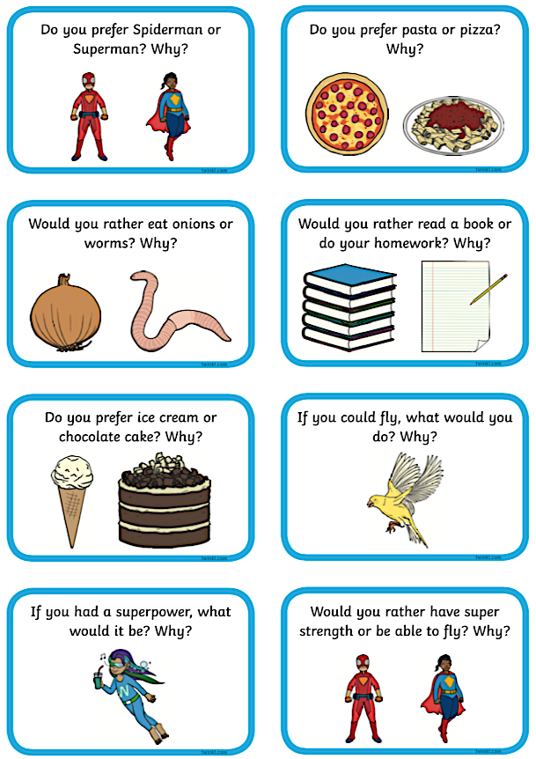

Name the story
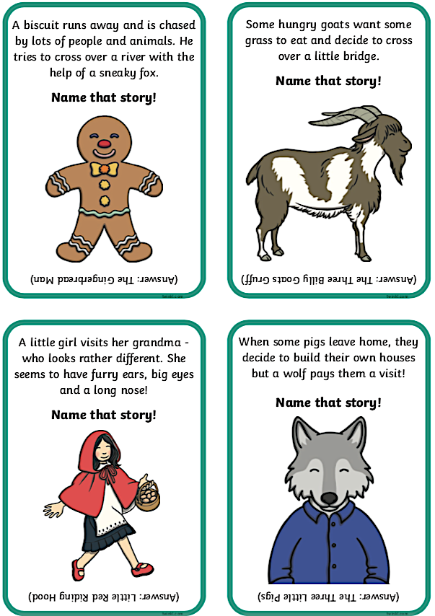
Use the clues to guess the name of the story

Mindfulness Challenges
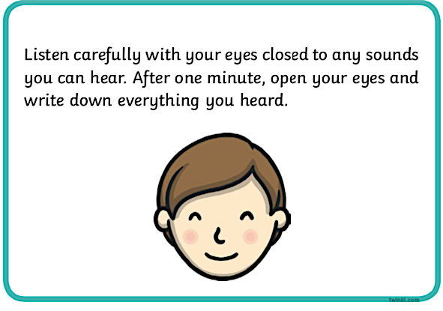
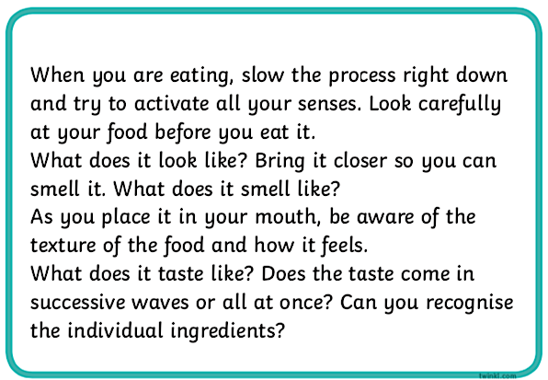
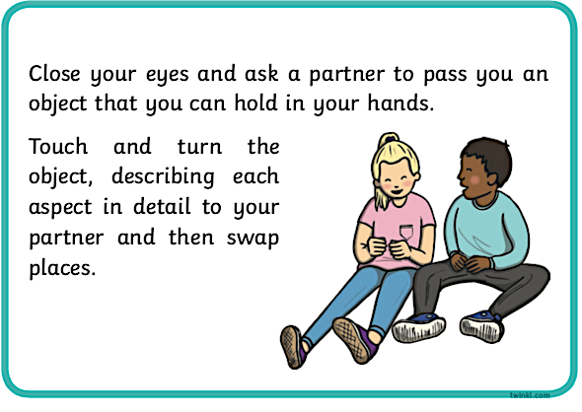
Movement Break

Have a break from whatever you are doing, and get moving
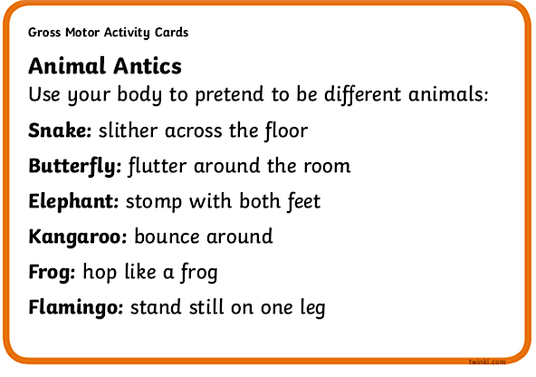
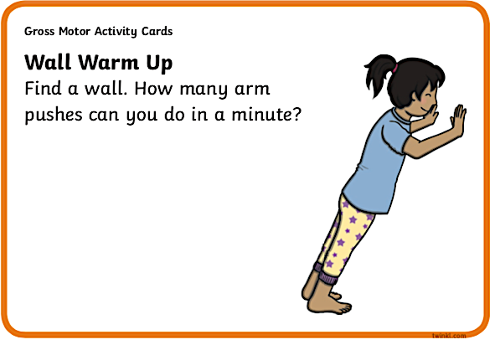
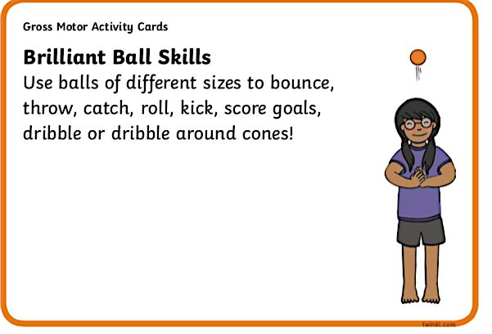
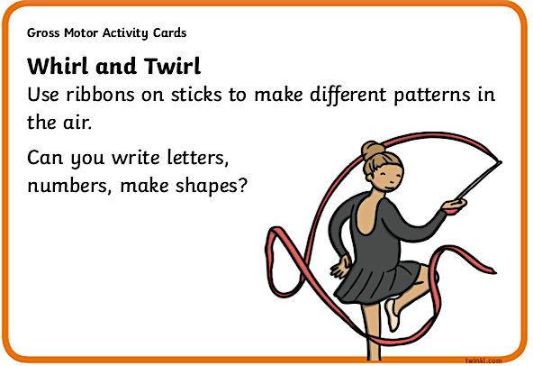
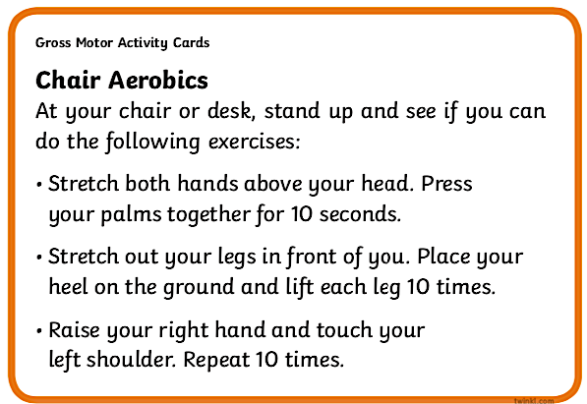
Yoga

Find a space indoors or in the garden and get moving. Yoga is about stretching and moving slowly.
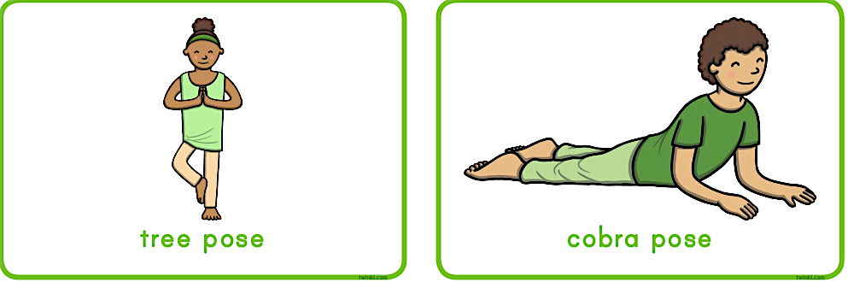

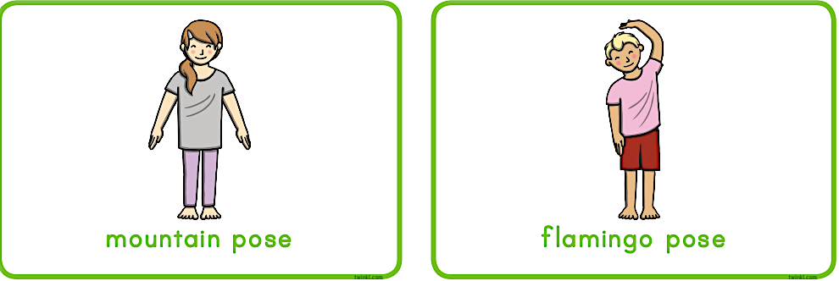
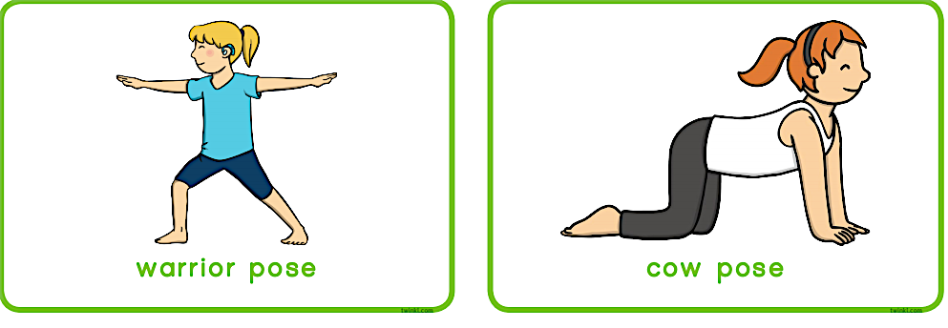

Breathing Exercises

Relaxation can help you find balance and feel better about yourself. Everybody has their own way of relaxing

Bumble Bee Breaths

Open your hands out with the palms facing towards your face. Place your thumbs over your ears and your fingers over your eyes. Close your mouth with your teeth slightly apart. Breath in through your nose. Count silently 1,2,3,4,5.
Breath out slowly through your mouth and make a humming sound like a bee. Count silently 1,2,3,4,5.
Starfish Breaths

Sit on the floor with your legs comfortably crossed in front of you. Open your left hand as wide as you can so it looks like a starfish. Using your pointer finger on your right hand, run your finger up and down each finger of your starfish (left hand). Start at the thumb and move up and down each finger till you reach the little finger. Breath in as you go up and out as you go down. Switch hands when finished.
Balloon Breaths

Sit comfortably on the floor with your legs crossed in front of you. Imagine that there is a big balloon in your stomach. Place your hands over your stomach. Take a deep breath in, sit up, and make you stomach puff out as if it was a balloon filling with air Then breath out. As you breath out, slowly roll your shoulder backwards.
Butterfly Breaths

Sit on the floor with the bottom of the feet touching and knees bent out to the sides. Put your hands on your ankles or knees and gently bounce your knees up and down as if you were flapping your wigs. Close your eyes and breathe slowly and calmly. Pretend you are flying to your favourite place in the world. Imagine what it looks like. What do you see? What do you hear? Now it’s time to return home. Stretch your arms out and slowly open your eyes.
Rainbow Breaths

Stand with your feet shoulder width a part, arms gently resting by your sides. Slowly raise your arms and take a deep breath in (you can close your eyes if you wish. Try to breathe in until your hands reach each other above your head. Breathe out slowly while lowering your arms. Try and imagine you are creating a rainbow above your head. Think about how many colours you wish to add- repeat the same steps above 5-10 times. Once your rainbow is done open your eyes.
Waves on the Ocean Breaths

Lie back gently on the floor with your feet out in front of you. Place your hands on your stomach. Breathe in through your nose and feel your hands rise up. As you slowly exhale, feel your hands rise up. As you slowly breath out, feels your hands go down. Pretend your stomach is waves in the ocean and your hands are boats. Each time you breath in the oat goes up on the wave and each time you breath out the boat goes down.

Sensory Play
Sensory play is about exploring your senses and having fun. The body has many senses, the main ones being touch (feeling textures), smell, taste, hearing, seeing, moving and balance.
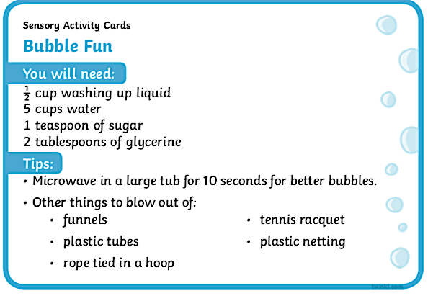

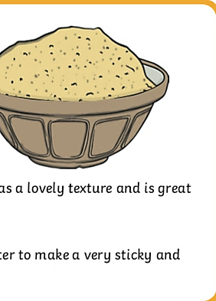

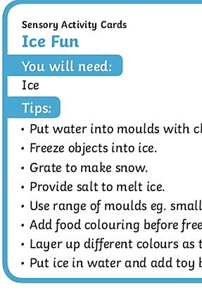

Sensory Play with Jelly

What you will need:
You will need jelly of course! You will also need an assortment of plastic containers of all shapes and sizes, ice cube trays and a large tray or container to put all the jelly mess in for playtime. Do the night before.

Mess Free Painting

What you will need:

- Paint
- Scissors
- A food bag
- Paper or card
- Scissors
- Tape (masking tape)

Method:

- Place the card or paper in the food bag
- Squeeze some of the paint into the bag
(as many colours as you wish)

- Carefully squeeze any air out of the back
and seal it closed (try and not squash any paint)

- Cut a few pieces of tape with the scissors
- Stick the bag to your workstation
(this helps to keep the bag still, however, this step is not important- if you don’t have any tape)

- Start squashing the paint

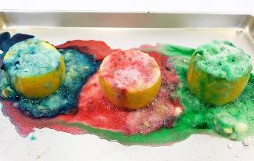
Lemon Volcano Experiment

Do this experiment with support-
This is not a real volcano, it just creates lots of frothy bubbles

What you will need:

- Lemons
- Baking soda
- Food colouring
- Craft stick (something to make a hole in the lemon)
- Washing up Liquid
- Tray
- Cup and spoons

Method:

- (adults only) make a hole in the lemon or cut the lemon in half and place on a tray

- Use a craft stick to mush the centre of the lemon (just until soft)

- Get another lemon and squeeze the juice into a jar

- Place a few drops of food colouring into the centre of the lemon

- Add in a good squeeze of washing up liquid. (you can miss this step if you wish-this helps to make more bubbles)

- Add a spoonful of baking soda. It should start to fizz. Use the lemon juice in the jug and more baking soda to keep creating bubbles

Follow this link to watch a video if you need any help-
https://youtu.be/ju8QibKPMp0

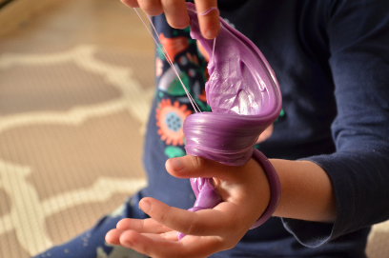
Silly Stretchy Putty
Edible Sensory Recipe

You will need:

- Cornflour
- Smooth yoghurt- any flavour
- Bowl or tray

Method:

- Mix 1 cup of yoghurt and 1 cup of cornflour together

- Keeping mixing until firm. Add more cornflour or yoghurt as needed

- Knead the dough until it is the consistency of stretchy putty

- Enjoy the stretchy, sticky dough!

Note: Although this recipe is safe to explore and taste with your mouth (if you wish), it is not intended to eat in large quantities

This recipe should not be stored to re-use another time

Calm down sensory jar

When you have made this calming jar, there is a script to read on the next page

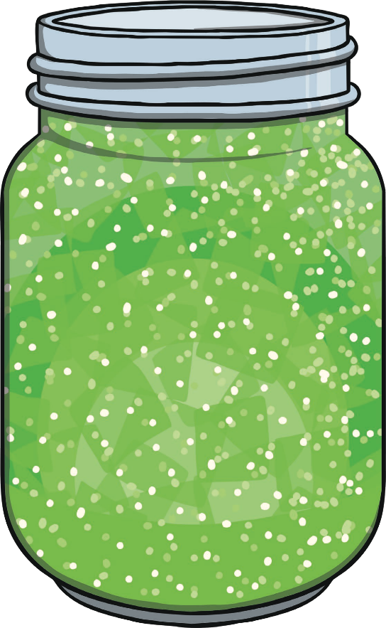

You will need: A jar or bottle, Glitter, Glitter glue, Gel food colouring, Warm water

Method:

1. Add the water to your jar until it is approximately a third of the way up.

2. Add the glitter glue into the warm water and whisk together, until combined.

3. Add a few droplets of the gel food colouring. (Keep in mind to use this sparingly as too much colouring will make the glitter harder to see).

4. Let’s get glittery! Add as much glitter as you wish. You can add chunky glitter or fine glitter, or both!

5. Top up your jar with the rest of the warm water, keeping a small gap near the top.

6. Shake, shake, shake!

Script for the calming jar

Get the person to shake the jar, before you read this script

“Imagine that the glitter is like your thoughts when you’re stressed, mad or upset. See how they whirl around and make it really hard to see clearly? That’s why it’s so easy to make (irrational, inappropriate, incorrect) decisions when you’re upset – because you’re not thinking clearly. Don’t worry this is normal and it happens in all of us.
[Now put the jar down in front of them.]
Now watch what happens when you’re still for a couple of moments. Keep watching. See how the glitter starts to settle and the water clears? Your mind works the same way. When you’re calm for a little while, your thoughts start to settle, and you start to see things much clearer”

Magic Moments

A collection of magic moments to make you smile.
Imagine a place you can go to when you are feeling stressed or down, or when things are feeling tough. Imagine a place full of special notes- reminding you of how great you are, helping to give you ideas of things you could do on a rainy day. You can make your own magic moments jar or even get a big jar and fill it up as a family.

How to make a magic moments jar

- Get a clean jar (big or small) with a lid. If it already has a label on it you can stick your own label on top or soak the jar in hot soapy water.

- Make a label for your jar- You don’t have to call it a magic moment jar

- Add a little ribbon or glittery stars to make your jar super special

- Begin to collect special notes, drawings (anything) that is meaningful to you. Place them in the jar, ready to take out and read whenever you are feeling low or if you need ideas of activities to do.

Mindfulness and technology
SESSION 3

Using technology is not always bad thing. There are plenty of online resources, videos and apps that you can use to help you search for information on how to practice mindfulness. However, you must be safe when using the internet and accessing different websites always ask for help from a parent/carer if someone is being cruel online or if you are unsure about anything-(do not give out any personal information-name, age, address, telephone number).

You have also probably been told plenty of times that ‘you spend too much time on your phone, IPad or computer’. If this is true, then one way to help, is to set a timer so that you know when to have a break and do a different activity away from technology.

The following page will give you a list of useful apps, and websites that you can try.

Online resources
- Storyline Online- This website is for those that love a good story but maybe you enjoy it more when someone else is reading. Click on a book and the video will begin on YouTube. Free on certain books
https://www.storylineonline.net/
- FunBrain- This website has games, a learning zone, videos on different topics and a reading area
https://www.funbrain.com/games

- Smiling Mind- (app) offers hundreds of mindfulness activities for all ages. In addition to breathing meditations, it also has sensory exercises, listening to music. The app has many options, so support may be needed to explore it. The creator is Australian so there will be an Australian voice. Its Free
- Headspace- (app/online as well) has fun cartoons to teach meditation and how to train mind to relax. This is free to try (subscribe with email address) but you have to pay monthly to access other things. If you type headspace into YouTube you can find some of the videos on there.

- YouTube- Has plenty of videos on mindfulness, and yoga. There are some animated ones such as cosmic kids (uses lots of animated backgrounds) https://www.youtube.com/watch?v=obzFP6eEGAg
- Or there is a simpler one that uses a plain background (less distracting) https://www.youtube.com/watch?v=t3joHNOOyYY

- If you are struggling to concentrate when practising one of the mindfulness breathing activities, there are videos online. There is also relaxing music that can help you to feel calm and relaxed https://www.youtube.com/watch?v=qFZKK7K52uQ
- If you fancy doing some more sensory crafts or experiments then learning4kids is the website to visit https://www.learning4kids.net/list-of-sensory-play-ideas/

Offline: Create your own books, draw, listen to music, create your own board games- there is plenty to do.

