MICROSOFT TEAMS ON YOUR TABLET/MOBILE DEVICE
- You will need to download the Microsoft Teams App for your device. This can be found by searching the App Store (Apple)/Play Store (Android) for ‘Microsoft Teams’ . This is a free download.
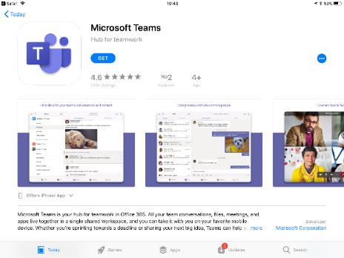
- You will receive an email with a meeting request. When it is time for the meeting. Click on ‘Join Microsoft Teams Meeting’ under the meeting information (see blue arrow)
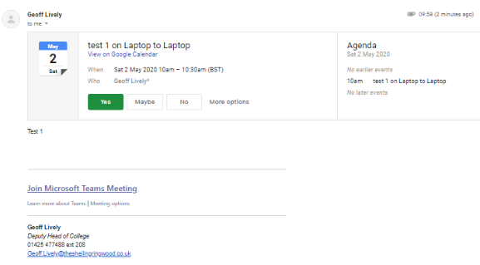
- This will take you to the below screen in your App. Click Join as guest (unless you already have Microsoft Teams and are familiar with it)
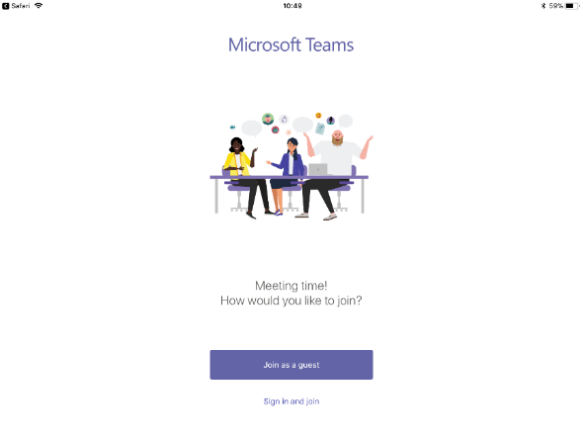
- In order to be seen and heard on the meeting you will need to activate your microphone and camera. The following screen should appear requesting this. If you do not see this you can activate once in the call. Click OK.
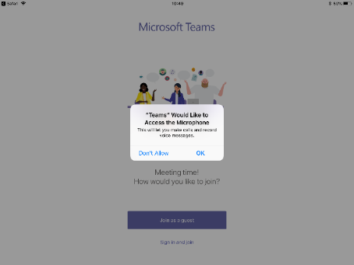

- You will then be asked to input your name. Once you have done this click ‘Join meeting’
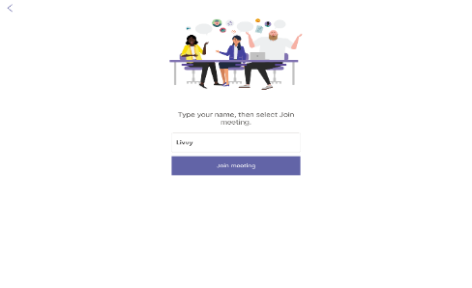
- You will then see the following screen. The meeting chair will need to allow you access to the meeting. Please note that in the screen shot below the microphone and video haven’t been activated. This can be activated by clicking on the microphone and speaker icons on the toolbar at the bottom on the screen.

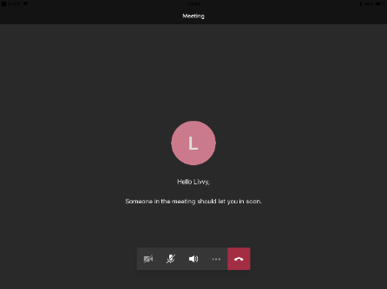

- You will then we able to see yourself and the meeting chair on your screen. You will be in the bottom right.
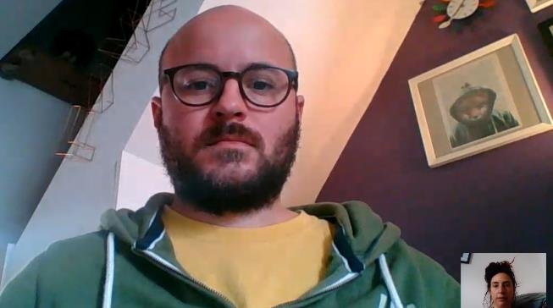
- If you click on the screen, a tool bar will appear with additional useful clickable features.
Opens chat facility
(see right of screen)
Turns audio on and off
Turns video on and off
Ends call

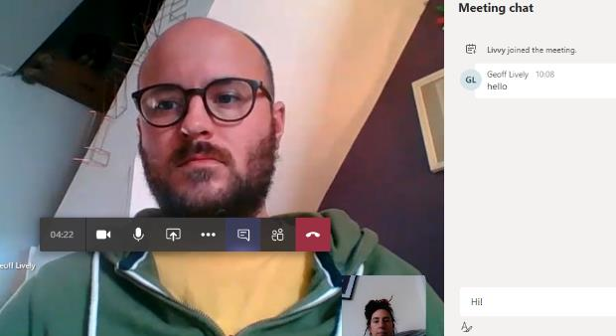
- Calls will be recorded which is why you will see a recording icon on the screen.
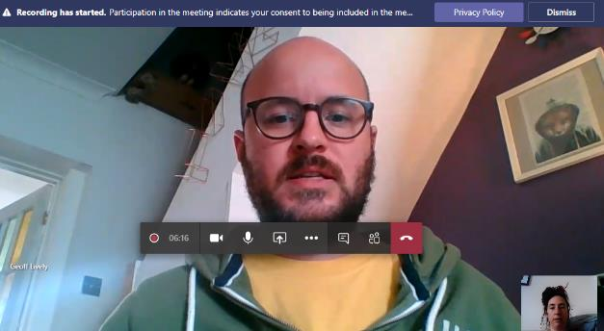
- When you are finished, simply hang up the call by clicking the end call symbol.

