MICROSOFT TEAMS ON YOUR COMPUTER
- You will receive an email with a meeting request. When it is time for the meeting. Click on ‘Join Microsoft Teams Meeting’ under the meeting information (see blue arrow)
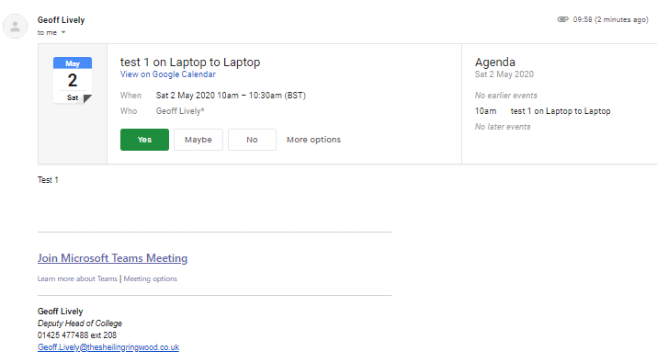
- This will take you to the below screen, if you do not have the app or wish to download the App, click on ‘Join on web instead’
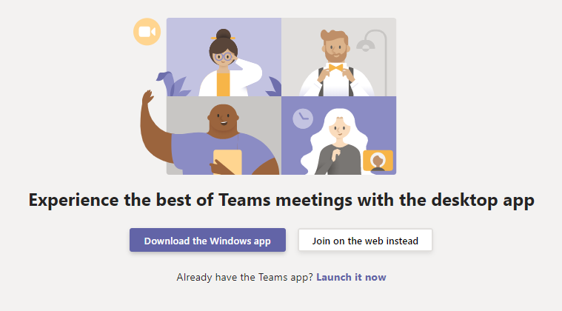
- In order to be seen and heard on the meeting you will need to activate your microphone and camera. The following screen should appear requesting this. If you do not see this you can activate once in the call. Click Allow.
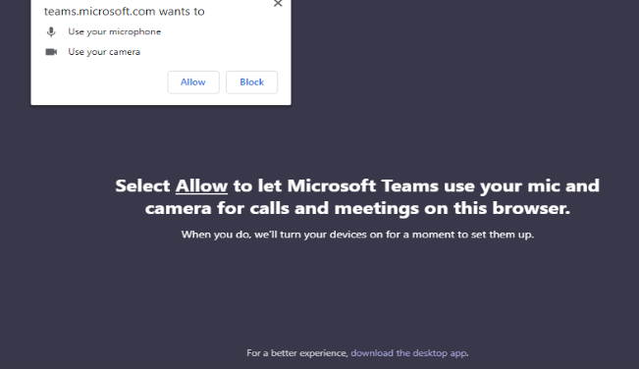
- You will then be asked to input your name. Once you have done this click ‘Join now’
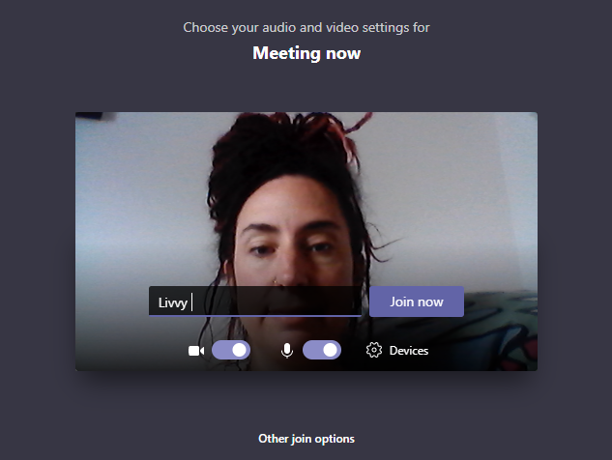
- You will then see the following screen. The meeting chair will need to allow you access to the meeting.
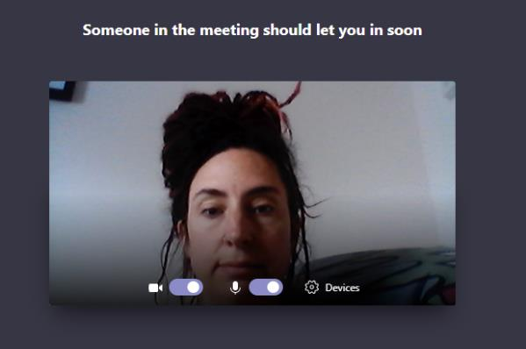
- You will then we able to see yourself and the meeting chair on your screen. You will be in the bottom right.
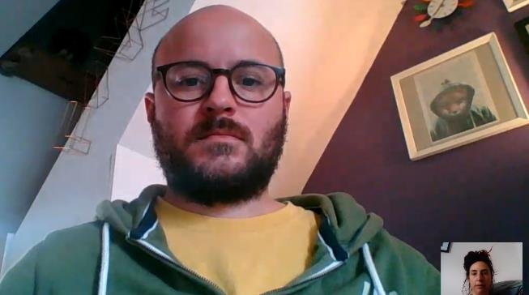
- If you scroll your curser onto the screen, a tool bar will appear with additional useful clickable features.
Opens chat facility
(see right of screen)
Turns audio on and off
Turns video on and off
Ends call

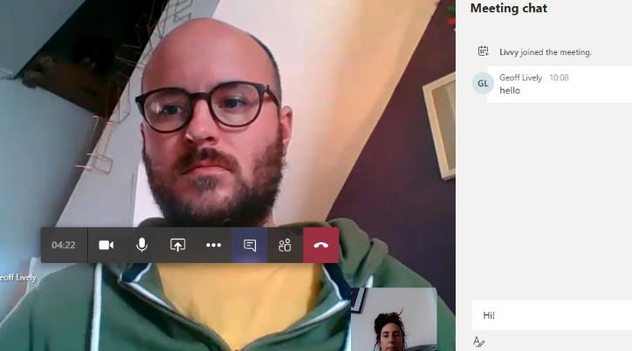
- Calls will be recorded which is why you will see the below on your screen.
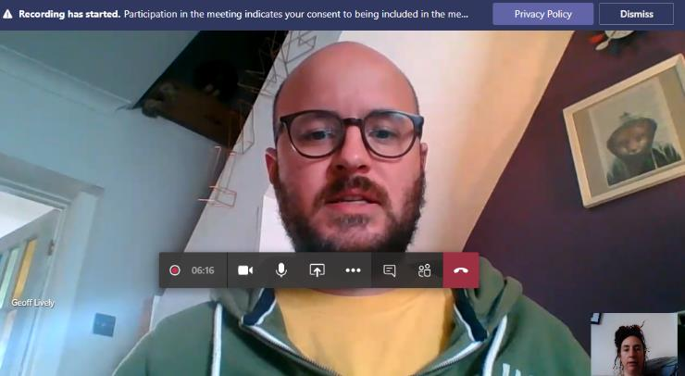
- When you are finished, simply hang up the call by clicking the end call symbol.

