The date today is ______________________.
(e.g. 10 May 2020 or 10.05.20)

I started this Rainbow craft pack on ______________ (day of the week) in the morning / afternoon.

I started work at _____ o’clock.
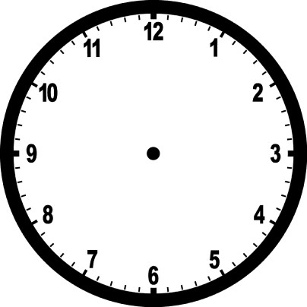 | Draw the hand and minute hands on the clock to show the time below

Rainbow Heart Card
Maths skill: Measure different lengths
Questions for young person to answer | Parent/Carer Feedback Tick which one is relevant
Can you cut out the measuring bar on the next page and use it to measure wool/string of 8cm to 10cm ? Can you put the measuring bar at the left side of the paper? | - With lots of support  - With a prompt  - Can do independently
Can you mark where 8 cms along is? | - With lots of support  - With a prompt  - Can do independently
 | Comments (Optional)

1 | 2 | 3 | 4 | 5 | 6 | 7 | 8 | 9 | 10

Rainbow Collage
Maths skill: Measure different lengths
Questions for young person to answer | Parent/Carer Feedback Tick which one is relevant
Can you cut out the measuring bar on the next page and use it to measure the gap between the lines (of 2 cms apart)? Can you put the measuring bar at the left side of the paper? | - With lots of support  - With a prompt  - Can do independently
Can you mark where 2 cms along is? | - With lots of support  - With a prompt  - Can do independently
 | Comments (Optional)

Questions for young person to answer | Parent/Carer Feedback Tick which one is relevant
Can you mark each strip 2 cms along? | - With lots of support  - With a prompt  - Can do independently
 | Comments (Optional)

1 | 2 | 3 | 4 | 5 | 6 | 7 | 8 | 9 | 10

Questions for young person to answer | Parent/Carer Feedback Tick which one is relevant
Can you mark each strip 2 cms along? | - With lots of support  - With a prompt  - Can do independently
 | Comments (Optional)

1 | 2 | 3 | 4 | 5 | 6 | 7 | 8 | 9 | 10

Rainbow Button picture
Maths skill: I can fill in the missing numbers in a sequence.

3 | 4
2 |  | 4
1 |  |  | 4

Parent/Carer Feedback Tick which one is relevant | Comments (Optional)
- With lots of support
- With a prompt
- Can do independently

Maths skill: I can place a jumbled sequence of numbers in order.
Smallest Largest
10 | 8 | 9 | 7

4 | 1 | 3 | 2

five | eight | six | seven
one | four | two | three

Parent/Carer Feedback Tick which one is relevant | Comments (Optional)
- With lots of support
- With a prompt
- Can do independently

Maths skill: I can match numbers in words and digits.

one 10
4
seven 7
ten 8
nine 2 six
Eight 1
two 9

Four 6
Parent/Carer  Feedback  Tick which one is relevant | Comments (Optional)
- With lots of support
- With a prompt • Can do independently

Maths skill: Put the numbers in size order from 0 to 10.

 | 1 |  |  |  | 5

Parent/Carer Feedback Tick which one is relevant | Comments (Optional)
- With lots of support
- With a prompt
- Can do independently

Rainbow Wool Tassels
Maths skill: I can understand the properties of shape

Name | Shape | Number of sides | Number of corners | 2 dimensional or 3 dimensional)
 |  |  | 4 | 2D
 |  |  | 4 | 2D
 |  | 0 |  | 2D
 |  | 12 | 8 | 3D

Parent/Carer Feedback Tick which one is relevant | Comments (Optional)
- With lots of support
- With a prompt
- Can do independently

Rainbow Wool Tassels Bookmark
Maths skill: reading numbers
Questions for young person to answer | Parent/Carer Feedback Tick which one is relevant
Can you read the following numbers in digit form?  15 | - With lots of support  - With a prompt  - Can do independently
Can you read the following number names? fifteen | - With lots of support  - With a prompt  - Can do independently
 | Comments (Optional)

Rainbow Wool Tassels keyring
Maths skills: I can add and subtract numbers
Questions for young person to answer | Parent/Carer Feedback Tick which one is relevant
Work out the following:  You’ve got 1 bead. You thread on another 2. How many beads do you have altogether?  1 + 2 =  Check this on a calculator | - With lots of support  - With a prompt  - Can do independently
You’ve got 10 beads in a pot. You take out 3 to use. How many beads do you have left?  10 – 3 =  Check this on a calculator | - With lots of support  - With a prompt  - Can do independently
 | Comments (Optional)

Pom Pom using a pom pom maker
Maths skills: I can understand positional language
Use the following words to complete the sentences: in between, first or second.

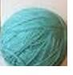

The wool is ________________ arch 1 and arch 2.

The arch is first in the line. True or false? __________________

The arch is second in the line. True or false? ____________________

Parent/Carer Feedback Tick which one is relevant | Comments (Optional)
- With lots of support
- With a prompt
•
- Can do independently

Pom Pom Garland
Maths skills: use mathematical vocabulary to state the length of an object
Questions for young person to answer | Parent/Carer Feedback Tick which one is relevant
Can you put the wool along the edge of the ruler? | - With lots of support  - With a prompt  - Can do independently
Can you move the ruler along the wool so that the 1cm mark is where the first ruler ended? Can you do this again? | - With lots of support  - With a prompt  - Can do independently
Can you measure 10cms more of wool? Can you cut the wool at 100cms (100cms is 1m)? | - With lots of support  - With a prompt  - Can do independently
Answer the following  The wool is a little longer than ____ rulers. | - With lots of support  - With a prompt  - Can do independently
 | Comments (Optional)

Pom Pom Wreath
Maths skills: Compare familiar objects in terms of capacity
Questions for young person to answer | Parent/Carer Feedback Tick which one is relevant
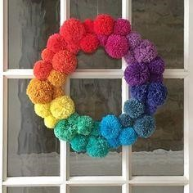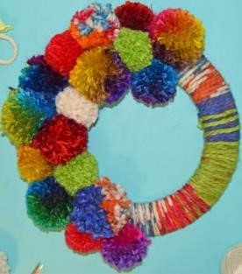  A B C | - With lots of support  - With a prompt  - Can do independently
Which wreath has the most amount of pom poms on it?

Which wreath has the least amount of pom poms on it? | - With lots of support  - With a prompt  - Can do independently
 | Comments (Optional)

Pom Pom and Tassel Rainbow Garland
Maths skills: use mathematical vocabulary to state the length of an object
Questions for young person to answer | Parent/Carer Feedback Tick which one is relevant
Can you put the wool along the edge of the ruler? | - With lots of support  - With a prompt  - Can do independently
Can you move the ruler along the wool so that the 1cm mark is where the first ruler ended? | - With lots of support  - With a prompt  - Can do independently
Can you measure 20cms more of wool? Can you cut the wool at 50cms? | - With lots of support  - With a prompt  - Can do independently
Can you repeat the process two times but this time measure 10cms more of wool?  30cms + 30cms + 10cms = ___________ Can you cut the wool at 70cms? | •
Can you repeat the process three times? 30cms + 30cms + 30cms = ___________ Can you cut the wool at 90cms? | - With lots of support  - With a prompt  - Can do independently
 | Comments (Optional)

Maths skill: use mathematical vocabulary to state the length of objects. Compare the length of objects.
Questions for young person to answer | Parent/Carer Feedback Tick which one is relevant
What objects are on the longest length of wool? The tassels or the beads? | - With lots of support  - With a prompt  - Can do independently
Does the shortest length of wool have the beads on it? Yes or no? | - With lots of support  - With a prompt  - Can do independently
 | Comments (Optional)

Rainbow tote bag
Maths skills: shape recognition
Questions for young person to answer | Tick which one is relevant
What 2d shape is each rainbow stripe? Arch or hexagon? | - With lots of support  - With a prompt  - Can do independently

Dandelion Rainbow Fingerprint Picture
Maths skill: Use the vocabulary of capacity to identify familiar objects.
Questions for young person to answer | Parent/Carer Feedback Tick which one is relevant
You collect the piece of equipment below:  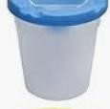  Can you name the item? | - With lots of support  - With a prompt  - Can do independently
 | Comments (Optional)

Maths skills: Compare familiar objects in terms of capacity.
Questions for young person to answer | Parent/Carer Feedback Tick which one is relevant
You pour out paint into 2 different water pots  A B Which has the least amount of paint? | - With lots of support  - With a prompt  - Can do independently
 | Comments (Optional)

Maths skills: adding numbers
Questions for young person to answer | Parent/Carer Feedback Tick which one is relevant
Complete the following sum for the number of paints you might use:  3 + ________ = 7  Check it on a calculator | - With lots of support  - With a prompt  - Can do independently
 | Comments (Optional)

Rock Painting in Bright colours
Maths skill: reading numbers
Questions for young person to answer |  | Parent/Carer Feedback Tick which one is relevant
Can you read the following numbers in digit form? 3, 5, 10 |  | - With lots of support  - With a prompt  - Can do independently
Can you read the following number names?  Three, five , ten |  | - With lots of support  - With a prompt  - Can do independently
Can you draw a line from the number in digit form to its number name each time?
3  10  5 | five  Three  ten | - With lots of support  - With a prompt  - Can do independently
 |  | Comments (Optional)

Maths skill: Order items from smallest to largest
Questions for young person to answer | Parent/Carer Feedback Tick which one is relevant
Complete the following statements about the tray and pots in your pack e.g. the tray is larger than the pot  ____________ is larger than____________  ____________ is smaller than____________ | - With lots of support  - With a prompt  - Can do independently
 | Comments (Optional)

Rainbow Sponge painting
Maths skill: I can understand the capacity of an object
Questions for young person to answer | Parent/Carer Feedback Tick which one is relevant
How many drops of paint did you use? | - With lots of support  - With a prompt  - Can do independently
 | Comments (Optional)

Maths skill: I can identify the position of objects.
Use the following words to complete the sentences: next to, above or under.
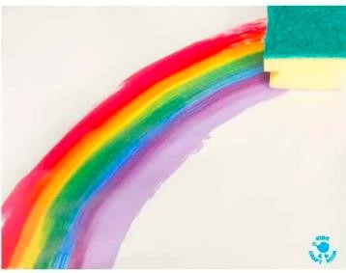
1

2

The second rainbow print is _______________________________________
the first rainbow print.

3

1

The third rainbow print is _____________________________________ the first rainbow print.

Parent/Carer Feedback Tick which one is relevant | Comments (Optional)
- With lots of support
- With a prompt
- Can do independently

Maths skill: understand more and less
Questions for young person to answer | Parent/Carer Feedback Tick which one is relevant
Do you need to add more or less paint ?  More  Less  (circle the correct word) | - With lots of support  - With a prompt  - Can do independently
 | Comments (Optional)

Rainbow String painting
Maths skill: I can order items.
You did your painting in this order.
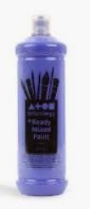
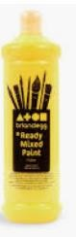
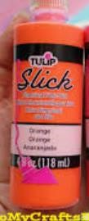
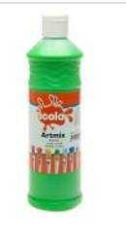
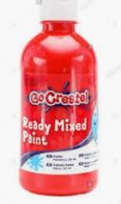
orange

1 2 3 4 5

Tick whether the following statements are true or false:
false
- The red paint is the 4th item true

false
- The orange paint is the 2nd item true

false
- The blue paint is the 5th item true

Parent/Carer Feedback | Comments (Optional)
Tick which one is relevant
- With lots of support
- With a prompt
- Can do independently

Maths skill: I can weigh objects
Object | Heavy | Light
1.

Complete the following sentences by filling in the gaps using the names of the objects and heavier or lighter:

1. The _______________ is _______________ than the _______________

Parent/Carer Feedback Tick which one is relevant | Comments (Optional)
- With lots of support
- With a prompt
- Can do independently

Please get someone to take photos of you completing the above tasks and email them if possible to jguthrie@rnibcollege.ac.uk
Once completed please send this form back in the envelope provided in your craft pack or send by email to jguthrie@rnibcollege.ac.uk. Jo Guthrie (Maths Tutor)

Support completed Signed: Date: _________________ (parent/carer) _______________________________________________________________
Student Name/signature: Date:

Assessment (Maths Signed: _______________________________________________________ Date: _________________
Tutor)

Feedback by Maths Tutor

