I started this Rainbow craft pack on __________________ in the morning/afternoon.
(day of the week)
Choose from
Monday Thursday Sunday
Tuesday Friday
Wednesday Saturday

Rock Painting in Bright colours
Maths skill: counting
1 | 2 | 3 | 4 | 5 | 6 | 7 | 8 | 9 | 10

Questions for young person to answer | Parent/Carer Feedback Tick which one is relevant
Can you use the number track to help you count 3 paints? | - With lots of support  - With a prompt  - Can do independently
Can you fill in a tally chart for the number of paints?  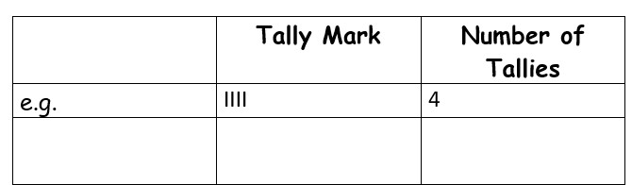 | - With lots of support  - With a prompt  - Can do independently
 | Comments (Optional)
Maths skill: identifying the capacity of containers in use, using simple vocabulary (e.g. full and empty, some in, some gone)
Questions for young person to answer | Parent/Carer Feedback Tick which one is relevant
You’ve poured out the paint into different small pots  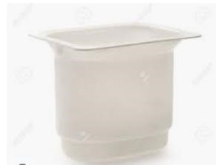  A B  Which paint pot is full? ________  Which paint pot only has some in it? ________ | - With lots of support  - With a prompt  - Can do independently

Maths skill: copy a simple pattern
Questions for young person to answer | Parent/Carer Feedback Tick which one is relevant
You are making a pattern on your rock. Can you copy the pattern I have chosen on the lines below?  _________________ __________________ _________________ ___________________ | - With lots of support  - With a prompt  - Can do independently

Maths skill: Order items from smallest to largest
Questions for young person to answer | Parent/Carer Feedback Tick which one is relevant
Complete the following statements about the tray and pots in your pack e.g. the tray is bigger than the pot  ____________ is bigger than____________  ____________ is smaller than____________ | - With lots of support  - With a prompt  - Can do independently
 | Comments (Optional)

Rainbow in a bag
Maths skill: know the name of a container that measures capacity
Questions for young person to answer | Parent/Carer Feedback Tick which one is relevant
What container is the paint in?  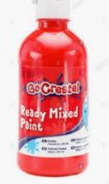 | - With lots of support  - With a prompt  - Can do independently
What did you pour the paint into?  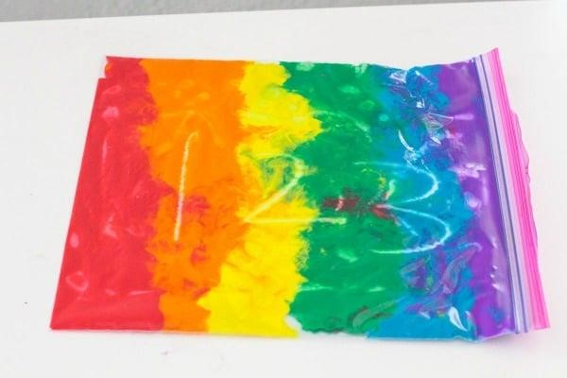  Can you name the item? | - With lots of support  - With a prompt  - Can do independently
 | Comments (Optional)

Maths skill: I can order items.
You did your painting in this order.
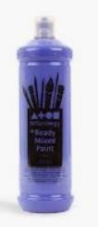
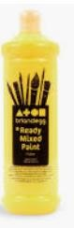
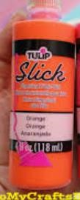
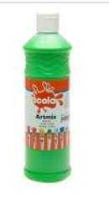
orange

1 2 3 4 5

Tick whether the following statements are true or false:
false
- The red paint is the 4th item true

false
- The orange paint is the 2nd item true

false
- The blue paint is the 5th item true

Parent/Carer Feedback Tick which one is relevant | Comments (Optional)
- With lots of support
- With a prompt e.g. press the on button
- Can do independently

Maths skill: understanding that objects have names relating to shape and trying to use some of these
Name | Shape | Number of sides | Number of corners | 2D or 3D  (2 dimensional or 3 dimensional)
S_________ |  |  | 4 | 2D
C_________ |  | 0 |  | 2D

Parent/Carer Feedback Tick which one is relevant | Comments (Optional)
- With lots of support
- With a prompt e.g. press the on button
- Can do independently

Rainbow Salt dough
Maths skill: counting past 5

1 | 2 | 3 | 4 | 5 | 6 | 7 | 8 | 9 | 10

Questions for young person to answer | Parent/Carer Feedback Tick which one is relevant
Can you use the number track above to help you count 6 balls, 6 small bowls and 6 coloured doughs? | •
Can you fill in a tally chart for the number of objects? Eg _____balls | - With lots of support  - With a prompt  - Can do independently
 | Comments (Optional)

Maths skill: I can understand the capacity of an object
Questions for young person to answer | Parent/Carer Feedback Tick which one is relevant
How many cups of flour did you use? | - With lots of support  - With a prompt  - Can do independently
How many cups of salt did you use? | - With lots of support  - With a prompt  - Can do independently
How many cups of water did you use? | - With lots of support  - With a prompt  - Can do independently
How many drops of scented oil did you use? | - With lots of support  - With a prompt  - Can do independently
 | Comments (Optional)

Rainbow Sponge painting
Maths skill: I can identify the position of objects.
Use the following words to complete the sentences: next to, above or under.
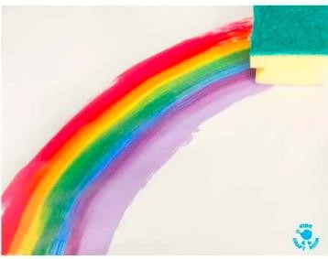
1

2

The second rainbow print is _______________________________________ the first rainbow print. 3

1

The third rainbow print is _____________________________________ the first rainbow print.

Parent/Carer Feedback Tick which one is relevant | Comments (Optional)
- With lots of support
- With a prompt e.g. press the on button
- Can do independently

Rainbow String painting
Maths skills: stacking objects
Questions for young person to answer | Parent/Carer Feedback Tick which one is relevant
Can you stack the 2nd piece of paper on top of the 1st? | - With lots of support  - With a prompt  - Can do independently
 | Comments (Optional)

Rainbow Comb painting
Maths skill: understand more and less
Questions for young person to answer | Parent/Carer Feedback Tick which one is relevant
Do you need to add more or less paint to get the rainbow marbled effect?  More  Less  (circle the correct word) | - With lots of support  - With a prompt  - Can do independently
 | Comments (Optional)

Rainbow sensory bottle
Maths skill: I can understand the capacity of an object
Questions for young person to answer | Parent/Carer Feedback Tick which one is relevant
Did you add a handful of rice into the bottle?  Yes  No  (circle the correct word) | - With lots of support  - With a prompt  - Can do independently
What equipment did you use?  Spoon  Funnel  (circle the correct word) | - With lots of support  - With a prompt  - Can do independently
 | Comments (Optional)

Rainbow Ribbon Ring
Maths skill: I can sort items
Questions for young person to answer | Parent/Carer Feedback Tick which one is relevant
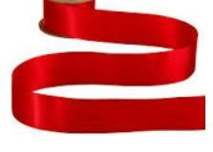  Which pile would this need to be put in?  (Put a circle around the correct one) | - With lots of support  - With a prompt  - Can do independently
I can identify the odd one out:

)
Tick or cross the correct one
(

•

With lots of support

•

With a prompt

•

Can do independently

Comments (Optional)

Maths skill: understand the length of objects
Cut out the measuring bar at the bottom of the page and use it to measure the length of the ribbons.

A.

B
1 | 2 | 3 | 4 | 5 | 6 | 7 | 8 | 9 | 10

Which ribbon length is the longest? _____

Which ribbon length is the shortest? _____

Parent/Carer Feedback Tick which one is relevant | Comments (Optional)
- With lots of support
- With a prompt e.g. press the on button
- Can do independently

Please get someone to take photos of you completing the above tasks and email them if possible to jguthrie@rnibcollege.ac.uk
Once completed please send this form back in the envelope provided in your craft pack or send by email to jguthrie@rnibcollege.ac.uk. Jo Guthrie (Maths Tutor)
Support Signed: Date:
completed _________________________________________________________________________ _________________
(parent/carer)

Student Name/signature: ____________________________________________________________ Date: ____________

Assessment Signed: __________________ Date:
(Maths Tutor) _________________

Feedback by Maths Tutor

Maths (Basic)

