I started this Rainbow craft pack on ____________________________________ in the morning / afternoon/evening. (Day of the week)
(*Please delete as applicable)

The date today is ______________________.
(e.g. 11 May 2020 or 11.05.20)

I started work at _____ o’clock.

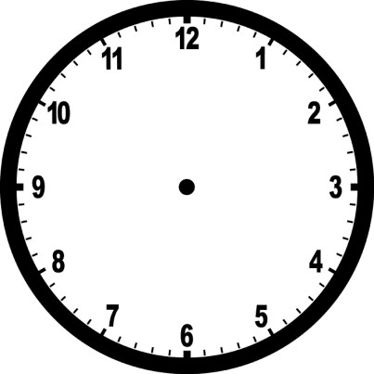 | Draw the hand and minute hands on the clock to show the time below

Dandelion Rainbow fingerprint picture
Maths skill: know the name of a container that measures capacity
Questions for young person to answer | Parent/Carer Feedback Tick which one is relevant
You collect the piece of equipment below:  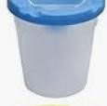  Can you name the item? | - With lots of support  - With a prompt  - Can do independently
 | Comments (Optional)

Maths skill: understand more and less
Questions for young person to answer | Parent/Carer Feedback Tick which one is relevant
Which paint colour has more dots? | - With lots of support  - With a prompt  - Can do independently
Which paint colour has less dots? | - With lots of support  - With a prompt  - Can do independently
 | Comments (Optional)

Rainbow Collage
Maths skill: Measure different lengths
Questions for young person to answer | Parent/Carer Feedback Tick which one is relevant
Can you cut out the measuring bar on the next page and use it to measure the gap between the lines (of 2 cms apart)? Can you put the measuring bar at the left side of the paper? | - With lots of support  - With a prompt  - Can do independently
Can you mark where 2 cms along is? | - With lots of support  - With a prompt  - Can do independently
 | Comments (Optional)

Questions for young person to answer | Parent/Carer Feedback Tick which one is relevant
Can you mark each strip 2 cms along? | - With lots of support  - With a prompt  - Can do independently
 | Comments (Optional)

1 | 2 | 3 | 4 | 5 | 6 | 7 | 8 | 9 | 10

Maths skill: Sort by colour
Questions for young person to answer | Parent/Carer Feedback Tick which one is relevant
Can you sort the paper squares into colour groups? | - With lots of support  - With a prompt  - Can do independently
 | Comments (Optional)

Rainbow Circle collage
Maths skill: I can name and describe shapes
Name | Shape | Number of sides | Number of corners | 2D or 3D  (2 dimensional or 3 dimensional)
S_________ |  |  | 4 | 2D
C_________ |  | 0 |  | 2D

Parent/Carer Feedback Tick which one is relevant | Comments (Optional)
- With lots of support
- With a prompt
- Can do independently

Rainbow circle collage – a bigger challenge!
Maths skill: Order items from smallest to largest
Questions for young person to answer | Parent/Carer Feedback Tick which one is relevant
Complete the following statements about the coloured circles e.g. the red circle is smaller than the yellow circle  ____________ is bigger than____________  ____________ is smaller than____________ | - With lots of support  - With a prompt  - Can do independently
 | Comments (Optional)

Paper or Card Rainbow heart
Maths skill: I can add numbers.
Questions for young person to answer | Parent/Carer Feedback Tick which one is relevant
You have 1 paper strip. You cut it in half. How many paper strips do you have altogether?  1 + 1 = | - With lots of support  - With a prompt  - Can do independently
Use a calculator to check your answer | - With lots of support  - With a prompt  - Can do independently
 | Comments (Optional)

Maths skill: I can identify the position of objects.
Use the following words to complete the sentences: next to, on top of or below.
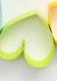The yellow heart is _____________________________ the green heart.

The light blue strip is ________________________ the dark blue strip.

Parent/Carer Feedback Tick which one is relevant | Comments (Optional)
- With lots of support
- With a prompt
- Can do independently

Maths skill: I can measure different lengths

Which piece of material is the longest (out of the paper strip and the ribbon)?

_____________________________________

Which piece of material is the shortest (out of the paper strip and the ribbon)?

____________________________________

Select objects from this craft’s equipment list and decided if they are longer, shorter or the same length as a ruler:
 | Object | Longer  (please tick ✓) | Shorter (please tick ✓) | Same length  (please tick ✓)
1

2

Parent/Carer Feedback Tick which one is relevant | Comments (Optional)
- With lots of support
- With a prompt
- Can do independently

Maths skill: I can fill in the missing numbers in a sequence.
Questions for young person to answer |  |  |  |  |  |  | Parent/Carer Feedback  Tick which one is relevant
You have made 10 heart loops. Can you fill in the missing numbers in the sequence?
6

 |  | 7 |  | 9
Put the numbers 0 to 10 in size order.  1 5 |  |  |  |  |  |  | - With lots of support  - With a prompt  - Can do independently
 |  |  |  |  |  |  | Comments (Optional)

Rainbow heart decoration
Maths skill: I can match pairs that are the same.
Put a tick next to the two heart decorations that are exactly the same in each set.

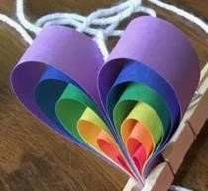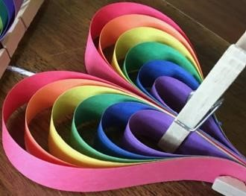

Parent/Carer Feedback Tick which one is relevant | Comments (Optional)
- With lots of support
- With a prompt
- Can do independently

Maths skill: identify that 2 objects are of different widths You have made different sized hearts.

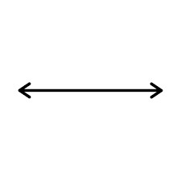
Width A Width B

Which coloured heart is the smallest in width? _________________

Which coloured heart is the biggest in width? _________________

Parent/Carer Feedback Tick which one is relevant | Comments (Optional)
- With lots of support
- With a prompt e.g. press the on button
- Can do independently

Heart Card and Pom Pom Card
Maths skill: I can copy and complete patterns.

Copy the patttern:
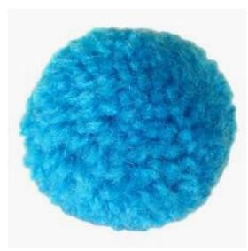

_________________ __________________ _________________ ___________________

Complete the patterns below.
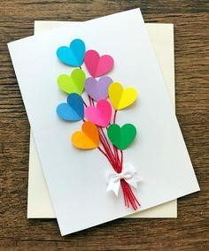
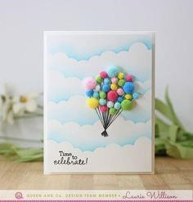

_______________ (heart/pom pom)

Parent/Carer Feedback Tick which one is relevant | Comments (Optional)
- With lots of support
- With a prompt
- Can do independently

Maths skill: know the name of a container that measures capacity
Questions for young person to answer | Parent/Carer Feedback Tick which one is relevant
Imagine you poured out the PVA glue into different yoghurt pots  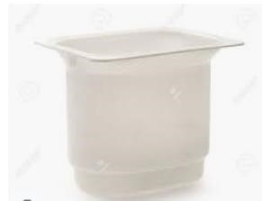  B  A  Which glue pot has the most amount of glue in it?  ________ | - With lots of support  - With a prompt  - Can do independently
Which glue pot has the least amount of glue in it?
________

You collect the piece of equipment below:  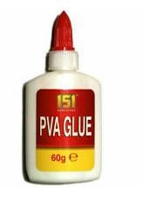  Can you name the type of container? | - With lots of support  - With a prompt  - Can do independently
 | Comments (Optional)

Pom Pom Card
Maths skill: Measure different lengths
Questions for young person to answer | Parent/Carer Feedback Tick which one is relevant
Can you cut out the measuring bar on the next page and use it to measure the wool/string (of 10 cms long)? Can you put the measuring bar at the left side of the paper? | - With lots of support  - With a prompt  - Can do independently
Can you mark where 10cms along is? | - With lots of support  - With a prompt  - Can do independently
 | Comments (Optional)

1 | 2 | 3 | 4 | 5 | 6 | 7 | 8 | 9 | 10

Rainbow Button picture
Maths skill: I can sort items
Questions for young person to answer | Parent/Carer Feedback Tick which one is relevant
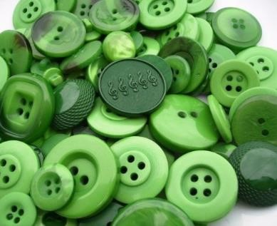  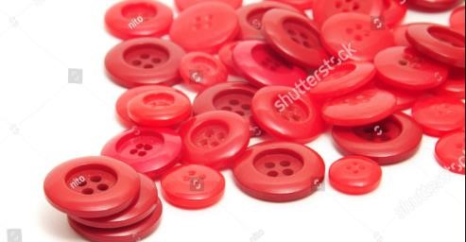  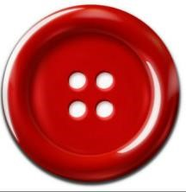  Which pile would this need to be put in?  (Put a circle around the correct one) | - With lots of support  - With a prompt  - Can do independently
I can identify the odd one out:  (Tick or cross the correct one) | - With lots of support  - With a prompt  - Can do independently
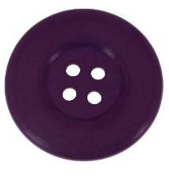 | Comments (Optional)

Please get someone to take photos of you completing the above tasks and email them if possible to jguthrie@rnibcollege.ac.uk
Once completed please send this form back in the envelope provided in your craft pack or send by email to
jguthrie@rnibcollege.ac.uk. Jo Guthrie

Support completed Signed: Date: _________________ (parent/carer) _______________________________________________________________
Student Name/signature: Date:

Assessment (Maths Signed: _______________________________________________________ Date: _________________
Tutor)

Feedback by Maths Tutor

