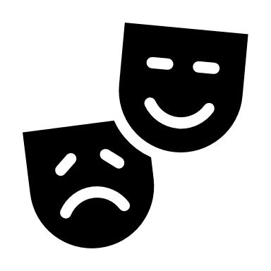
ISOLATION REFRAMING

Changing our words can change how we feel!

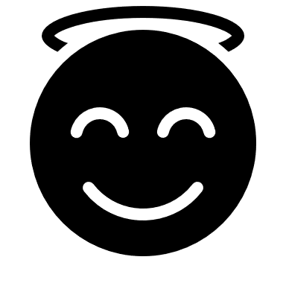
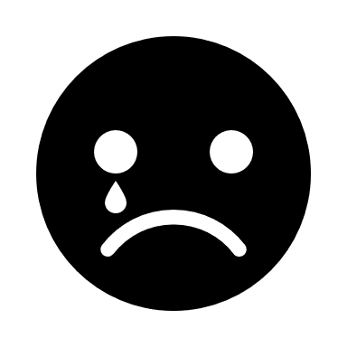
I miss my friends and family By staying away I am protecting

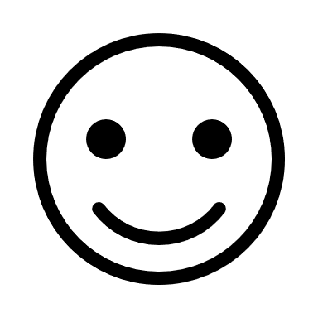
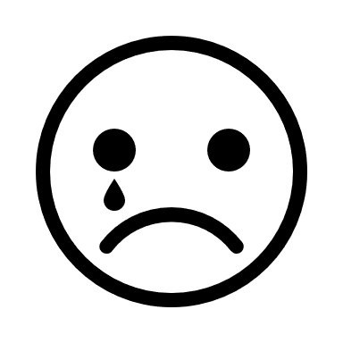
I can’t go out By staying home, I am staying safe

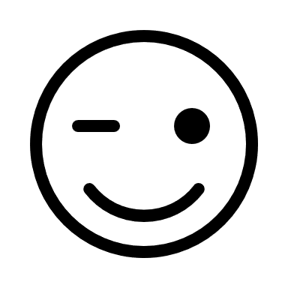
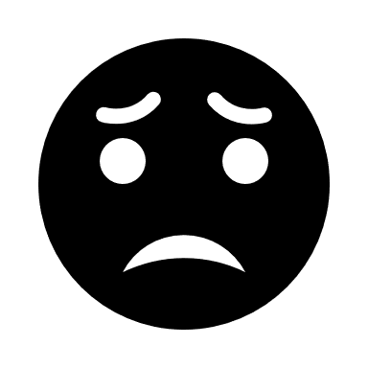
I miss the things I used to do I can learn new things at home

SEE, IT’S NOT SO BAD!

