Islamic Art
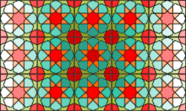

Equipment Required:
- templates (provided);
- ruler;
- pencil;
- scissors;
- rubber / eraser;
- coloured crayons / pens / pencils.

Islamic Art
The starting point of all Islamic geometric designs is the circle: the symbol of ‘unity’, and the centre from which all else emerges. The starting circle is then subdivided into sectors – usually multiples of four, five or six – the number of which influence how the pattern tiles.

One way of categorising Islamic geometric designs is to label them according to how the pattern tiles. ‘Fourfold’ patterns tessellate in squares, ‘Fivefold’ patterns tessellate (repeated use of a single shape, without gaps or overlapping) in pentagons (with extra bits) and ‘Sixfold’ patterns tessellate in hexagons.

You can tell whether a pattern exhibits fourfold, fivefold or sixfold tiling by counting the points on the stars or the ‘petals’ on the rosettes.
Multiples of 4 – fourfold, multiples of 5 – fivefold, multiples of 6 – sixfold. Common multiples of 4 and 6 (e.g. 12) can be found tiling as either fourfold or sixfold patterns.

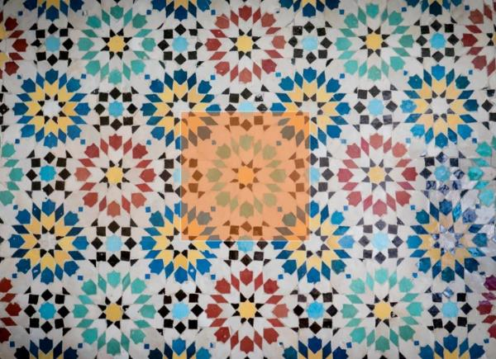
Count the ‘petals’ in the design. You should be able to see that there are 8 of them. As 8 is a multiple of 4 so this is a fourfold design.

How many ‘petals’ does this pattern have? It has 10, therefore it is a fivefold pattern and tessellates in pentagons (with extra bits)
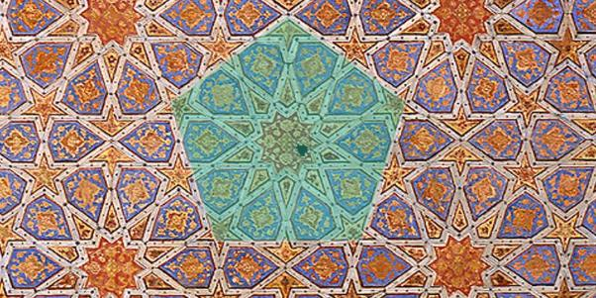

If you count the points on the star you will see that there are 6. Therefore this is a sixfold pattern and tessellates in hexagons.
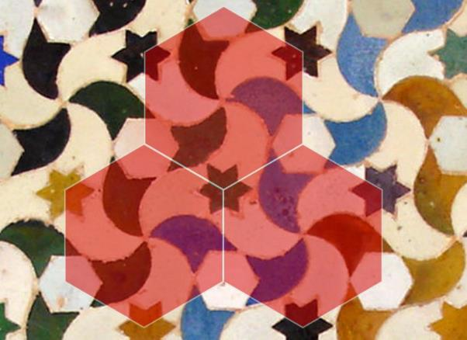

Making your own Islamic Art
This activity contains instructions for three different fourfold patterns, all starting from a ‘5-grid’ – one central circle surrounded by four others using a provided template. As an extension activity there is another template if you wish to tessellate your designs.

Pattern 1 – The Khatam
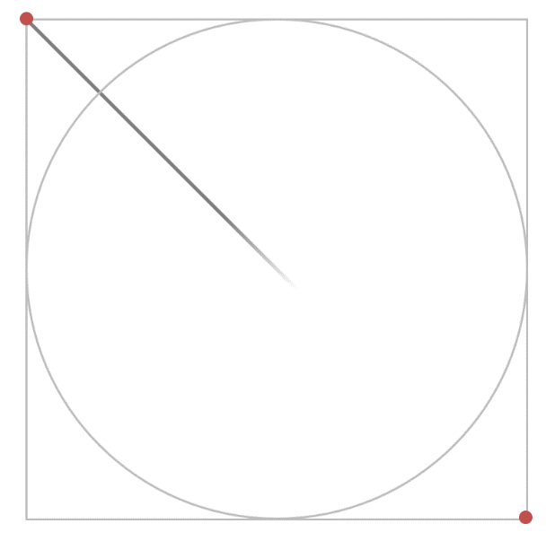
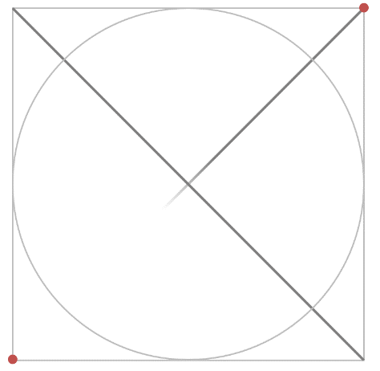
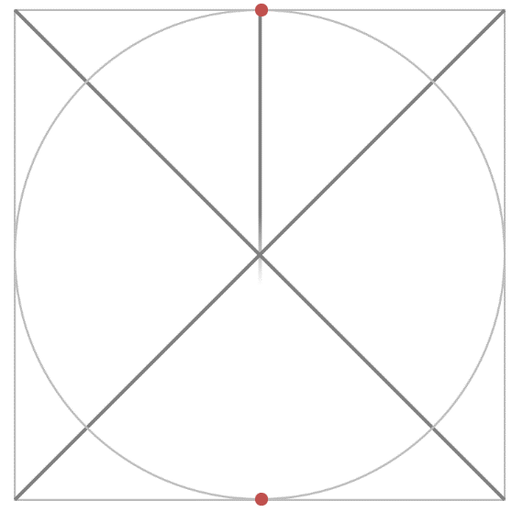
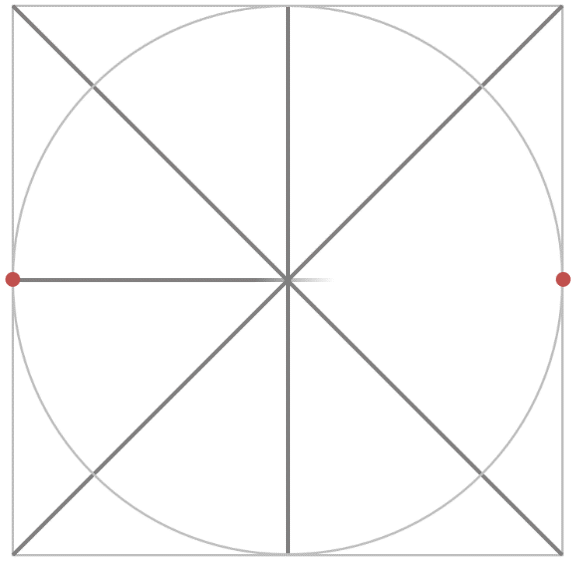
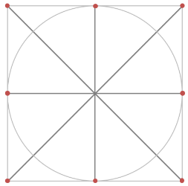
Using a ruler draw some pencil lines from each corner and then through the middle of the circle as shown here.

Now onto the next step to make the underlying grid for your pattern. Mark four dots where your new lines meet the circumference (perimeter) of the circle. Then connect these up using a ruler and pencil to form a square shape.
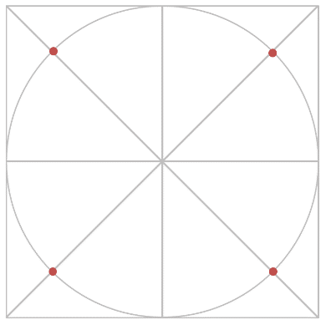
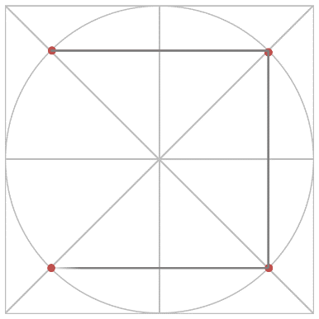

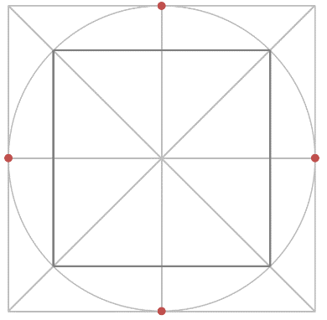
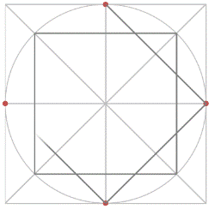
Mark four more points at the top middle, bottom, left and right of the circle where the lines cross. Then connect these up to form another square.

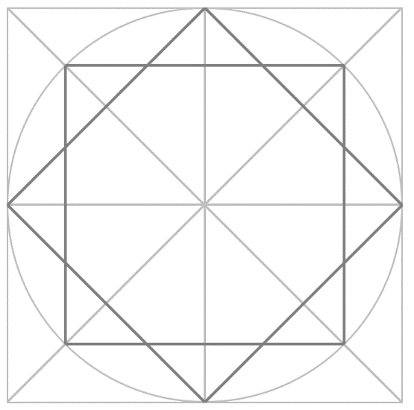

Now you need to pick out the underlying pattern using a different colour, or with a pen. This is your finished pattern – now colour it in and cut out the square. You can make more of these and tessellate them into an even bigger piece of art. We would really like to see your work!
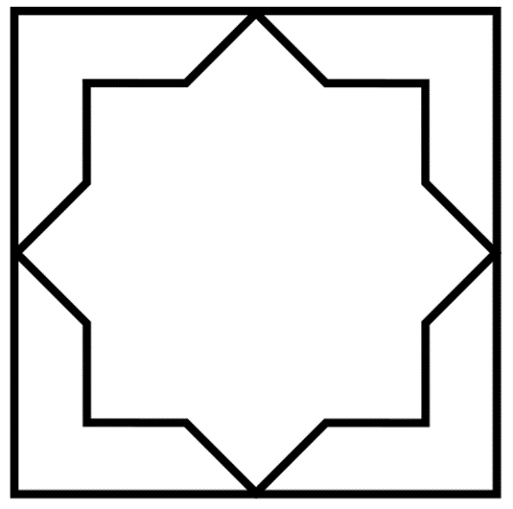
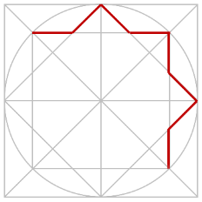

If you feel confident why not use the smaller template and create a different design? Again, we would really like to see it!
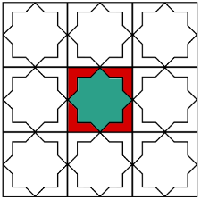
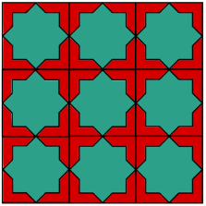

Pattern 2 – Octagram
Follow the same steps as before until you get to this stage. Now we are going to mark some more points and join up these lines in a different pattern than before.
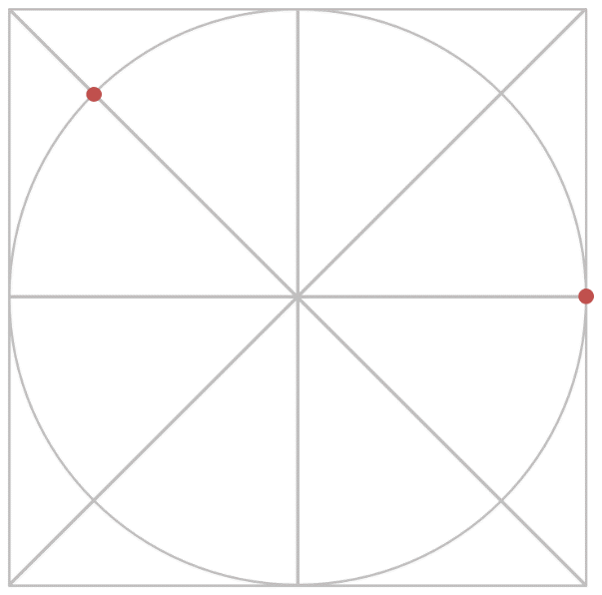
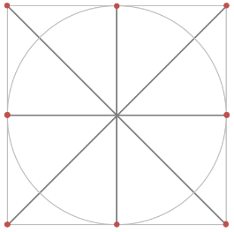

Using a ruler connect up these two new points, then repeat the process as shown below making a set of parallel (having the same distance between them) lines.

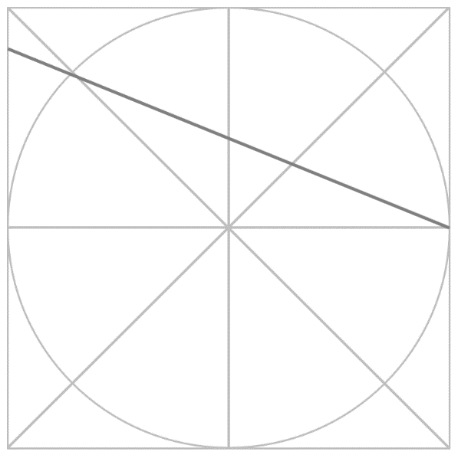
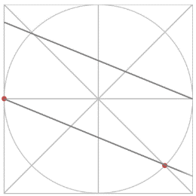

Do the same marks as before, but this time on the other side of the circle template. Then join the points up using a ruler and pencil.
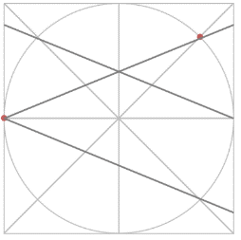
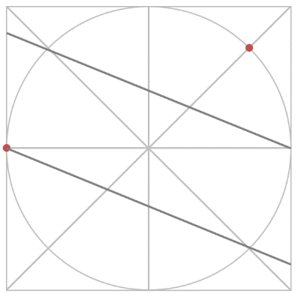

Repeat the process again – making another pair of parallel lines.
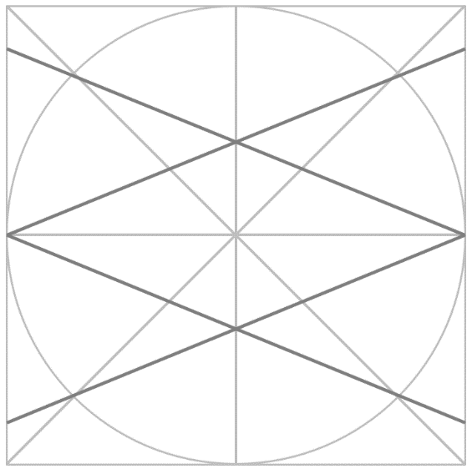
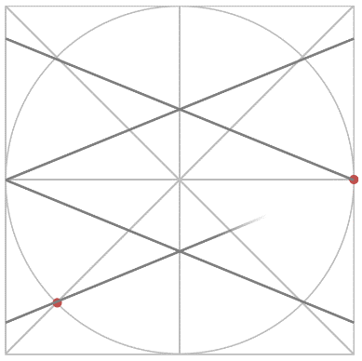

Mark some more points as shown below then join them up using a ruler and a pencil.
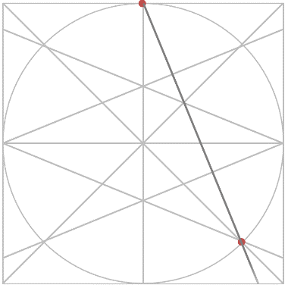
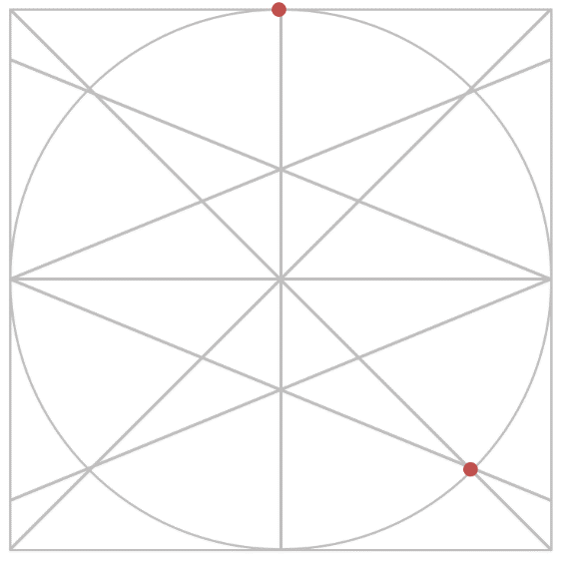

Again, using a ruler connect up these two new points, then repeat the process as shown below making another set of parallel lines.
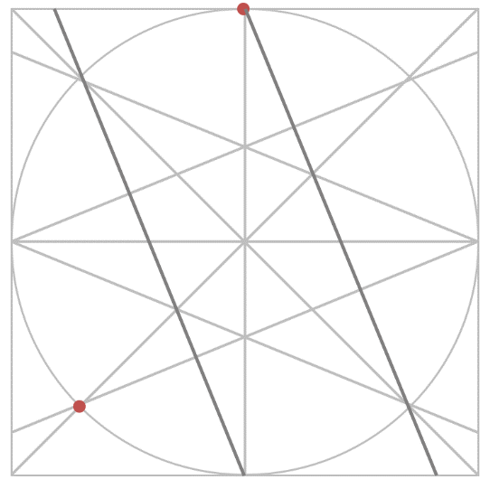
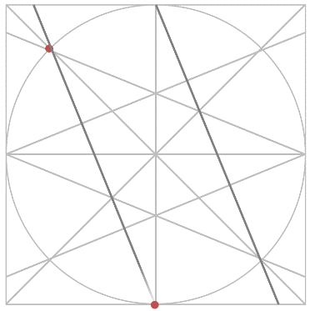

Complete the pattern by making some more points and joining them up as shown below.
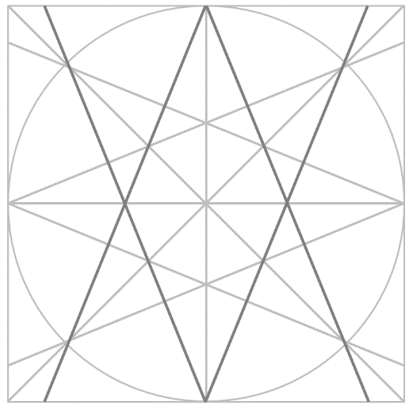
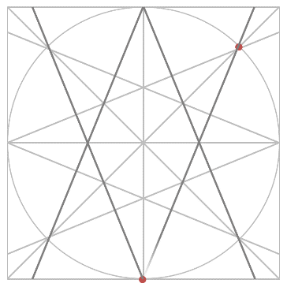

Now you need to pick out the underlying pattern using a different colour, or with a pen. This is your finished pattern – now colour it in and cut out the square. You can make more of these and tessellate them into an even bigger piece of art. We would really like to see your work!
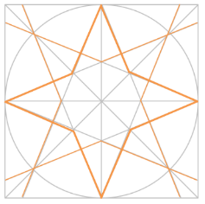
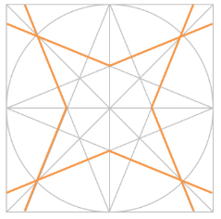

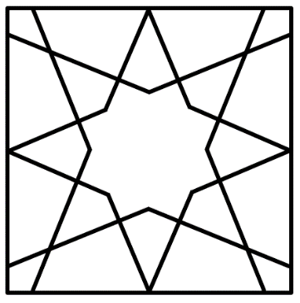
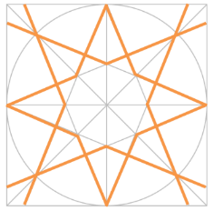

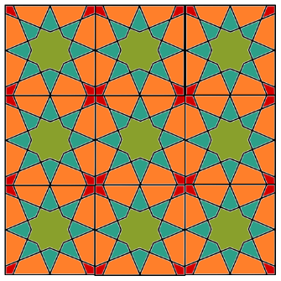

Pattern 3 – 8 Petal Rosette
Follow the steps that you did for Pattern 1 until you get to this stage
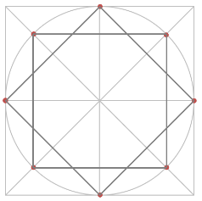
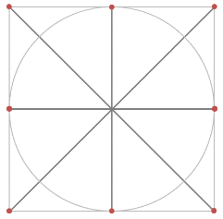

We are going to make some mark some extra points on it to create a different design. Then join them up with a ruler and a pencil.
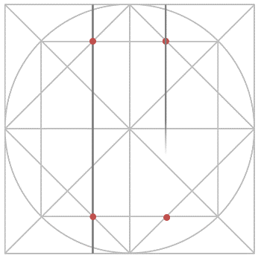
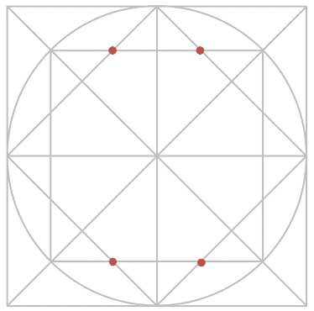

Mark some more points as shown below and join these up.
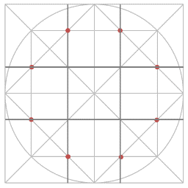
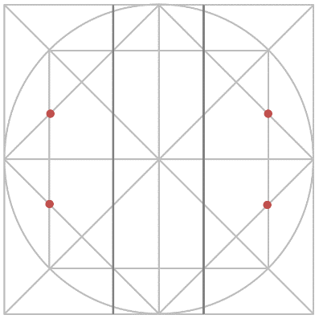

Repeat as before making some new points and joining these up using a ruler and a pencil.
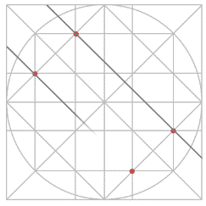
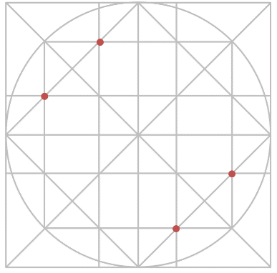

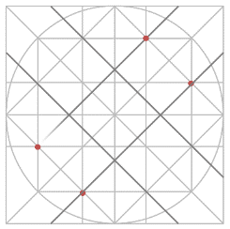
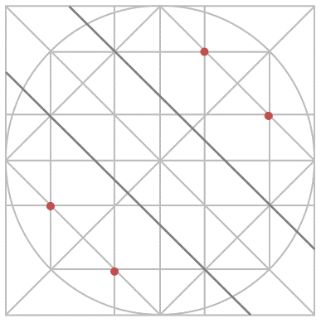

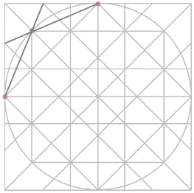
More points to mark and lines to join up here…
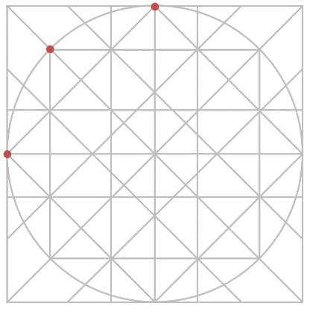
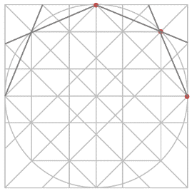
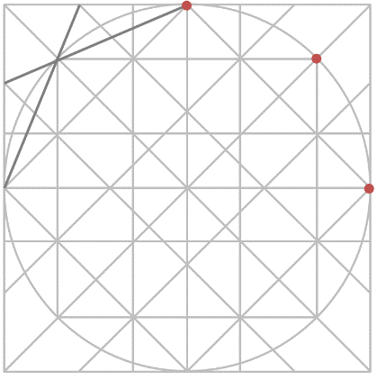
Repeat this process on the bottom half of the design.
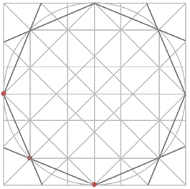
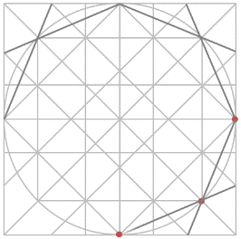

Now comes the tricky part, you need to pick out the underlying pattern using a different colour, or with a pen. This is your finished pattern – Now colour it in and cut out the square. You can make more of these and tessellate them into an even bigger piece of art. We would really like to see your work!
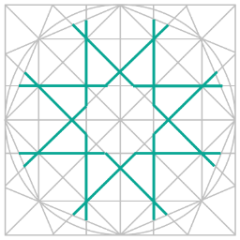
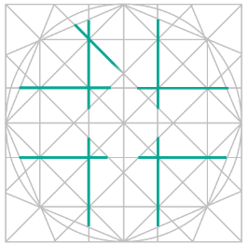

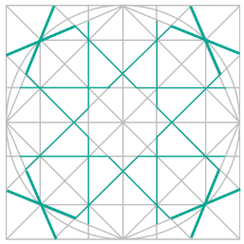
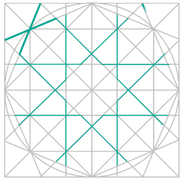

More underlying pattern work here and then your finally done!
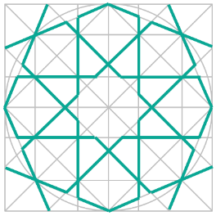
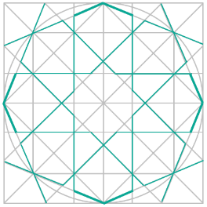

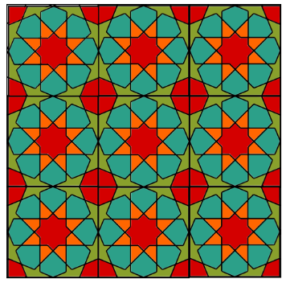
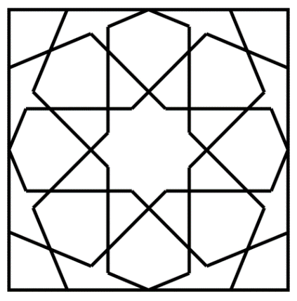

This is your finished pattern – Now colour it in and cut out the square. You can make more of these and tessellate them into an even bigger piece of art.

We would really like to see your work!

