Islamic Art
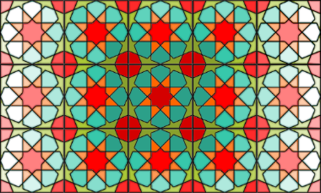

Equipment Required:
- templates (provided);
- ruler;
- pencil;
- scissors;
- rubber / eraser;
- coloured crayons / pens / pencils

Islamic Art
All Islamic geometric designs start with the circle. This symbolises ‘unity’. It is at the centre and rest of the pattern forms out from this. The starting circle is then divided into sections. They are usually multiples of four, five or six. The number of which affects how the pattern tiles.
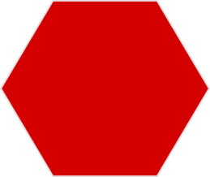
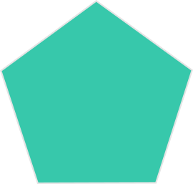
Islamic geometric designs can be sorted by looking at how the pattern tiles. You can look at what is called ‘tessellation’. A tessellation is an arrangement of shapes closely fitted together, in a repeated pattern without gaps, or overlapping.

‘Four-fold’ patterns tessellate in squares, ‘Five-fold’ patterns tessellate in pentagons (with extra bits) and ‘Six-fold’ patterns tessellate in hexagons.
You can tell whether a pattern has four-fold (multiples of 4), five-fold (muliples of 5) or six-fold (multiples of 6) tiling by counting the points on the stars or the ‘petals’ on the rosettes.
Note: Common multiples of 4 and 6 (e.g. 12) can be found tiling as either four-fold or six-fold patterns.

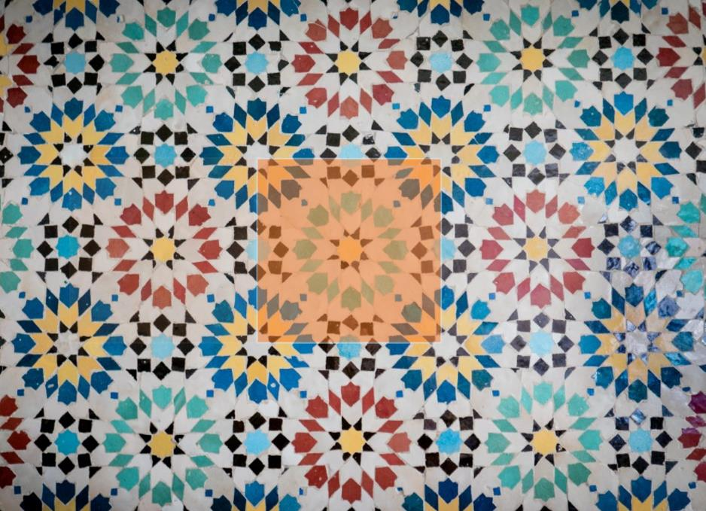
Count the ‘petals’ in the design.

You should be able to see that there are 8 of them. As 8 is a multiple of 4 so this is a fourfold design.
How many ‘petals’ does this pattern have? 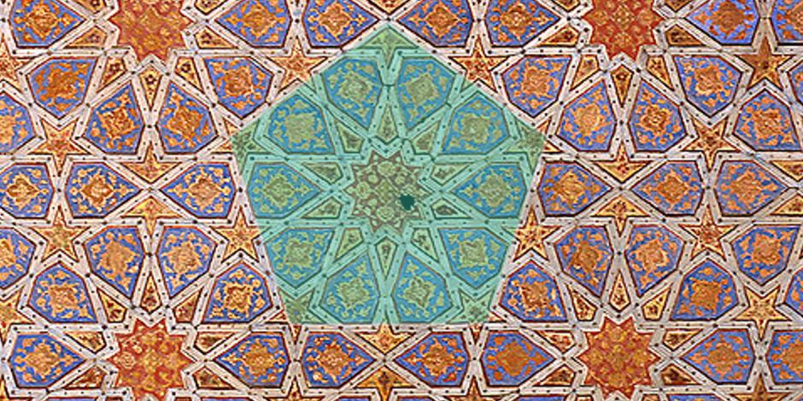

It has 10, therefore it is a five-fold pattern and tessellates in pentagons (with extra bits)

If you count the points on the star you will see that there are 6. 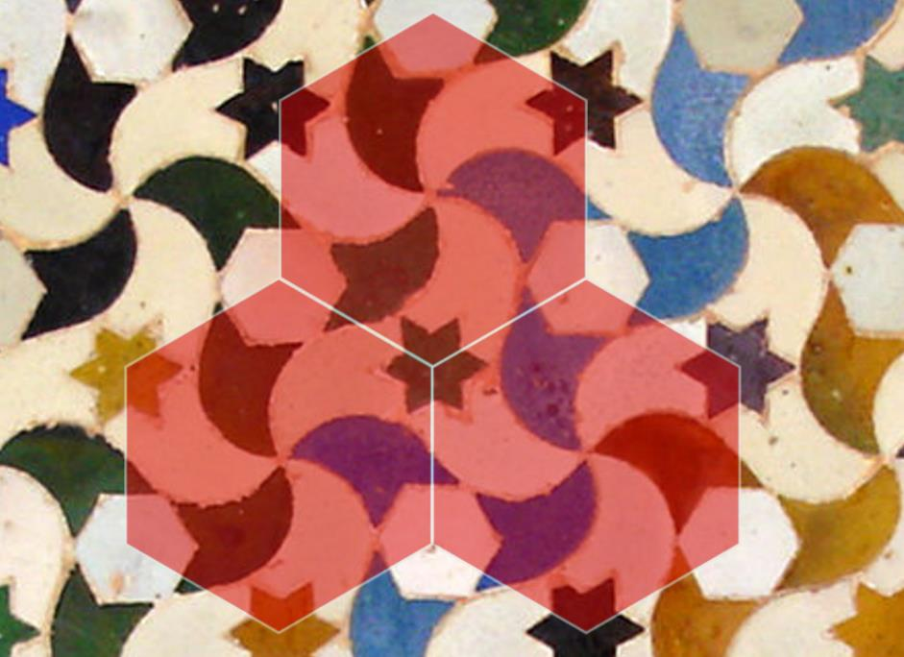
Therefore this is a six-fold pattern and tessellates in hexagons.

Making your own Islamic Art
The next activity contains instructions to create ‘The Khatam’ which is a four-fold pattern design.

Pattern 1 – The Khatam
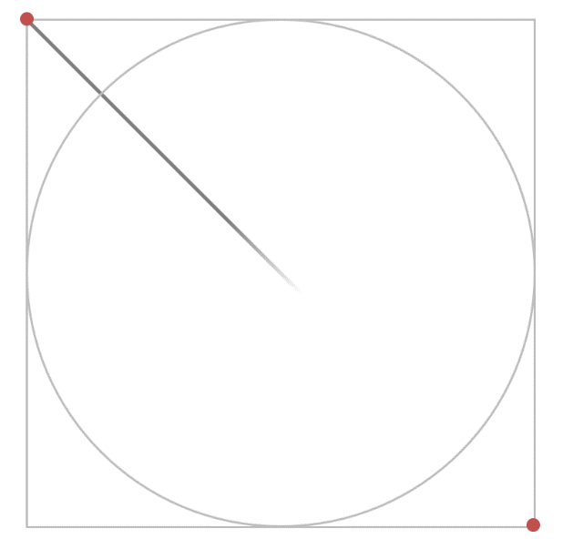
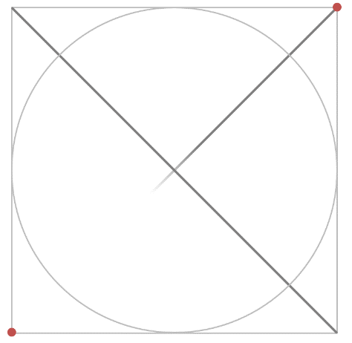
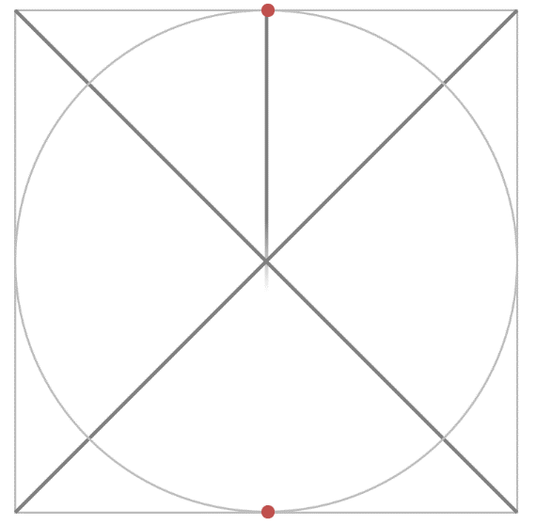
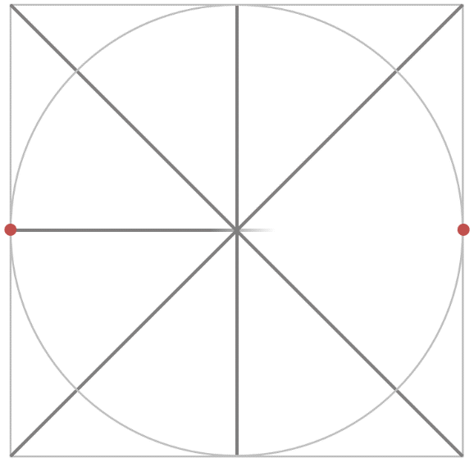
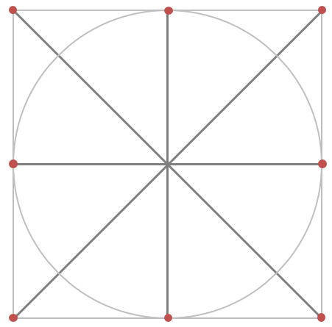
Using a ruler draw some pencil lines from each corner and then through the middle of the circle as shown here.

Now you need to make the grid for your pattern.
Mark four dots where your new lines meet the circumference (perimeter) of the circle. Then connect these up using a ruler and pencil to form a square shape.
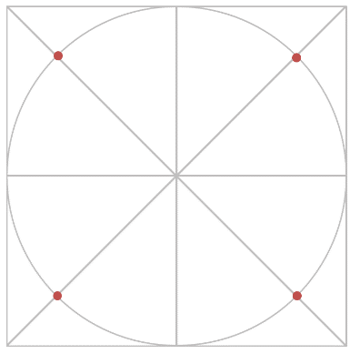
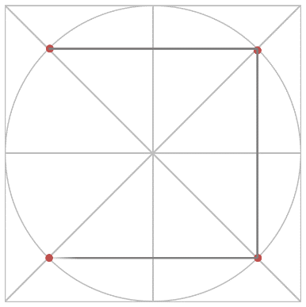

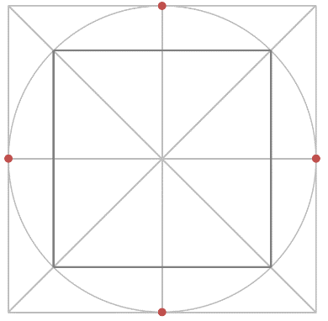
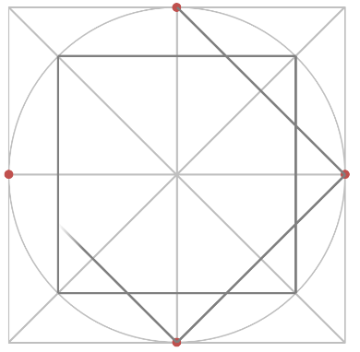
Mark four more points at the top middle, bottom, left and right of the circle where the lines cross. Then connect these up to form another square.

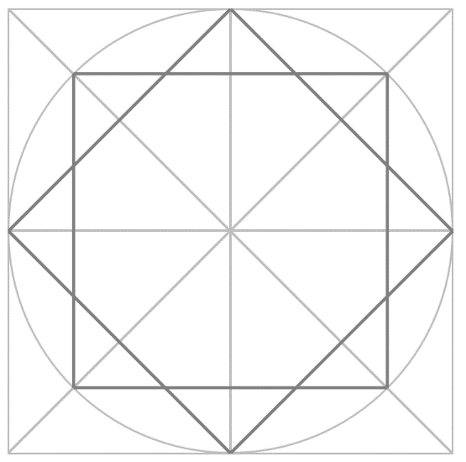

Now you need to pick out the underlying pattern using a different colour, or with a pen.
This is your finished pattern – now colour it in and cut out the square. You can make more of these and tessellate them into an even bigger piece of art. We would really like to see your work!
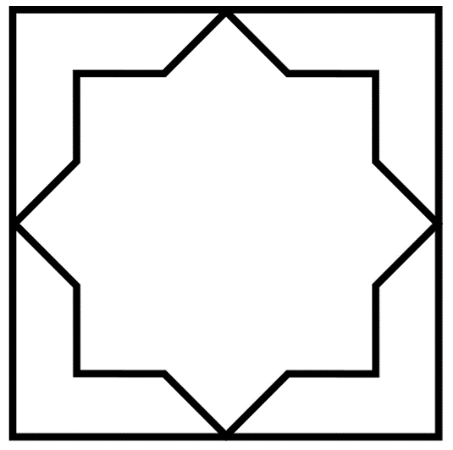
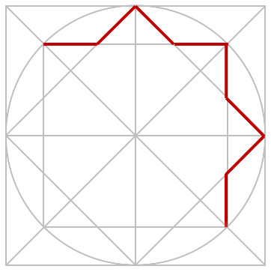

If you feel confident why not use the smaller template and create a different design? Again we would really like to see your work!
