Preparation and Presentation for an Interview



**Name: ________________________**

**Tutor: _________________________**

**Date: ­­­­_________________________**

**Key terms** and **words** are used in **in this booklet.** To help you learn these words use a dictionary or this website - https://www.collinsdictionary.com/ to find words you don’t know.

Practice spelling these words.



 You can add more on the last page of this booklet ☺



**Before the interview**

In this section we will be thinking about what you do before an interview.

We will look at applying for a job, researching before an interview, job descriptions and person specifications.

**Activity 1**

What do you think you should do before an interview? Answer using complete sentences.

**Create** a **mind map** of things you think that you **should look for** when doing your **research**.

**Activity 2**

When you apply for a job, what information do you think would be available? Circle your answer.

1. Recipes and Method
2. Job Description and Certificate
3. Person Specification and Remote Instructions
4. Person Specification and Job Description

What do you think you should do with the Job Description and Person Specification? Circle your answer.

1. Throw it in the bin
2. Read it and check you meet their requirements
3. Use it as toilet roll
4. Eat it

Create a mind map of things you would expect to see within a **job description**. An example has been given.

What the job is

Write a list of features you would expect to see within **a person specification.**



The extract below is from a job description.

Read the extract and identify any words which you don’t understand.

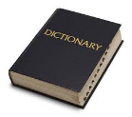Use a dictionary - <https://www.collinsdictionary.com/> to help you find the meanings for the words you don’t know.

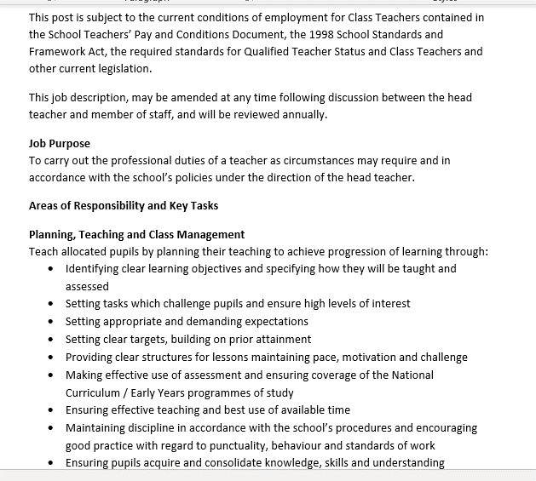



We are going to think about some words you might hear in an interview.

Using a dictionary or the internet -

What does ‘qualities’ mean?

What does ‘responsibilities’ mean?

What does ‘skills’ mean?

Identify key **qualities** and **responsibilities** for the above job.

|  |  |
| --- | --- |
| Qualities | Responsibilities |
|  |  |
|  |  |
|  |  |
|  |  |
|  |  |
|  |  |



**In the interview**

When you are in an interview, you will get asked questions about why you would like the job and things you are good at.

The next section will help you to think about these things and it may help you to answer questions within you interview.

**Activity 3**

In an interview, you are likely to be asked these questions, answer them in as much detail as you can.

You can imagine this is for your dream job.

What is your dream job? ­­­­­­­­­­­­­­­

_____________________

Why are you applying for this job?

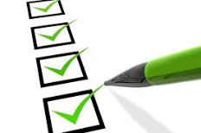Create a list of your strengths.



Write in paragraphs, your strengths and give examples of them.

Create a list of your **weakness**. These are things that you might find difficult now, but what you could improve on.



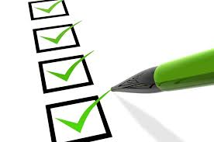



Create **a mind map** of the skills which you have.

Give examples, about when you have used these skills.

Remember to write in sentences.



**Dressing for an interview**

When we go for an interview, we need to make sure that we look presentable and smart.

In this next section, we will look at the clothes you should wear to an interview and how you should be presented for an interview.

**Activity 4**

Which outfit is best to wear for an interview? Tick your answer.

|  |  |  |
| --- | --- | --- |
| C:\Users\Matthew Garton\AppData\Local\Microsoft\Windows\INetCache\Content.MSO\E4AFB8EE.tmp  Pyjamas | Buy Black Nike Repeat Tape Poly Full Zip Tracksuit Children | JD ...  Tracksuit | C:\Users\Matthew Garton\AppData\Local\Microsoft\Windows\INetCache\Content.MSO\7CAFB13D.tmpSuit |
|  |  |  |

|  |  |  |
| --- | --- | --- |
| Suit | C:\Users\Matthew Garton\AppData\Local\Microsoft\Windows\INetCache\Content.MSO\C3E54D38.tmpTracksuit | Women's Loungewear | Women's Hoodies & Joggers | ASOS | Loungewear ...Loungewear |
|  |  |  |

Why did you choose these outfits?

**Activity 5**

Ironing board | Creases | Iron

Creased | Ironing

Setting | Bottom | Touch

Using the word bank, fill in the blanks.

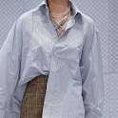

This shirt is _______.

I would use an ____ to make the _______ disappear.

When ______ you should also use an ___________.

Adjust the ________ to the height that you need.

Make sure that the _______ is on the correct _______.

Be careful not to ______ the _____ of the ______ as you will burn.

**Activity 6**

Label this dress-shirt.

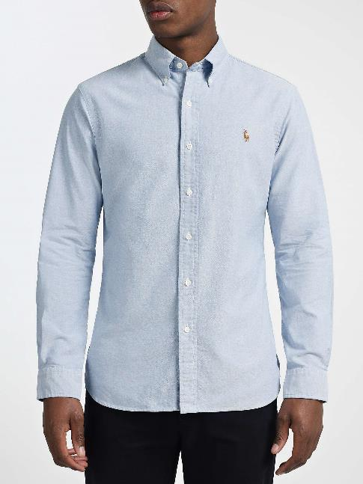

**Activity 7**

Reorder the method of ironing a shirt/blouse.

|  |  |  |  |
| --- | --- | --- | --- |
| 1. | 2. | 3. | 4. |
| 5. | 6. | 7. |  |

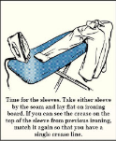 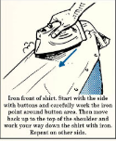 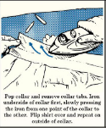 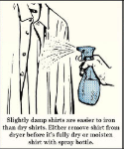

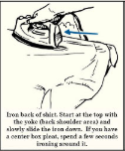 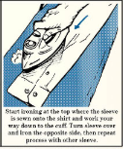 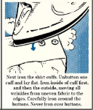

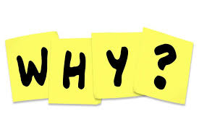**Explain why** it is a good idea for your clothes to be washed and to have excellent **personal hygiene** when attending an interview.



**Arriving on time to an interview and being prepared**

When we have an interview, or a meeting we need to make sure we turn up on time.

In this section we will look at time keeping and ways we could be on time for an interview. We will also look at being prepared for an interview.

**Activity 8**

What time should you arrive for your interview? Tick your answer

|  |  |  |
| --- | --- | --- |
| On time | 10 minutes early | 10 minutes late |
|  |  |  |

What should you take with you to your interview?

Create a mind map of your answers.

**Activity 9**

Create a poster or a leaflet explaining how to be prepared for an interview.

Use the websites provided on the next page to help you with ideas to create your poster.

**Have a look at these websites to help you with your interview skills –**

To help you prepare for an interview watch the video.

Think about how you might prepare for a job interview.

<https://www.youtube.com/watch?v=q7hRnjNbvAc>

When preparing for an interview you need to think about what you are going to wear.

Have a look at this website and choose the outfit that you would wear to an interview.

Once you’ve made your outfit, click “walk” to see your outfit on a runway.

Don’t forget to print screen your efforts.

<https://www.virtualoutfits.com/>

Some of the words used when you are trying to find a job can be quite difficult to understand.



Use this website to help you find out the meanings of words you don’t know.

<https://www.collinsdictionary.com/>

Top tips for preparing for an interview

<https://www.acuitytraining.co.uk/news-tips/interview-preparation-infographic/>

Watch the following videos and think about the good things, and the bad things.

What would you do instead? Are there any points that you would do?

<https://www.youtube.com/watch?v=guUOmfq303s> 

<https://www.youtube.com/watch?v=VadQskWdFhc> 

Access this website and read through it. Make sure you’re familiar with all of the tips as these will help you with your future interviews.

<https://www.livecareer.com/resources/interviews/prep/teen-job-strategies>

