Ruskin Mill Mindfulness Card

Making a ‘Calm Down Jar’. You can do this alone, or get someone to read the instructions and support you.

Facts about the activity

What is ‘Mindfulness’?

- Mindfulness is paying attention to something.

- It is about slowing down to really notice what you’re doing.

- Being mindful often means noticing a thing, thought, or feeling that you might normally ignore.

- When you’re mindful, you are thinking in a relaxed and positive way.

What is a ‘Calm Down Jar’?

- The calm down jar reminds us to stop, breath, and relax.

- Whenever things are swooshing around in our head, the jar reminds us to settle and be calm.

- It helps you to take your time.

Why do it?

- Being mindful is the opposite of rushing, worrying, or doing lots of things at once.

- It stops you from thinking about the past or future.

- It helps you to think about the present in a cool and calm way.

Give this simple task a try! :)

Ingredients | Equipment
- water  - glitter (any colour) | - 1 clear jar with a tight lid (could be glass or plastic)  - your hand!
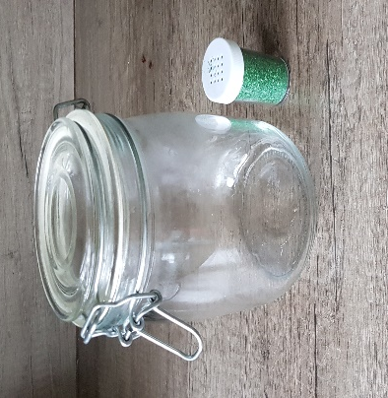

Step 1
Get your jar and open the lid. | 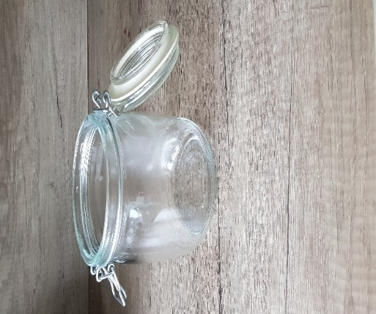
Step 2
Pour some water into the jar until it is half full. | 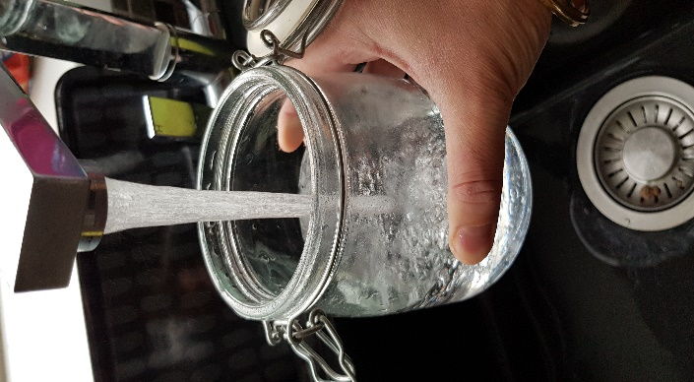

Step 3
Sprinkle some glitter into the jar.  If you don’t have a shaker, around half a teaspoon is enough. | 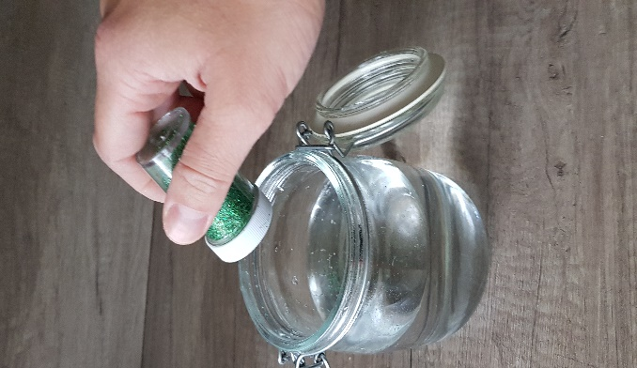
Step 4
Close the lid. | 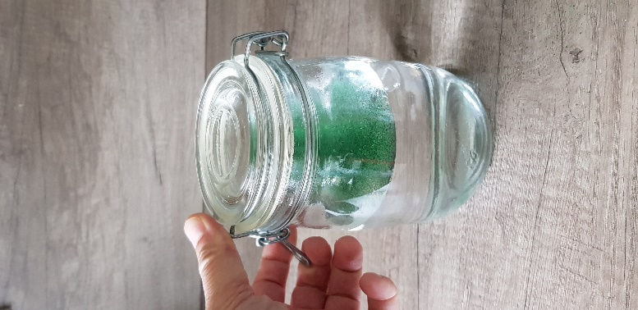

Step 5
Now shake the jar until the glitter moves.  You may want to give it a little swirl if your lid is not tight! | 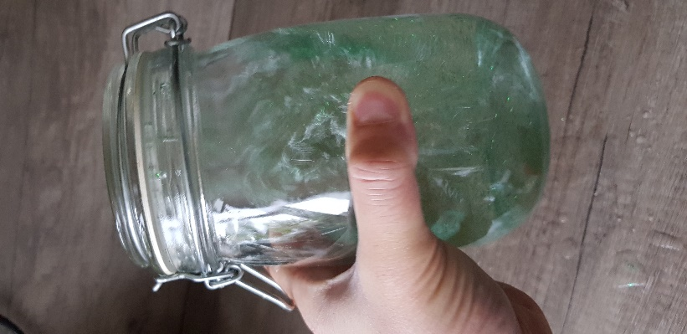
Step 6
Notice how the glitter is racing around.  Put the jar down. Wait for the glitter to begin slowing down.  It will sink to the bottom, or float to the top.  Just enjoy watching the glitter slow down and eventually settle. | 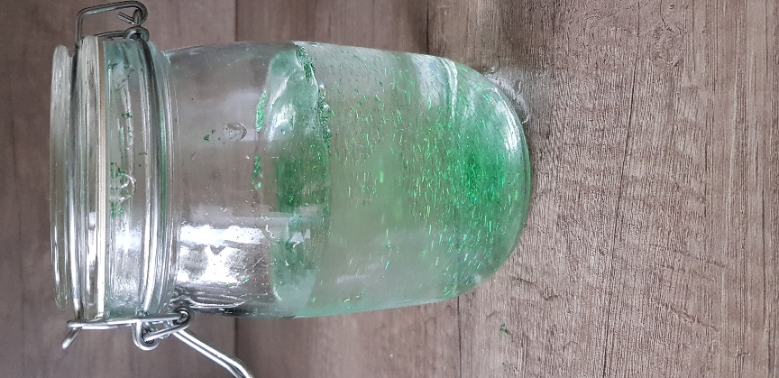

Step 7
Take a minute to just look at the still jar. | 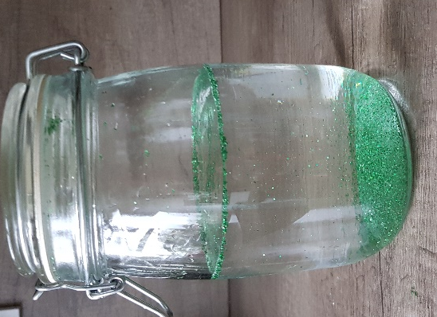
Step 8
Now close your eyes for 5 mins.  Let your thoughts calm down – just like the glitter in the jar.  Be still, focus on your breathing and relax.  Now find a positive thought. You could think about:  - a beach  - a mountain top  - or any place that you love…  What can you see, hear, touch, and smell?  Let your mind take you there. It is your world, a world where everything is calm and relaxed.  Your thoughts are now as still and calm as the glitter. | 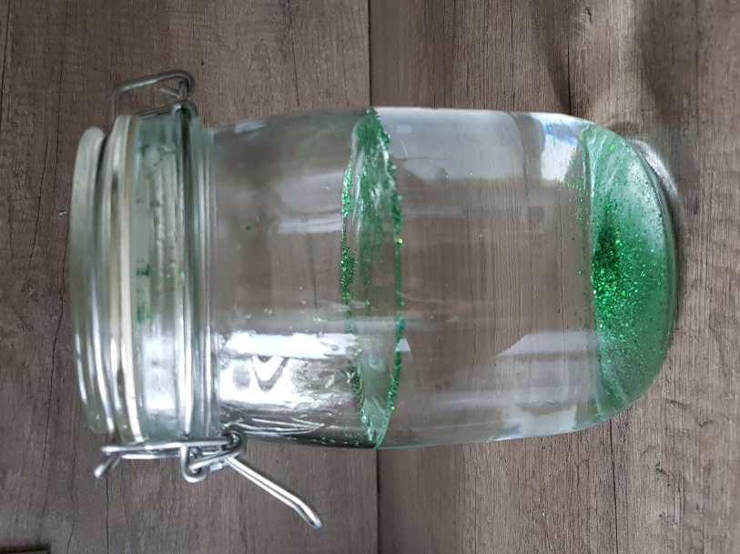

Final thoughts…

Our thoughts often overwhelm us, and can be as busy as the glitter in the jar.

We could be thinking about hundreds of things. What somebody said to us, what we are having for dinner, stressing about being in isolation, they all add up.

It is not bad to have many thoughts and feelings at once.

However, to have positive thoughts, and to feel relaxed and calm is really important.

The next time your thoughts race around and make you feel worried or anxious … give your calm jar a shake and watch the glitter slow down!

How long it can be stored for | Where it should be stored
Forever! | Anywhere you want

