Indoor Measures Scavenger Hunt
We would like you to go on a maths scavenger hunt.
Look at the list. We have described various objects. See if you can find the objects that match the description.
You need to choose and use appropriate standard units to guess:
- length/height in any direction (m/cm);
- quantity (Kg/g); using rulers & kitchen scales.
Then check your guess by accurately measuring each object.
Draw a picture, or take a photograph, of the objects you chose.
In my room / my house

 | Guess/Estimate | Measurement
The length of a window

The height of a door

The length of a pencil

The length of a pen

The length of a book

The height of a desk, or table

The length of my bedroom

The width of my bedroom

The weight of the pencil

The weight of the book

The weight of a shoe

The weight of a mobile phone

The weight of pair of socks

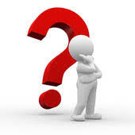 | Challenge
Now try to convert all your measurements into different units. You could also try using decimals.
e.g. 20 centimetres (cm) = 0.2 metres (M),
2 metres (M) = 200 centimetres (cm)
20 grams (g) = 0.02 kilograms (Kg)
2 kilograms (Kg) = 2000 grams (g)

