LearnerHub SharePoint Upload Template

**Please use this template when uploading to the LearnerHub, ensure all fields in the table are filled in. See the bottom of this document for a detailed explanation of what is needed in each category**

**Can you save on SharePoint in the following title format**

**Subject – entry /Levels – term**

**.**

|  |  |  |  |
| --- | --- | --- | --- |
| **Subject** | **Entry / Levels** | **Term** | **Week** |
| Preparation Adulthood –  Interview skills and personal presentation. | Level 1  Level 2 | Term 3 |  |
| **Overview** | | | |
| This term / week we will be focusing on:  This week we will be looking at how to prepare for an interview.  This includes:  -Questions for you to think about before your interview which you are likely to be asked,  -The information you should study in detail in preparation for an interview  -How to dress appropriately. | | | |
| **What else is being taught this term?** | | | |
| This week we are going to look at:  Interview Skills and Personal Presentation. | | | |
| **Resources** | | | |
| Watch the following videos and think about the good things, and the bad things.  What would you do instead? Are there any points which you would do?  <https://www.youtube.com/watch?v=guUOmfq303s>  <https://www.youtube.com/watch?v=VadQskWdFhc> | | | |
| When preparing for an interview you need to think about what you are going to wear.  Have a look at this website and choose the outfit that you would wear to an interview.  Once you’ve made your outfit, click “walk” to see your outfit on a runway.  Don’t forget to print screen your efforts.    <https://www.virtualoutfits.com/> | | | |
| Access this website and read through it. Make sure you’re familiar with all of the tips as these will help you with your future interviews.    <https://www.livecareer.com/resources/interviews/prep/teen-job-strategies> | | | |
| Some of the words used when you are trying to find a job can be quite difficult to understand.    Use this website to help you find out the meanings of words you don’t know.  <https://www.collinsdictionary.com/> | | | |
| Top tips for preparing for an interview  <https://www.acuitytraining.co.uk/news-tips/interview-preparation-infographic/> | | | |

**Subject**

Animal care / horticulture / DIY and Trade

Art / Media / Performing Arts

Duke of Edinburgh / sport / hospitality and catering

Maths / English / enterprise

Prep for adulthood

**Entry /Levels**

Entry 1 / Entry 2 / Entry 3 / Level 1 / Level 2

**Term / week**

Which college term will this information be used in? Term 2

What week within the term will this resource be used – Week 2

**Overview**

What will be the main focus of this term for the session? English – Reading skills, picking out key information.

Prep for adulthood – Focus on employability and independence.

**What else is being taught this term?**

What other things may be looked into during this terms?

E-safety – Computer cleaning, Stranger Danger, Sharing Details.

Safety – Home

Safety – Personal

Safety – Road

Safety – Food

Kitchen Skills

Independence

**Resource**

A resource can be any information that you think would be useful for students to look at and be able to find an answer to something or practice their skills. E.g. a link to the BBC Skills page on counting money. A top ten tips for something that is on a word document, a link to a program or website with a learning game

Please **don’t** include **all** the resources you have on a subject like lesson plans / lesson photos all that is required is the bare minimum of resources to build around.

Linking a resource

If linking to a document you have uploaded onto SharePoint you will need to navigate to the page where you uploaded this to

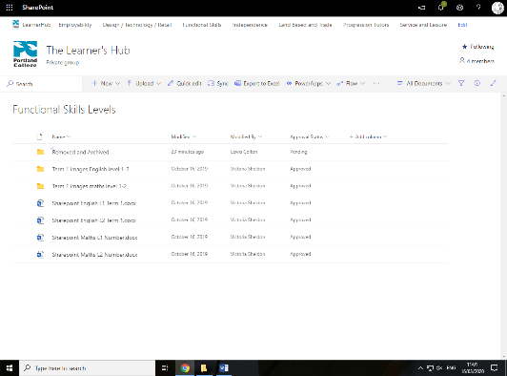

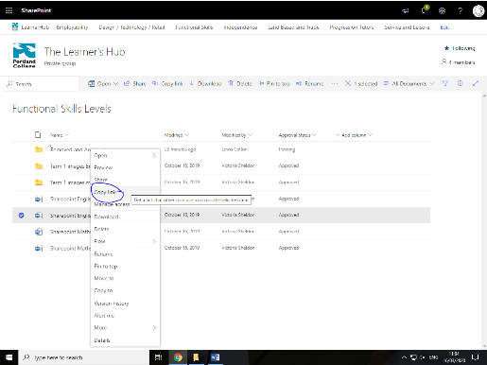Right Click the document you uploaded and select copy link. You can then paste the link into this document in the resource box