LearnerHub SharePoint Upload Template

Please use this template when uploading to the LearnerHub, ensure all fields in the table are filled in. See the bottom of this document for a detailed explanation of what is needed in each category

Can you save on SharePoint in the following title format
Subject – entry /Levels – term
.
Subject | Entry / Levels | Term | Week
Preparation for Adulthood  Employability Skills | Level | 3 | 1
Overview
This week we will be working on:

Identifying different job roles and what jobs you are interested in. We will also be looking at employability skills and what skills you need for employment such as, communication, problem solving and self-management.

What else is being taught this term / week?
During this term we will look be looking at different employment opportunities and voluntary work. We will also be looking at CV writing, application letters and interview skills.

We will look at health and safety in the work place, PPE, safety signs and hazards and risks.

Resources
Play the Kahoot challenge below about vocational roles and employability

https://kahoot.it/challenge/08741477?challenge-id=2fed4e42-cbe7-44e3-8970-b9d38108bb27_1587719375800
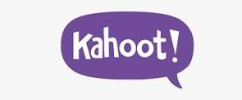

Here is a game you can play about having a job:
https://www.jobfit.me.uk/play

Here is a website to support you with employability skills and job roles:
https://www.liketobe.org/

Here is a video for you to watch about employability skills:
https://www.youtube.com/watch?v=vGjNI16pxn8

Here is a link to the workbook (insert link to uploaded document)

See attached work sheets

Subject
Prep for adulthood
Entry /Levels
Level 1 / Level 2
Term / week
Which college term will this information be used in? Terms 1 2 or 3
What week within the term will this resource be used

Overview
What will be the main focus of this term for the session? E.g. Maths – This term the focus will be on counting Money, English - This term we will be developing your communication skills.
What else is being taught this term?
What other things may be looked into during this terms? E.g. a look into the different coins and notes that are used, item pricing, how money is exchanged.
Resource
A resource can be any information that you think would be useful for students to look at and be able to find an answer to something or practice their skills. E.g. a link to the BBC Skills page on counting money. A top ten tips for something that is on a word document, a link to a program or website with a learning game
Please don’t include all the resources you have on a subject like lesson plans / lesson photos all that is required is the bare minimum of resources to build around.

Linking a resource

If linking to a document you have uploaded onto SharePoint you will need to navigate to the page where you uploaded this to
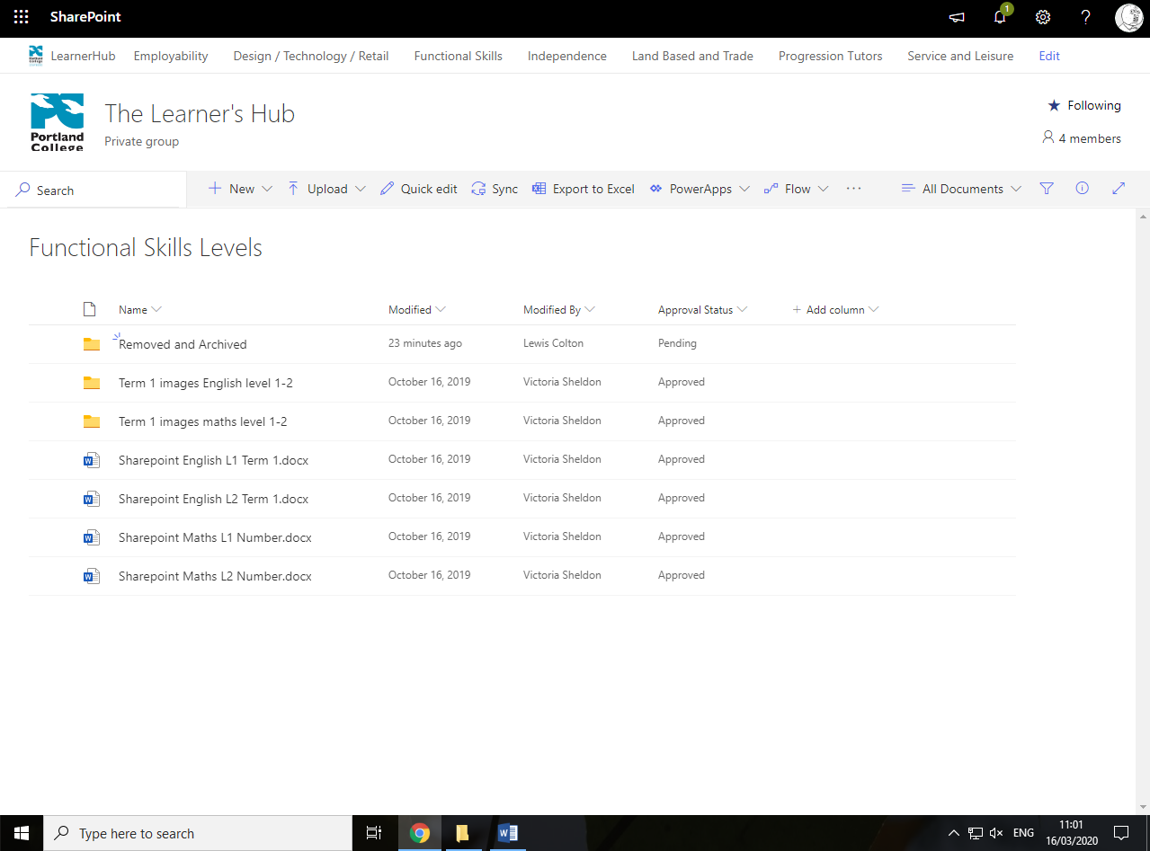

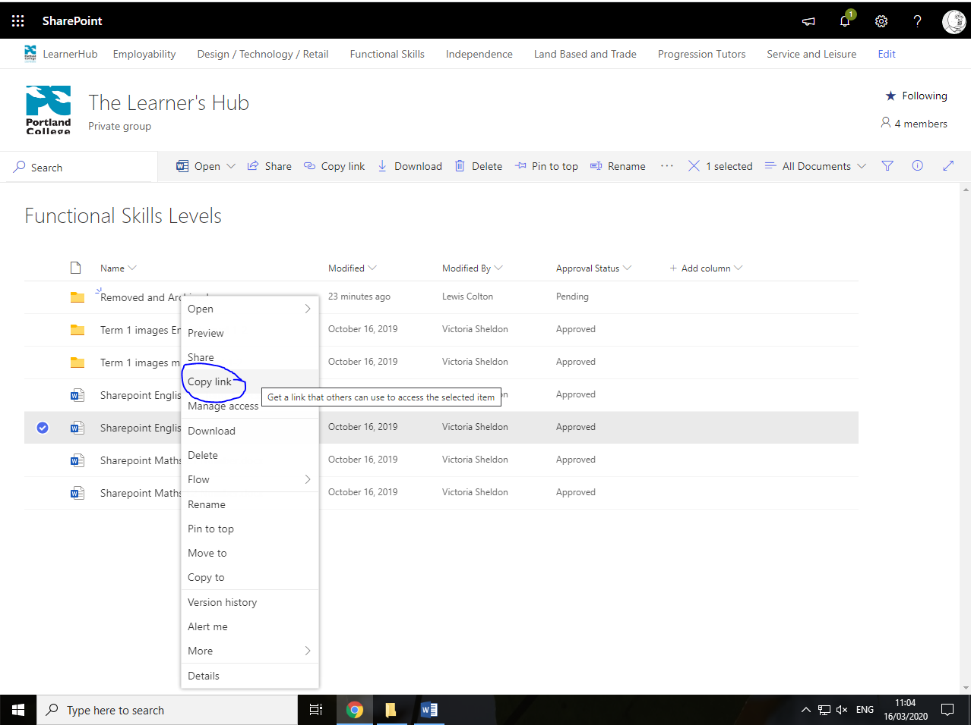
Right Click the document you uploaded and select copy link. You can then paste the link into this document in the resource box

