LearnerHub SharePoint Upload Template

Please use this template when uploading to the LearnerHub, ensure all fields in the table are filled in. See the bottom of this document for a detailed explanation of what is needed in each category

Can you save on SharePoint in the following title format
Subject – entry /Levels – term
.
Subject | Entry / Levels | Term | Week
CV writing | Level 1 and 2 | Term 3 | Week 2
Overview
This week you are going to practise your skills in writing a CV.

What else is being taught this term / week?
A CV is a document that summaries your skills, qualities, employment history and education.
A CV helps a future employer know if you are the right person for the job, but it gives you the opportunity to present your experiences and skills.

Watch the video.
https://www.youtube.com/watch?v=CP-wWXjQ4Oo

Resources
Visit these websites to help you identity what a good CV looks like.

https://standout-cv.com/pages/cv-writing-tips
https://www.youthemployment.org.uk/write-first-cv-tips-students-school-leavers/

Top tips for writing a CV

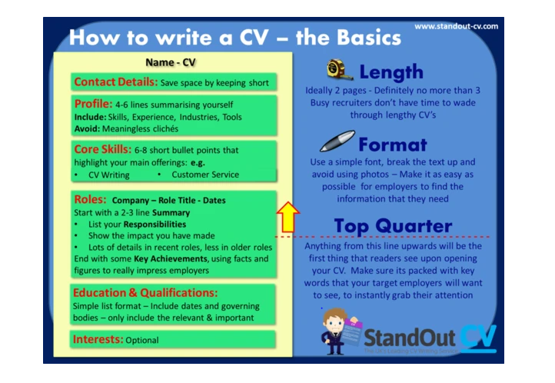

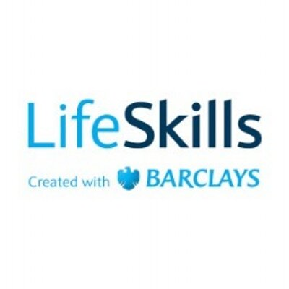
Register for Barclays LifeSkills to develop your skills further.
https://barclayslifeskills.com/young-people/

Subject
Prep for adulthood
Entry /Levels
Level 1 / Level 2
Term / week
Term 2/3 ready for transitioning
Overview
Creating a CV for jobs or college in term 3.
What else is being taught this term?
What other things may be looked into during this terms? E.g. a look into the different coins and notes that are used, item pricing, how money is exchanged.
Resource
Activities to support to complete a CV

Linking a resource

If linking to a document you have uploaded onto SharePoint you will need to navigate to the page where you uploaded this to
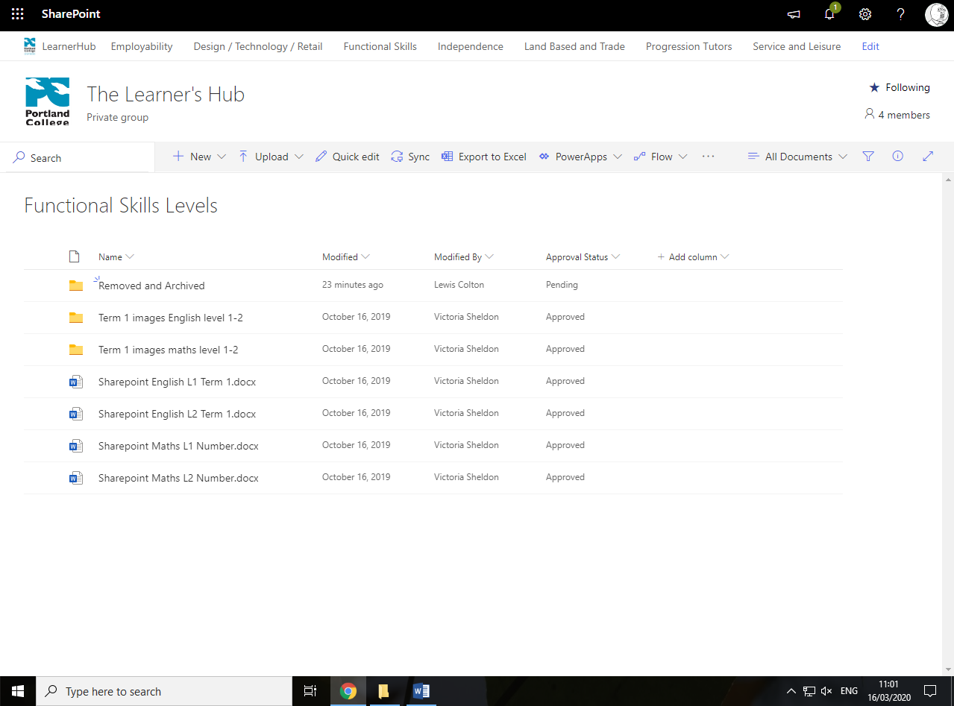

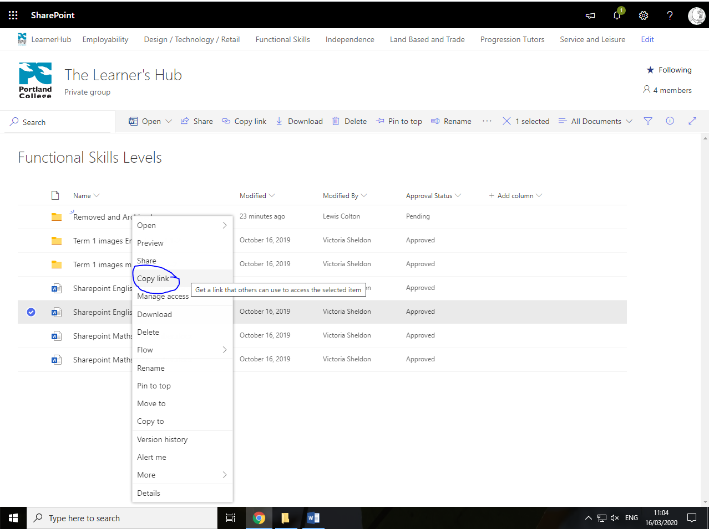
Right Click the document you uploaded and select copy link. You can then paste the link into this document in the resource box

