The date today is ______________________.
(e.g. 10 May 2020 or 10.05.20)

I started this Rainbow craft pack on ______________ (day of the week) in the morning / afternoon.

I started work at _____ o’clock.

Rainbow Wood Tassels
Maths skill: reading numbers
Questions for young person to answer |  | Parent/Carer Feedback Tick which one is relevant
Can you read the following numbers in digit form?  30, 20, 15 |  | - With lots of support  - With a prompt  - Can do independently
Can you read the following number names?  Thirty, twenty,fifteen |  | - With lots of support  - With a prompt  - Can do independently
Can you draw a line from the number in digit form to its number name each time?
30  20  15 | fifteen  Thirty  Twenty | - With lots of support  - With a prompt  - Can do independently
 |  | Comments (Optional)

Maths skill: Measure different lengths
Questions for young person to answer | Parent/Carer Feedback Tick which one is relevant
Can you cut out the measuring bars on the next page? Can you put them side by side? | - With lots of support  - With a prompt  - Can do independently
Can you use them to measure a piece of wool (of 20cms long)? | - With lots of support  - With a prompt  - Can do independently
Can you use the measuring bar to measure another piece of wool? | - With lots of support  - With a prompt  - Can do independently
Can you measure a piece of wool of 2cms long? | - With lots of support  - With a prompt  - Can do independently
 | Comments (Optional)

1 | 2 | 3 | 4 | 5 | 6 | 7 | 8 | 9 | 10
1 | 2 | 3 | 4 | 5 | 6 | 7 | 8 | 9 | 10

Maths skill: I can understand the properties of shapes
Name | Shape |  | Number of sides | Number of corners | 2 dimensional or 3 dimensional)
 |  |  |  | 4 | 2D
 |  |  |  | 3 | 2D
S_______________ | 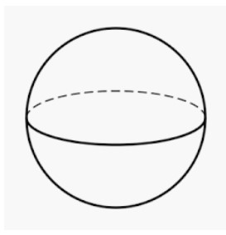 |  | 0 | 0 | 3D
Parent/Carer Feedback Tick which one is relevant |  | Comments (Optional)
- With lots of support
- With a prompt
- Can do independently

Rainbow Wool Tassels
Maths skill: I can understand the properties of shape
Name | Shape | Number of sides | Number of corners | 2 dimensional or 3 dimensional)
 |  |  | 4 | 2D
 |  | 0 |  | 2D
 |  | 12 | 8 | 3D

Parent/Carer Feedback Tick which one is relevant | Comments (Optional)
- With lots of support
- With a prompt
- Can do independently

Rainbow Wool Tassels keyring
Maths skills: I can add and subtract numbers
Questions for young person to answer | Parent/Carer Feedback Tick which one is relevant
Work out the following:  You’ve got 1 bead. You thread on another 2. How many beads do you have altogether?  1 + 2 =  Check this on a calculator | - With lots of support  - With a prompt  - Can do independently
You’ve got 10 beads in a pot. You take out 3 to use. How many beads do you have left?  10 – 3 =  Check this on a calculator | - With lots of support  - With a prompt  - Can do independently
 | Comments (Optional)

Pom Pom using a pom pom maker
Maths skills: I can understand positional language
Use the following words to complete the sentences: in between, first or second.

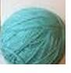

The wool is ________________ arch 1 and arch 2.

The arch is first in the line. True or false? __________________

The arch is second in the line. True or false? ____________________

Parent/Carer Feedback Tick which one is relevant | Comments (Optional)
- With lots of support
- With a prompt
- Can do independently

Pom Pom Garland
Maths skills: use mathematical vocabulary to state the length of an object
Questions for young person to answer | Parent/Carer Feedback Tick which one is relevant
Can you put the wool along the edge of the ruler? | - With lots of support  - With a prompt  - Can do independently
Can you move the ruler along the wool so that the 1cm mark is where the first ruler ended? Can you do this again? | - With lots of support  - With a prompt  - Can do independently
Can you measure 10cms more of wool? Can you cut the wool at 100cms (100cms is 1m)? | - With lots of support  - With a prompt  - Can do independently
Answer the following  The wool is a little longer than ____ rulers. | - With lots of support  - With a prompt  - Can do independently
 | Comments (Optional)

Pom Pom Wreath
Maths skills: Compare familiar objects in terms of capacity
Questions for young person to answer | Parent/Carer Feedback Tick which one is relevant
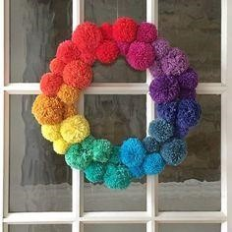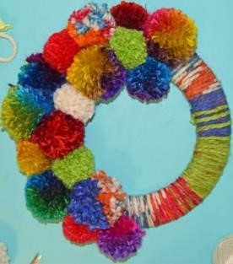  A B C  Which wreath has the most amount of pom poms on it? | - With lots of support  - With a prompt  - Can do independently
Which wreath has the least amount of pom poms on it? | - With lots of support  - With a prompt  - Can do independently
 | Comments (Optional)

Pom Pom and Tassel Rainbow Garland
Maths skills: use mathematical vocabulary to state the length of an object
Questions for young person to answer | Parent/Carer Feedback Tick which one is relevant
Can you put the wool along the edge of the ruler? | - With lots of support  - With a prompt  - Can do independently
Can you move the ruler along the wool so that the 1cm mark is where the first ruler ended? | - With lots of support  - With a prompt  - Can do independently
Can you measure 20cms more of wool? Can you cut the wool at 50cms? | - With lots of support  - With a prompt  - Can do independently
Can you repeat the process two times but this time measure 10cms more of wool?  30cms + 30cms + 10cms = ___________ Can you cut the wool at 70cms? | •
Can you repeat the process three times? 30cms + 30cms + 30cms = ___________ Can you cut the wool at 90cms? | - With lots of support  - With a prompt  - Can do independently
 | Comments (Optional)

Maths skill: use mathematical vocabulary to state the length of objects. Compare the length of objects.
Questions for young person to answer | Parent/Carer Feedback Tick which one is relevant
What objects are on the longest length of wool? The tassels or the beads? | - With lots of support  - With a prompt  - Can do independently
Does the shortest length of wool have the beads on it? Yes or no? | - With lots of support  - With a prompt  - Can do independently
 | Comments (Optional)

Rainbow tote bag
Maths skills: shape recognition
Questions for young person to answer | Tick which one is relevant
What 2d shape is each rainbow stripe? Arch or hexagon? | - With lots of support  - With a prompt  - Can do independently

Rainbow Heart Watercolour Art
Maths skill: Use the vocabulary of capacity to identify familiar objects.
Questions for young person to answer | Parent/Carer Feedback Tick which one is relevant
You collect the piece of equipment below:  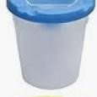  Can you name the item? | - With lots of support  - With a prompt  - Can do independently
 | Comments (Optional)

Maths skills: Compare familiar objects in terms of capacity.
Questions for young person to answer | Parent/Carer Feedback Tick which one is relevant
You pour out water into 2 different water pots  A B Which has the least amount of water? | - With lots of support  - With a prompt  - Can do independently
 | Comments (Optional)

Rainbow Beaded decoration
Maths skills: adding numbers
Questions for young person to answer | Parent/Carer Feedback Tick which one is relevant
Complete the following sum:  3 +_____ = 6  Check it on a calculator | - With lots of support  - With a prompt  - Can do independently
Complete the following sum:  3 + ________ = 9 | - With lots of support  - With a prompt  - Can do independently
 | Comments (Optional)
Please get someone to take photos of you completing the above tasks and email them if possible to jguthrie@rnibcollege.ac.uk
Once completed please send this form back in the envelope provided in your craft pack or send by email to jguthrie@rnibcollege.ac.uk. Jo Guthrie (Maths Tutor)

Support completed Signed: Date: _________________ (parent/carer) _______________________________________________________________
Student Name/signature:

Date:

Assessment Signed: _______________________________________________________ Date: _________________
(Maths Tutor)

Feedback by Maths Tutor

