English and Math Activity Ideas
English
Write a Letter
Ask students to think about brand ambassadors, what are they?
- What is a brand ambassador?
  - Someone who represents a brand in a positive way.
  - They can use their fame/position to promote the brand and make people aware of it.
Students can write a letter to a famous person they think would make a good ambassador for their college:
- Think of someone famous who you think would make a good ambassador for college.
- Write a letter to them, inviting them to be an ambassador for your college.
- Remember to write in full sentences, use correct grammar and explain yourself clearly.
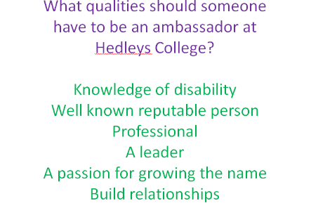
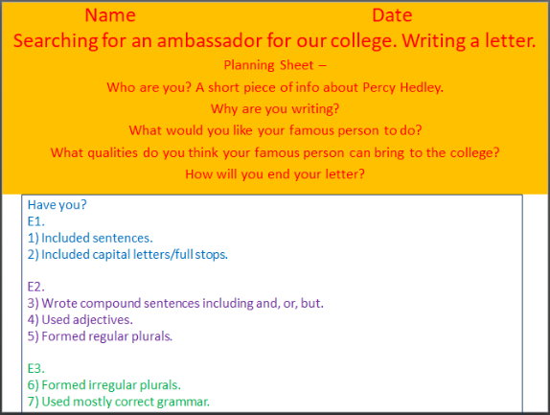
Activity can be differentiated according to the level of the students taking part.
Write a Story
Give students a character and some background.
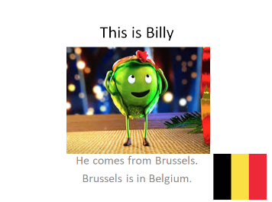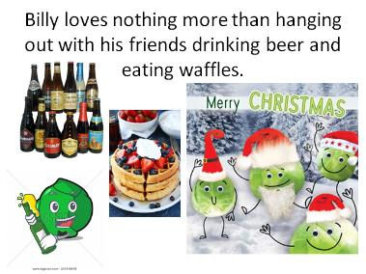

- You are going to write a short story about Billy on his adventures in Newcastle. Think about the type of story you’d like to write: funny, silly, scary, romantic.
- Don’t forget correct grammar – full stops, capital letters, commas.
- Think about the beginning, middle and end of the story.

Maths
Survey
Ask students to collect data and make a graph from it.
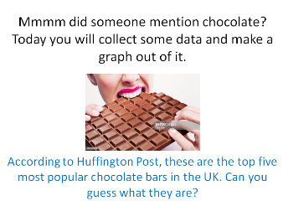
- Ask the people in your house to pick their most favourite chocolate bar from the list of 5. Everyone must pick only 1.
- Use the phone or social media to contact friends and family who don’t live with you and ask them to pick their own favourite. (Have a chat with them while you are there, ask them how they are!)
- Using Smarties as counters, decide on a colour per bar.
  - Green = Dairy Milk.
  - Brown = Snickers
  - Yellow = Twirl
  - Blue = Bounty
  - Red= Twirl
- Use the tally chart included to count up the smarties.
- Fill out the bar chart included.
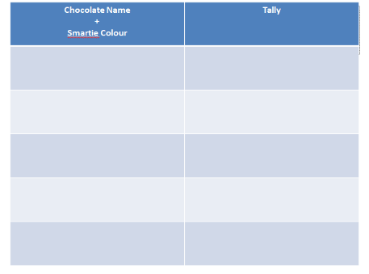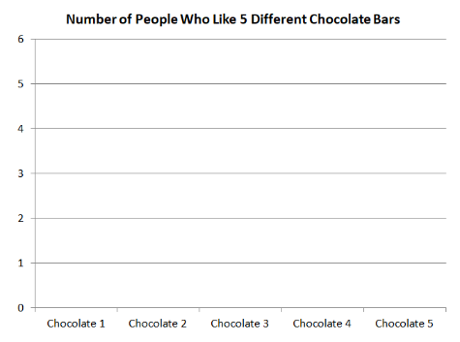
Measurement
Apply maths to real life scenarios
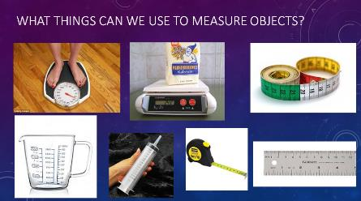
Discuss the literacy around measure:
More/Less, Longer/Shorter, Heavier/Lighter, Small/Large, Little/Big, Thicker/Thinner
Have student collect various items of different sizes and compare the size of the objects; Estimate, Bigger or Smaller, More or Less, Broad/wide or Thinner, Heavier or Lighter etc.
