**Employability Skills**

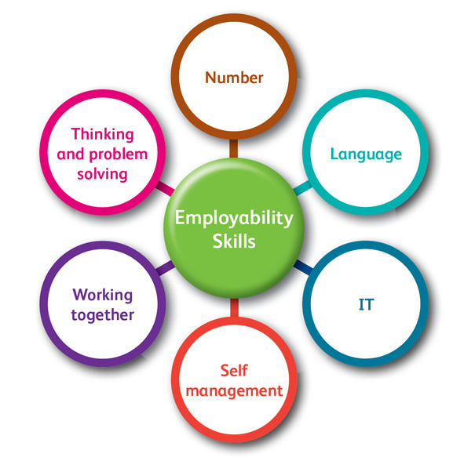**Level 1-2**

**Name:**

**Tutor:**

**Job roles**

In this section, we will look at different job roles.

**Key terms** and **words** are used in **Employability Skills**. To help you learn these words use a dictionary or this website - https://www.collinsdictionary.com/ to find words you don’t know.

Practice spelling these words.



**Task 1 –**

Match the job to the picture.



1. Teacher _____



1. Postman ____

3 Builder ____

 4 Removal man ___



5 Police Officer ____

6 Firefighter ____



**Task 2 –**

Write a brief **summary** of the **responsibilities** for each of these jobs

Builder

Teacher

Chef

Works with

Hairdresser

Vet

**Task 3 –**

Complete a mind map of jobs you would like to do using the list of jobs provided. You can add some yourself.

Add in the **skills** that you would need to do these **jobs.**

Teacher Police Officer Hairdresser Farmer Shop Assistant IT Technician Receptionist Bus Driver Doctor Nurse Firefighter Translator Cleaner Dentist Florist Barmaid/man Chef

**Employability and you**

In this section, we will look at your employability skills.

We will look at different qualities needed for employment.

**Task 1 –**

Using the internet and your own knowledge, list 10 **employability** **skills**:



List 5 **qualities** you think that you have:



Which of your qualities would you like to improve?

How could you improve or this quality or qualities?

Complete the table below:

|  |  |  |  |  |
| --- | --- | --- | --- | --- |
| Things you are good at or might need a bit of help with… | I am confident, I can do this well | I can do this with help | I am nervous about doing this | I avoid doing this if I can |
| Working with other people |  |  |  |  |
| Listening and following instructions |  |  |  |  |
| Speaking on the phone |  |  |  |  |
| Giving other people instructions |  |  |  |  |
| Talking to new people |  |  |  |  |
| Working as part of a team |  |  |  |  |
| Being polite and considerate |  |  |  |  |
| Asking other people question |  |  |  |  |
| Good at sharing information |  |  |  |  |
| Planning your work load |  |  |  |  |
| Problem solving |  |  |  |  |
| Using your initiative |  |  |  |  |
| Adapting to new situations |  |  |  |  |
| Being creative |  |  |  |  |
| Managing your time |  |  |  |  |
| Taking responsibility |  |  |  |  |
| Turning up on time |  |  |  |  |
| Being open to new ideas |  |  |  |  |

**Team Work**

In this section, we will look at being part of a team when at work or other situations.

We will look at what team work is, the advantages and disadvantages and some rules we would think about for team work.

**Task 1 –** *Write in full sentences.*

What is team work?

Think about a time that you have worked as part of a team before.

Where was it?

What was the task you had to complete?

Were you able to complete the task as a team? Was it easier to complete the task a team?

**Task 2 –**

Think about what it means to be part of a team;

Complete the mind map below about what it means to be a successful team.

*One has been done for you.*

Is good at listening to each other.

**A good team…**

**Task 3 –**

Think about the advantages and disadvantages of working as part of a team.

Complete the table below.

|  |  |  |
| --- | --- | --- |
|  | **Advantages** | **Disadvantages** |
| **Working on your own** |  |  |
| **Working with one person** |  |  |
| **Working with a group of people** |  |  |

**Task 4 –**

When working as part of a team, you might need to have a list of rules to make sure everyone gets a say and is listened to, but also to make sure you complete the task.

Make a list of rules you might need when working in a team.

|  |
| --- |
| **List of rules for team work** |
| **1.** |
| **2.** |
| **3.** |
| **4.** |
| **5.** |
| **6.** |
| **7.** |
| **8.** |
| **9.** |
| **10.** |

**Communication Skills**

In this section, we will look at communication skills that you might need to develop or some that you already have.

We will think about what are good communication skills, what are bad communication skills and why we need to use communication skills when developing our employability skills.

**Task 1 –** *Write in full sentences*

What is verbal communication?

What is non-verbal communication?

Describe examples of verbal and non-verbal communication below:

|  |  |
| --- | --- |
| **Verbal communication examples** | **When would you use verbal communication?** |
|  |  |
|  |  |
|  |  |
|  |  |

|  |  |
| --- | --- |
| **Non-verbal communication examples** | **When would you use**  **non-verbal communication?** |
|  |  |
|  |  |
|  |  |
|  |  |

**Task 2 –**

Body language is an important part of communication.

Complete the table below to decide what is positive body language and what is negative body language.

*Some words have been provided for you.*

|  |  |  |
| --- | --- | --- |
| Folded arms | Yawning | Smiling |
| Good eye contact | Nodding | Frowning |
| pointing | Rolling eyes | Turned away from the person talking to you |
| Using your phone and not concentrating | Not making eye contact | Arms crossed |

|  |  |
| --- | --- |
| **Positive body language** | **Negative body language** |
|  |  |

**Self-management and problem solving skills**

In this section, we will look at self-management and problem solving skills.

We will think about what self-management and problem solving is. We will look at ways to solve problems.

**Task 1 –** *Write in full sentences*

Using the internet or a dictionary, find out the definition of self-management:

Using the internet or a dictionary, find out the definition of problem-solving:



When you are getting ready for work, what are some of the things you need to think about? E.g. dressing appropriately

**Task 2 –**

You might come across some problems when working. You will need to think of ways to solve the problem.

Answer the following questions. *Write in full sentences*

What problems might you face in the workplace?

Why is it important to deal with problems?

How will you know when a problem has been solved?