How can you keep children safe online?
You don’t need to be an expert to keep your child safe on online! The following tips will not help keep your child safe but encourage positive and responsible use.

What are the issues?
The internet can be a very informative and positive place but there are many dangers, especially for younger and more vulnerable children/adults. Always remember the 4 C’s!

- Conduct
Children could be at risk because of their own behaviour, such as sharing too much personal information with people e.g photos, address, telephone number.

- Content
Some content can be hurtful or harmful for children. The content could either be age-inappropriate or unreliable/false - this include social networking, apps, gaming, websites and blogs.

- Contact
Children can be contacted by bullies or people who seek to abuse or groom them. It is important to regularly monitor their friends lists and followers. Delete any contacts that you are suspicious of. If you suspect your child is or has been the subject of inappropriate sexual contact or approached by another person, you can contact the Police online or offline. Child Exploitation and Online Protection Centre (www.ceop.police.uk) can be contacted if you have any concerns.

- Commercialism
Children can be unaware of the hidden costs of some apps and websites. Encourage your children to keep their personal information and bank details private.

Useful Tips!

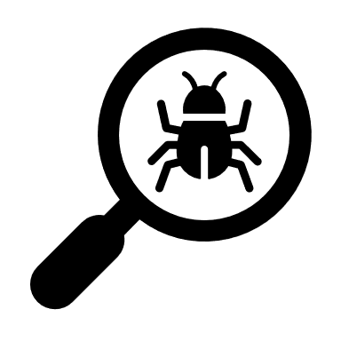Explore together: Ask your child to show you their favourite websites and apps and what they do on them. Encourage them to teach you the basics of the site or app.
Start (and continue) conversations about online safety: Ask them if anything ever bothers or worries them while they’re online. The key message…. if anything happens online which makes them feel worried, scared or sad, the best thing to do is talk to you or another adult who they trust.

Help your child identify people who can help: Reinforce the importance of telling a trusted adult if they are worried about anything. Help your child identify trusted adults from different areas of their life such as at home or at Ruskin Mill.

Be nice!: Explain that sometimes bad people can be hiding behind a computer pretending to someone else, you would never blame them for anything that might happen online, and you will always give them support.

Supervise your child while they’re online: Keep the devices your child uses in communal areas of the house such as in the living room or kitchen where an appropriate adult is able to supervise. Accessing the internet in bedrooms and bathrooms can sometimes be a worrying sign. Mobile phones will be trickier so reinforce the key messages here.

Talk to your child about how their online actions can affect others: Remind your child that when messaging others, they only have words to communicate which means it is easy to get offended or offend someone by a message. Without facial expressions and a voice, what we say online is very different to what we say in the real world. If your child is engaging with others online, remind them to consider how someone else might feel before they post or share something.

SafeSearch: Most web search engines will have a ‘SafeSearch’ function, which will allow you to limit the content your child is exposed to whilst online. Look out for the ‘Settings’ button on your web browser homepage (often shaped like a small cog). Parental controls: Make use of the parental controls available on your home broadband and any internet-enabled device in your home.

