Creating a Daily Planner
with Learners who are Sensory Impaired
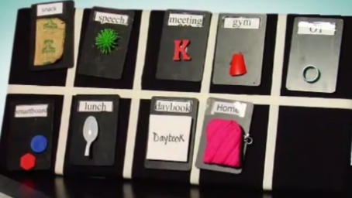

Who will benefit from a daily planner?
A daily planner is great way to structure and organise the day to establish routine for those who find routine important. It is also great for individuals who lack formal communication skills and struggle to access information about what is happening outside of the here and now. These individuals may have an underdeveloped concept of time so working their way through a tactile ‘list’ helps create a countdown to the events of the day they anticipate, such as mealtimes and bedtime. A tactile planner can also enable individuals to affect control over how they spend their time by setting up their daily planner each morning.

What type of planner should I choose?
Consider how may steps or objects are appropriate for the individual. Initially, a now and next system might be suitable way of introducing this concept to prevent anxiety about happening later in the day. The system could be built up to a Now, Then and Next system before moving onto a 4 step planner split between morning and reorganised at midday for the afternoon.

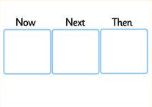

Carefully identify an accessible format for information. For example, learners with profound vision loss might benefit from real objects or audio recordings. Ensure objects are items the individual recognises and associate with the activity. Although those with useful vision may use photos, True Object Based Icons (TOBI’s) or symbols.

See below for useful links to creating and developing a planner from a calendar box to a more abstract system.

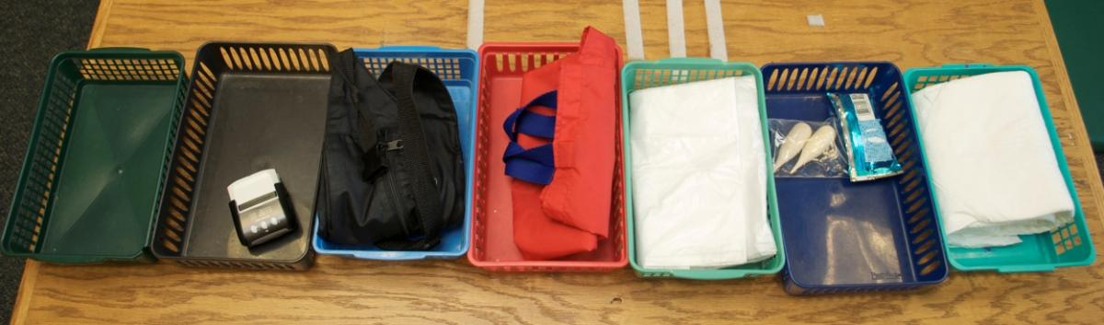
https://www.pathstoliteracy.org/blog/calendar-boxes-and-schedule-systems-literacy-tools
https://www.pathstoliteracy.org/strategies/daily-desk-schedule-child-who-deafblind

