**Cheese Scones**



Watch Alan’s tutorial video on YouTube at the link below!

<https://youtu.be/nU1FHgsykk0>

* Wash Hands
* Wear PPE (Apron)
* Ask for help if you need it

**Health and Safety**

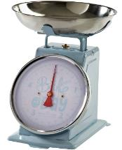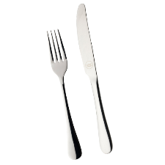

**Equipment**

* Bowl
* Jug
* Grease-Proof Paper
* Scales
* Knife and Fork
* Baking Tray

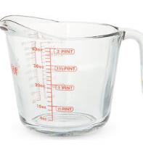

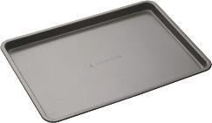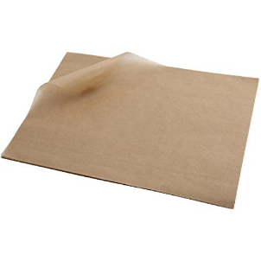

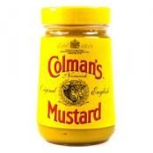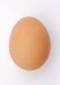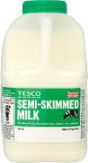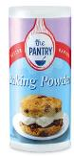

**Ingredients**

1 Teaspoon Mustard

1 Teaspoon Baking Powder

2 Eggs

150ml Milk

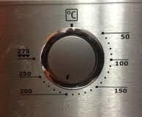

**1**

**Heat the oven to 200C.**

2

**Mix the dry ingredients together; flour, salt, baking powder and mustard powder.**

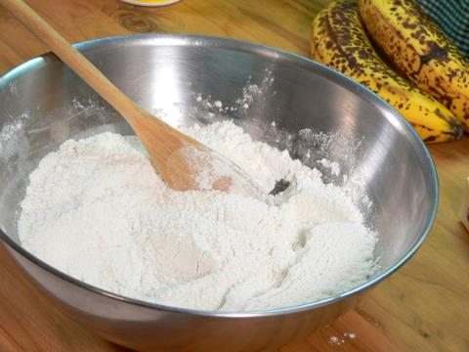

**Add margarine and rub in till it looks like bread crumbs**

**3**

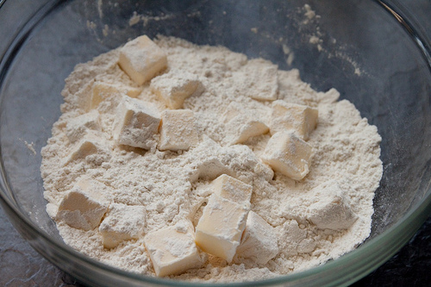

**4**

**Stir in the cheese**

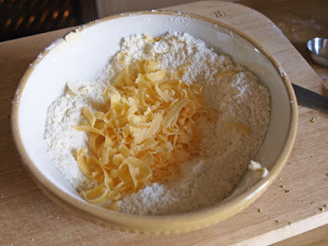

**5**

**Add 2 eggs to the milk and beat.**

**Gradually add the mix to the dry ingredients to get a soft dough**.

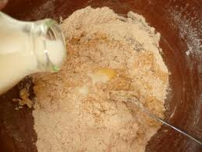

**Turn on to a floured work surface and knead very lightly.**

**6**

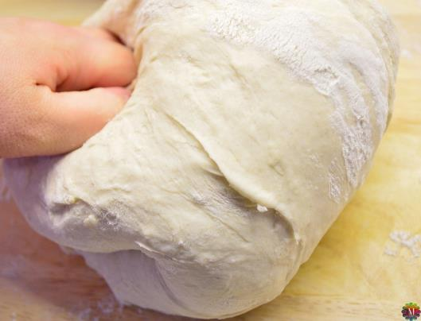

**7  
Roll out to 1 inch thickness. Cut into rounds**

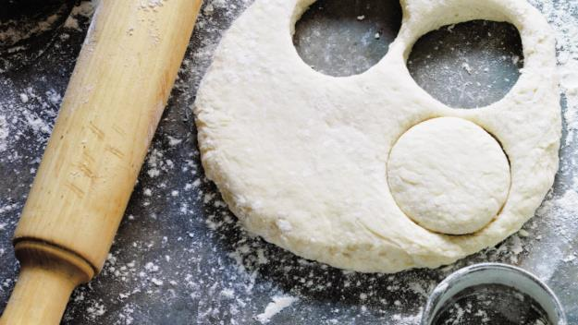

**8  
Place on a baking tray, egg wash and sprinkle with cheese.**

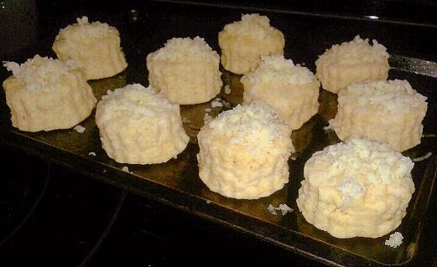

**Cook for 12-15 mins.**

**9**

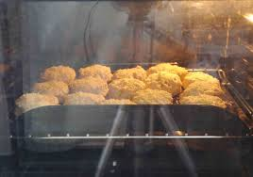

**10**

Leave to cool.



11

Wash up

