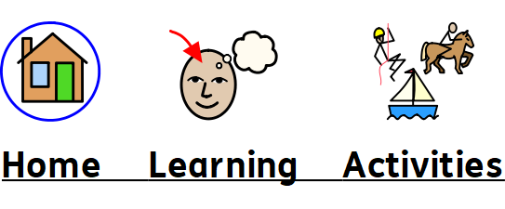

Name: Complete ………..activities in a row to win your Home Learning Bingo! Stick your activities in the blank spaces!

Copyright © Queen Alexandra College. All rights reserved.

